**AED Chapter Record Form Instructions for older versions of Adobe Reader**

Scroll down for instructions for the newer versions of Adobe Reader.

**Step 1: Click on “Open Sign Pane” at top right corner.**

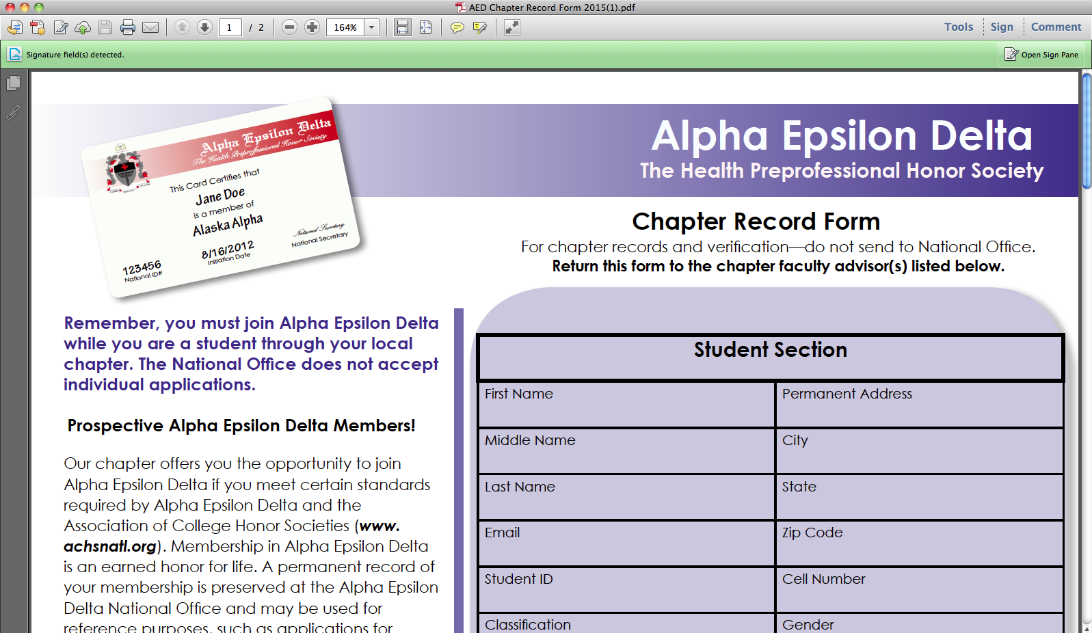

**Step 2: Click on “Add Text” at the top right corner.**

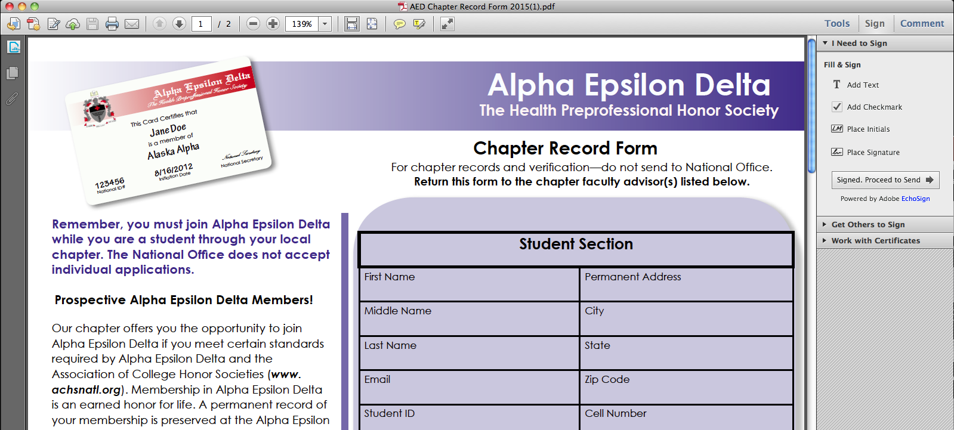

**Step 3: Click on each box and type in your information.**

**Step 4: Print the completed document and *hand-sign* *and date* the application.**

**AED Chapter Record Form Instructions for newer versions of Adobe Reader**

**Step 1:** **Click on “Fill & Sign” option on the right.**

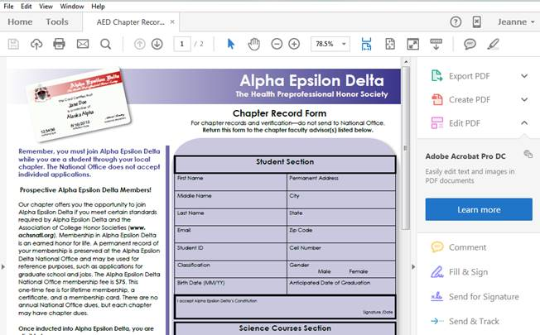

**Step 2:** **Click on each individual box and complete the form.**

**Step 3: Print the completed document and *hand-sign* *and date* the application.**

Follow the instructions for all documents needed and turn them in at the AED Welcome Back Meeting on **January 23, 2018** or to Dr. Ivey (SCEN 627) before **6:00pm** on **January 26, 2018**.