First Essay
Due October 1
2-3 pages

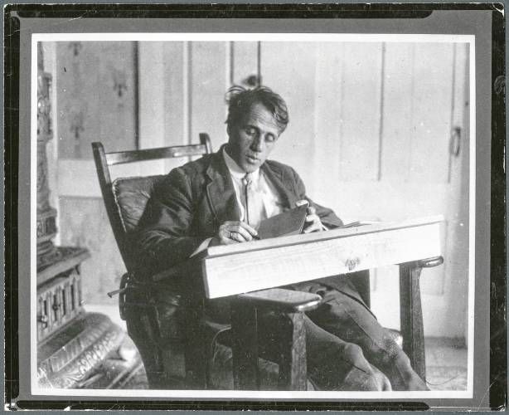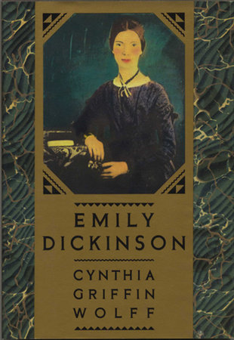
Robert Frost Emily Dickinson

In his 1941 poem, “The Lesson for Today,” Robert Frost writes that he “had a lover’s quarrel with the world” (162). Consider his imagery: a “lover’s quarrel,” or a dispute, difference, or argument between those who love each other – in particular, a person and the world they inhabit. Choose a poem by Frost or Dickinson and write about how it conveys or disputes Frost’s statement. Use examples from the poem to make your point and cite the poem’s line numbers in parentheses.

Work Cited
Frost, Robert. The Poetry of Robert Frost. Macmillan, 1979.

- You may handwrite or type your essay
- Use MLA format (for more information, check out www.owl.purdue.edu)
- The essay should be 2-3 pages, or about 1,000 words

How to cite poetry in an essay:
When using short (fewer than three lines of verse) quotations from poetry, mark breaks in verse with a slash, ( / ), at the end of each line of verse (a space should precede and follow the slash). If a stanza break occurs during the quotation, use a double slash ( // ). Then follow the quotation with a parenthetical citation in which you include the line numbers of what you quoted.

Emily Dickinson opens with a metaphor, "Hope is a thing with feathers / That perches in the soul" (1-2).

For quotations that are more than four lines of prose or three lines of verse, place quotations in a free-standing block of text and omit quotation marks. Start the quotation on a new line, with the entire quote indented ½ inch from the left margin while maintaining double-spacing. Your parenthetical citation should come after the closing punctuation mark. When quoting verse, maintain original line breaks.

When citing long sections of poetry -- four lines of verse or more -- keep formatting as close to the original as possible. For example:

In his poem "After Apple Picking," Robert Frost conveys a kind of weariness while pursuing something you desperately want:

For I have had too much
Of apple-picking: I am overtired
Of the great harvest I myself desired.
There were ten thousand thousand fruit to touch,
Cherish in hand, lift down, and not let fall. (27-31)

