Experiment 45: Green Synthesis of Rhodamine B Dye

Andrew Tyson
05 December 2013
Chemistry 213-101
Pradeep Chauhan

INTRODUCTION
Green chemistry is a relatively new type of chemistry that focuses on sustainable chemistry. It is based on the principle that it is easier to prevent waste than it is to treat or clean waste up after it has already been produced.¹ Green chemistry focuses on using every starting material used in order to prevent forming waste.¹ Many new methods are being developed to reduce waste such as solvent-less reactions, which is a method being used in this experiment, replacements for environmentally damaging compounds, greener fluorination methods, and many more.¹
Green chemistry has recently been an often used method of producing synthetic dyes. Synthetic dyes have replaced many natural dyes because they are cost less to produce, offer new color options, and are more effective than natural dyes.² Synthetic dyes are used in several different industries including textile, paper, ink, medical, cosmetics, and pharmaceutical.²
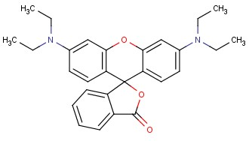
Figure 1. Rhodamine B
The synthetic dye that will be focused on in this experiment is Rhodamine B. Rhodamine B is a synthetic dye that is produced through two Friedel-Crafts like reactions. It appears as a magenta colored dye that absorbs yellow light. Rhodamine B dye has many uses as a laser dye, ink dye, cosmetics dye, biological cell stain and tracer, clothing dye, and in the production of crayons.³ Its most important use is in the as a tracer dye in water to determine the rate and direction of water flow.³
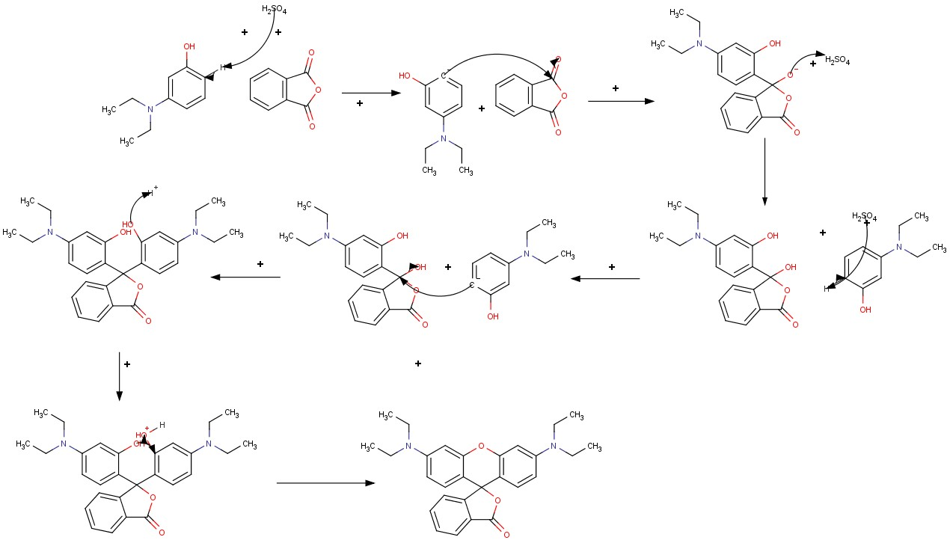
Scheme 1. Mechanism of Friedel-Crafts like reactions of phthalic anhydride and 3-(diethylamino)-phenol to Rhodamine B

In the first step, the carbon para substituted in relation the amine group on 3-(diethylamino)-phenol is deprotonated to gain a negative charge. This carbon than attacks a carbon one of the carbonyl groups on phthalic acid. The oxygen that was formerly in a double bond as part of the carbonyl group is then protonated to give it a neutral charge. This same process repeats itself with the second 3-(diethylamino)-phenol with a small variation in the last step. In the last step of the process, alcohol group is not protonated again but instead eliminated from the molecule. One of the two identical alcohol groups on the molecule is protonated. The remaining alcohol group will then bond with the carbon bonded to the protonated alcohol group which will be eliminated from the molecule to form Rhodamine B.
Synthetic dyes are very important in organic chemistry and very useful in several industries including the textile, paper, ink, medical, cosmetics, and pharmaceutical industries to name a few. Specifically, Rhodamine B dyes are very useful as a cell stain. The purpose of this lab is to synthesize Rhodamine B dye from 3-(diethylamino)-phenol and phthalic acid through the use of Friedel-Crafts reactions. The product can then be quantified and analyzed using NMR instrumentation and Ultraviolet/Visible spectroscopy.

EXPERIMENTAL
Rhodamine B. 3-(diethylamnio)-phenol (228 mg, 1.3799 mmol) and phthalic anhydride (100 mg, 0.6751) were added to a test tube and heated over sand until the mixture turned orange. 8M sulfuric acid (0.15 mL) was added to the mixture, and it was allowed to heat over sand (180-200°C) for 60 minutes. Upon completion, methanol (3 mL) was added, the mixture was stirred until the solid dissolved completely, and it was washed with dichloromethane (15 mL), 5% NaHCO₃ (10 mL x 2), and distilled H₂O (5 mL). After drying over anhydrous sodium sulfate, the product was left to dry overnight. Flash column chromatography (5:95 methanol:acetone) afforded Rhodamine B as a magenta solid (148 mg, 49.54%) mp 203-205°C; ¹H NMR (60 MHz, CDCl₃) δ (ppm) 1.17 (t, 12 H), 3.34 (q, 8 H), 6.20-7.96 (m, 10 H); ¹H NMR (400 MHz, CDCl₃) δ (ppm) 1.17 (t, 12H), 3.34 (q, 8 H), 6.20-8.05 (m, 10 H); UV/Vis λ_{max} 542 nm.

RESULTS AND DISCUSSION
The synthesis of Rhodamine B dye takes place through two Friedel-Crafts like reactions that occur in the absences of a typical Lewis acid catalyst. Both 3-(diethylamino)-phenol and phthalic anhydride are combined with a catalytic amount of sulfuric acid to obtain the product through a solvent-less green reaction.
The products were analyzed using Ultraviolet/Visible Spectroscopy (Figure 1, Supplemental Information). The λ_{max} value for the product was 542 nm. This value is close to the value of 523 nm found in an experiment of the same type run by scientists at the Manhattan College.³ This value means that the solution absorbed yellow light and looked red-violet in solution which matches the description of the product. Some small contamination could have been present in the solution which would account for the small disparity in the λ_{max} values between the product made and the literature value.
NMR analysis was also helpful in characterizing the identity of the product. When analyzing the ¹H NMR spectra (Figures 2, 3, and 4, Supplemental Information), several key peaks are seen that indicate the product formed was indeed Rhodamine B dye. A triplet at approximately 1.17 ppm with an integration value of 12.32 and a quartet at approximately 3.34 ppm with an integration value of 6.12 indicate the presence of the four ethyl groups attached to two separate nitrogen atoms that are characteristic of Rhodamine B. The multiplet of peaks at approximately 6.20-8.05 ppm with an integration value of 8.77 indicates the presence of the ten aromatic hydrogen atoms present in the three aromatic rings of Rhodamine B. All of these features indicate that product formed was indeed Rhodamine B dye. The lack of a singlet with an integration value of one at 7.00-12.00 ppm also indicates that no aromatic alcohol group is present. This indicates that no 3-(diethylamino)-phenol is present in the product, another indicator that the synthesis and purification were successful.
Ultraviolet/Visible spectroscopy and NMR analysis both confirmed the identity of the formed products as Rhodamine B dye. These analyses also indicated that the product was pure and lacked major impurities such as starting material. Rhodamine B was synthesized at a 49.54% yield. While this yield was acceptable, it was not necessarily ideal. The previously referenced experiment by Manhattan College had a yield of 66.7% which is marginally higher than the yield found in this experiment.³ This lower yield could be due to material being lost on the glassware during various steps of the experiment, not allowing the reaction to run long enough, or poor isolation techniques.
The melting point of the product formed was 203-205°C. This is close to the accepted value of 210-211°C but still different enough to indicate that some small impurities may have been present. This small difference in melting point values could be due to any of the above sources of error.
Green chemistry is a relatively new yet very important area of synthetic organic chemistry. Green chemistry is very useful due to very low amount of waste it produces. Synthetic dyes can often be made via green chemistry and are also very useful in organic chemistry. The have use in medicine, engineering, biochemistry, and many other fields. This experiment focused on synthesizing Rhodamine B dye from 3-(diethylamino)-phenol and phthalic anhydride. The product was successfully synthesized and Ultraviolet/Visible spectroscopy and NMR analysis were used to confirm the identity of the product.

REFERENCES
- Constable, D. Green Chem. 2007, 9, 411-420.
- Shah, M.K. Asian Journal of Water, Environment and Pollution. 2013, 10, 77-87.
- McCullagh, J.V. J. Chem. Ed. 2007, 811, 1799-1802

