Adeline Answine, Chem 213
Synthetic #1 FFR
Saponification of Trimyristin to form Sodium Myristate
Introduction
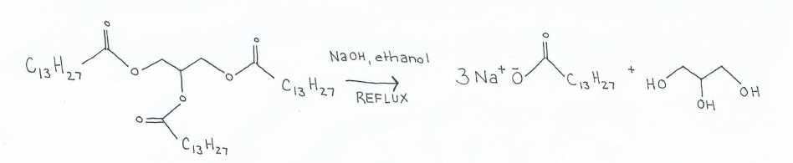
Scheme 1. Saponification of trimyristin to sodium myristate.
Saponification is a common procedure in which esters are hydrolyzed in basic solutions via a nucleophilic acyl substitution. The nucleophile, hydroxide, from the basic solution attacks the ester carbonyl and results in the formation of a carboxylic acid, or in the case of this experiment, three fatty acid salts and a glycerol. This process has been used for over 5,000 years in the production of soaps from triglyceride fatty acids.¹ In ancient times, a combination of animal fats and basic plant ash was used to elicit the amphiphilic, or both polar and nonpolar, qualities of soap involved in washing.² After the saponification of the triglycerides, the resulting fatty acid salts have the unique, aformentioned amphiphillic qualities which allow them to emulsify fats in order to clean surfaces. The highly polar, electronegative oxygen of the fatty acid salt interacts easily with polar water molecules. The non-polar, hydrophobic hydrocarbon chain of the fatty acid salt dissolves in oils and other nonpolar molecules. In water, the hydrocarbon chains orient themselves away from water and congregate together to form spherical micelles with the electronegative oxygen on the polar head facing the water. If oil or grease is present, the hydrocarbon chains will dissolve in the grease and the grease will then be contained in the internal portion of the micelles.¹ Since the electronegative oxygen will continue to interact with water, the grease within the micelles can easily be washed away in a water rinse. These fatty acid salts are commonly used as soaps and detergents in the cleansing of oils from surfaces.
In this experiment, trimyristin serves as the triglyceride, or a series of three hydrocarbon tails attached to a glycerol backbone, that will undergo hydrolysis to become three fatty acid salts. Trimyristin consists of three ester groups, each attached to a thirteen carbon tail. It is a saturated fat, meaning that it has no double bonds in its carbon chain, produced via extraction from ground nutmeg. Though trimyristin is used to make fatty acid salts in this experiment, due to the electronegative nature of the ester carbonyl, it can participate in reactions with many nucleophiles, or electron acceptors. When refluxed with methanol and a base catalyst, trimyristin undergoes a nucleophillic acyl substitution, with methanol as the nucleophile, to produce a methyl ester that can then be utilized as a biodiesel . Triacylgylcerols, such as trimyristin, can produce significant yields of methyl esters when they undergo microwave esterifications in the presence of catalytic scandium triflate.³ The easy one step esterifications and saponifications of trimyristin make it a useful reactant that can form many products.
When trimyristin is refluxed in a basic solution, a glycerol and three fatty acid salts, specifically, sodium myristate, are produced. As stated above, these fatty acids exhibit amphiphilic properties that allow them to interact with both polar and nonpolar molecules resulting in effective emulsion of oils and grease. The amphiphilic qualities of sodium myristate also allow it to interact with other polar molecules and serve protective functions. For instance, sodium myristate can be combined with magnesium alloys to protect them from corrosion. Without protection, magnesium alloys react frequently with environmental factors and are easily corroded. When combined with sodium myristate, magnesium forms salts with the electronegative ions while the nonpolar tails of the myristate congregate to form a protective layer. In this way, sodium myristate interacts closely with the magnesium while simultaneously protecting it from other reactive species. ⁴ Sodium myristate, a salt which is easily produced from trimyristin, is useful as both an emulsifier and a protector in many environments.
In the first step of the experiment, trimyristin is isolated from ground nutmeg via a reflux reaction in diethyl ether. The purpose of this is to allow the desired trimyristin to be separated from other components within the nutmeg so only trimyrisitn will be present in the saponification reaction. Once the trimyristin is isolated, it undergoes a nucleophilic acyl substitution in the saponification reaction, as illustrated by scheme 2. The presence of the sodium ion in the solution allows the resulting soap product to be easily removed from solution and purified.² The purpose of this experiment is to demonstrate the age-old process of soap formation from natural fats and the effectiveness and accessibility of the saponification reaction.
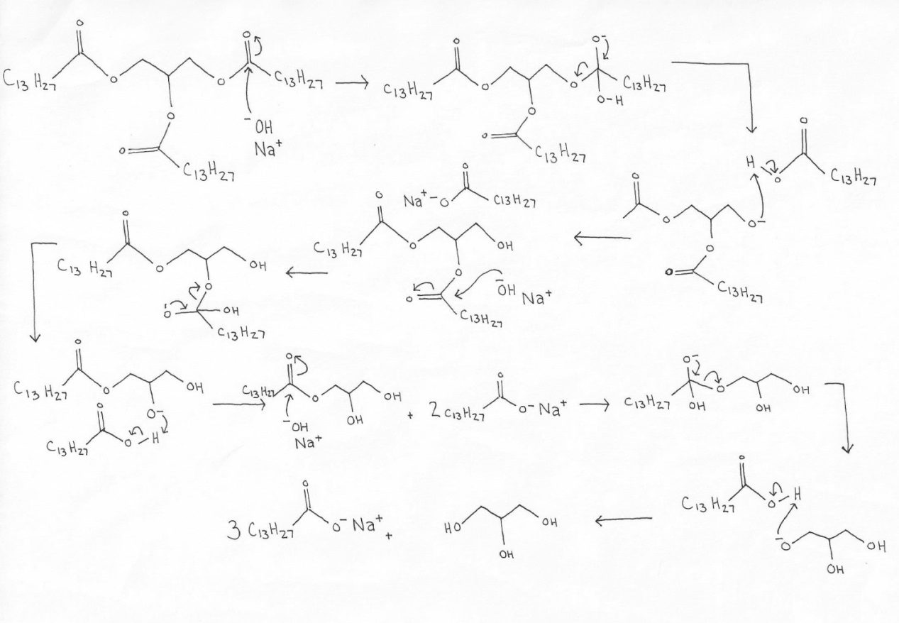
Scheme 2. Mechanism of the saponification of trimyristin to sodium myristate in basic conditions.
In the saponification reaction, the hydroxide of the base serves as the nucleophile while the carbonyl carbon of the ester serves as the electrophile. The hydroxide from the sodium hydroxide attacks the carbonyl carbon, forcing the electron from the double bond to the adjoining electronegative oxygen. Once the instable tetrahedral intermediate is formed, the negatively charged oxygen forces the nearby oxygen from the species and reforms the double bond. The negatively charged oxygen then removes the acidic hydrogen from the formed carboxylic acid, forcing the newly formed ion to associate with the positively charged sodium ion. A hydroxide group is therefore formed where the ester was on the trimyristin molecule. Due to the electrophilic character of all three of the esters on the trimyristin molecule and the abundance of hydroxide ions in solution, the trimyristin molecule undergoes the saponification three times until three sodium fatty acid salts and a glycerol molecule are produced.
Through two reflux reactions, an extraction and a saponification, soap is quickly and easily produced from nutmeg, a common household spice. The extraction allows for the isolation of the desired trimyristin reactant and the saponification allows for the hydrolysis of esters in the production of amphiphilic sodium myristate. Further analysis using IR and melting point determines if the desired soap has been formed. Mixing the salt with both olive oil and ferrous chloride in separate test tubes indicates the uses and reactivity of the produced fatty acid salts.
Experimental
Trimyristin. Ground nutmeg (5 g) was stirred in diethyl ether (15 ml) and refluxed for 30 minutes. The solution was then cooled to room temperature. It was filtered and solids were washed with ether (2 x 10 ml). The solution was evaporated to produce a thick, yellow solid. After drying completely, the product was recrystallized in warm 95% ethanol (15 ml) to produce a white, powdery solid (0.706 g, 14%) from a translucent, orange solution. The product and solution were analyzed with TLC (50% ethyl acetate/hexanes), R_{f =} 0.92, mp 55-56°C; IR (ATR)γ_{max} (cm⁻¹) 2913, 2849, 1732, 1272, 1253, 1229, 1172, 1112.
Sodium Myristate. To 95% ethanol (4 ml) and sodium hydroxide pellets (0.04 g, 1 mmol) was added trimyristin (200 mg, .277 mmol), then refluxed for 20 minutes. The solution was cooled and distilled water (5ml) and saturated sodium chloride solution (10ml) were added. The solid soap was collected via vacuum filtration and washed with cold water (2x 10 ml), to produce sodium myristate as a hard, white solid (0.949g, 456%) decomposes at 275°C; IR (ATR) γ_{max} (cm⁻¹) 3372, 2918, 2847, 1556, 1444, 1421, 1045, 923,722, 697, 540.
Tests with Sodium Myristate. Sodium myristate (0.25 g) was dissolved in water (25 ml) with heat and dispensed into two test tubes (5 ml each). To one tube, olive oil was added drop wise, creating two immiscible liquid layers. Upon shaking, a white, foamy lather was produced throughout the solution. To the other tube, 1% ferrous chloride was added, creating a slowly sinking yellow layer on top of the water solution. Upon shaking, white, suspended precipitate was produced.
Results and Discussion
In the first procedure, the triglyceride trimyristin was extracted from ground nutmeg through a reflux reaction in ether in order to separate the desired molecule from the mixture of nutmeg. The mildly polar trimyristin dissolved easily in the ether solution due to the presence of its three ester groups. The trimyristin can easily be dried out of the ether because the volatility of ether prevents it from remaining in its liquid form. After utilizing 5 grams of nutmeg, 0.708 grams of trimyrisitin was extracted, resulting in a percent recovery of 14%. This low recovery indicates that the trimyristin in nutmeg is one of many other molecules within the spice, indicating the need for the initial extraction process. This yield was slightly lower than the literature yield of 1 to 1.5 grams due to the inability to wash all of the solids from the flask during filtration.¹ Even though the recovery may indicate that the extraction is not highly efficient, the relative ease in which the trimyristin was separated from the other nutmeg components makes nutmeg a good precursor to pure trimyristin product. After the trimyristin was recrystallized in ethanol, the purity of the product was tested with TLC by comparing a solution of the trimyrisitin product to the solution it was recrystallized in. Ethanol was used as the solvent because it contains a polar hydroxide group which easily dissolves the trimyristin due to its polar ester groups when warmed. The trimyristin, though, does not dissolve well in cooled ethanol and easily precipitates out. The spot of the trimyristin appeared with an R_{f} of 0.92 and distinct from the spots of the solution, indicating that the impurities in the solution were no longer in the trimyristin. The high retardation factor was expected due to the carbon chain steric hindrance that prevents the trimyristin polar groups from interacting with the stationary phase. In the melting point test to confirm purity, the observed melting point range of 55 to 56°C was close to the literature established melting point of 56.5°C.¹ There may have been some slight melting point depression due to the presence of minimal nutmeg impurities that were not washed away during filtration.
After the melting point was determined, the identity of the extracted trimyristin was confirmed with IR analysis (Figure 1). The IR spectral data allows for the determination of the presence or absence of identifying functional groups. The first notable peaks in the IR spectral data were the two steeps peaks located in the 2900 cm⁻¹ range (2913 and 2849). These indicate the presence of C-H bonds, and though C-H bonds are present in trimyristin, C-H bonds are present in all organic compounds and these peaks are not particularly helpful in trimyristin identification. The second most notable peak was the single 1732 cm⁻¹ peak. This peak indicates the presence of a C=O bond associated with an aliphatic ester functional group. This peak is essential for the presence of trimyristin because trimyristin contains three aliphatic esters attached to the glycerol backbone. The third identifying peak of the IR spectral data is the 1112 cm⁻¹ peak representing a C-O bond associated with an ester which typically occurs in the 1150 to 1060 cm⁻¹ range. The importance of the peaks in the 1730 cm⁻¹ and 1100 cm⁻¹ ranges are confirmed by the trimyristin IR spectral data found in other experiments with nutmeg.⁵ Though all of the components of nutmeg are not identified in this experiment and, therefore, it is impossible to know if all the unwanted molecules were removed during extraction, the presence of the aliphatic ester stretch peaks indicates the trimyristin was present within the extracted sample.
In the second procedure, trimyristin was utilized as the reactant in a reaction refluxed in basic conditions to produce the soap, sodium myristate. The basic solution was necessary because the hydroxide ions from the sodium hydroxide serve as the nucleophile responsible for attacking the trimyristin ester group. The trimyristin and sodium hydroxide easily dissolved in the polar ethanol solution. The sodium ions that remained within the ethanol solution interacted with the carboxylate ions of the sodium myristate and allowed the soap to form a solid and be filtered from the solution. The solid product was further insured due to the addition of saturated sodium chloride solution which provided more sodium ions that could interact with any remaining myristate anion and precipitate out. The percent yield was calculated to be 456%, indicating that more than just sodium myristate was present in the dried soap product. Since the polar end of the carboxylate anion interacts readily with the O-H groups of water and glycerol, it is likely that the extra yield was due to water and glycerol that could not be separated from the product. A melting point could not be obtained for sodium myristate due to the strong ionic bonds exhibited by the salt. Since the bonds are strong within the salt structure, the stability of the compound is able to resist heat energy and, instead of melting, decomposes at high temperatures. This decomposition was observed as the salt sample turned black around 275°C. This was the first indication that the desired salt product was produced.
The IR spectra (Figure 2) further confirmed that the product produced was the desired fatty acid salt. The first notable peaks were, as seen in the trimyristin IR spectral data as well, the C-H stretch peaks seen in the 2900 cm⁻¹ range (2918 and 2847). These peaks are characteristic of all organic compounds and do not identify the product. The identifying peak appeared in the 1550 cm⁻¹ range (1556) and indicates the presence of the C=O bond within a carboxylate anion. The carboxylate anion is the identifying functional group of sodium myristate giving it its unique polar head. Trimyristin is not present within this sample because the 1750cm⁻¹ C=O ester stretch is no longer present. The peak in the 3300 cm⁻¹ range (3372), indicating an O-H bond, confirms the presence of water and/or glycerol within the product. As stated before, these products could not be completely removed do to their strong associations with the carboxylate anion. According to both the IR and the melting point test, sodium myristate was easily and effectively produced from trimyristin via a saponification reaction. Unfortunately, the efficiency of the reaction cannot be fully determined due to the presence of water and glycerol which affects the calculated yield.
In the final procedure, a solution of water and soap product was separated into two test tubes. A few drops of olive oil were added to one tube and a few drops of 1% ferrous chloride were added to the other. Both tubes were corked and shaken vigorously and the resulting solutions were observed. In the olive oil tube, a thick white foam was formed throughout the tube, indicating that the nonpolar ends of the fatty acid salt had dissolved in the nonpolar oil and engulfed it in micelles. According to the literature, this homogeneous mixture within the solution is expected.¹ This interaction resulted in soap’s characteristic lather within the tube. In the ferrous chloride tube, a visible precipitate, specifically, iron myristate, resulted due to the ionic interactions of the iron ions and the carboxylate ions of the fatty acid salt. The interaction simulates the formation of the insoluble soap scum when soap interacts with metal-containing hard water. ¹ These unique interactions with ionic and nonpolar molecules further substantiated that the desired soap product had been produced.
Conclusion
The production of soap via the ester hydrolysis of the saponification reaction is a simple process that has had a significant impact for thousands of years. When heated in a basic solution, trigylcerides, like the ones found naturally in nutmeg and other plants, can easily be hydrolyzed into three fatty acid chains via simple nucleophilic acyl substitution. The amphiphilic nature of resulting soap allows it emulsify nonpolar lipids into water so they can easily be removed from surfaces via a simple water rinse. These soaps have practical applications in both the cleansing of various surfaces and the protection of materials. The amphiphilic qualities of fatty acid salts are important for interactions with many molecules and are relevant to many areas of study. In this experiment, one such soap product, sodium trimyristate, was effectively produced via a two-step extraction and reaction process from the common spice nutmeg. The formation of the product was confirmed by melting point, IR and the product’s interactions with both olive oil and 1% ferrous chloride.

References
- De Mattos, M.C.S.; and Nicodem, D.E. J. Chem. Educ., 2002, 79, 94-95.
- Phansteil IV, O.; Dueno, E; and Wang, Q.X. J. Chem. Educ., 1998, 75,
612-614.
- Socha, A.M.; and Sello, J.K. Org. Biomol. Chem., 2010, 8, 4753–4756.
- Frignani, A.; Grassi, V.; Zucchi, F; and Zanotto, F. Materials and Corrosion, 2011, 62, 995- 1002.
- Kuo, Y., Lin, S., and Wu, R. Chem. Pharm. Bull. 1989, 37, 2310-2312.

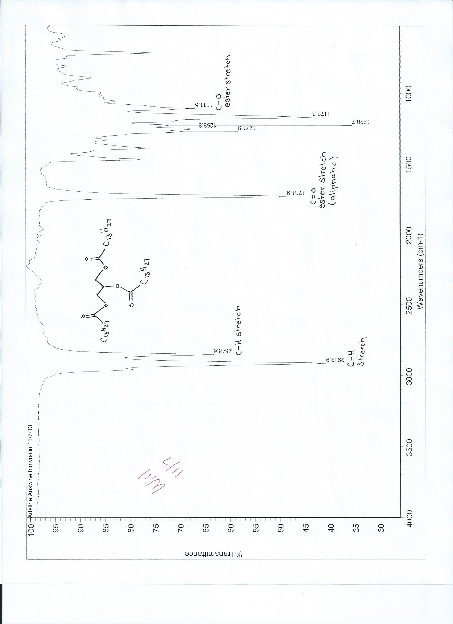
Figure 1. IR of Trimyristin
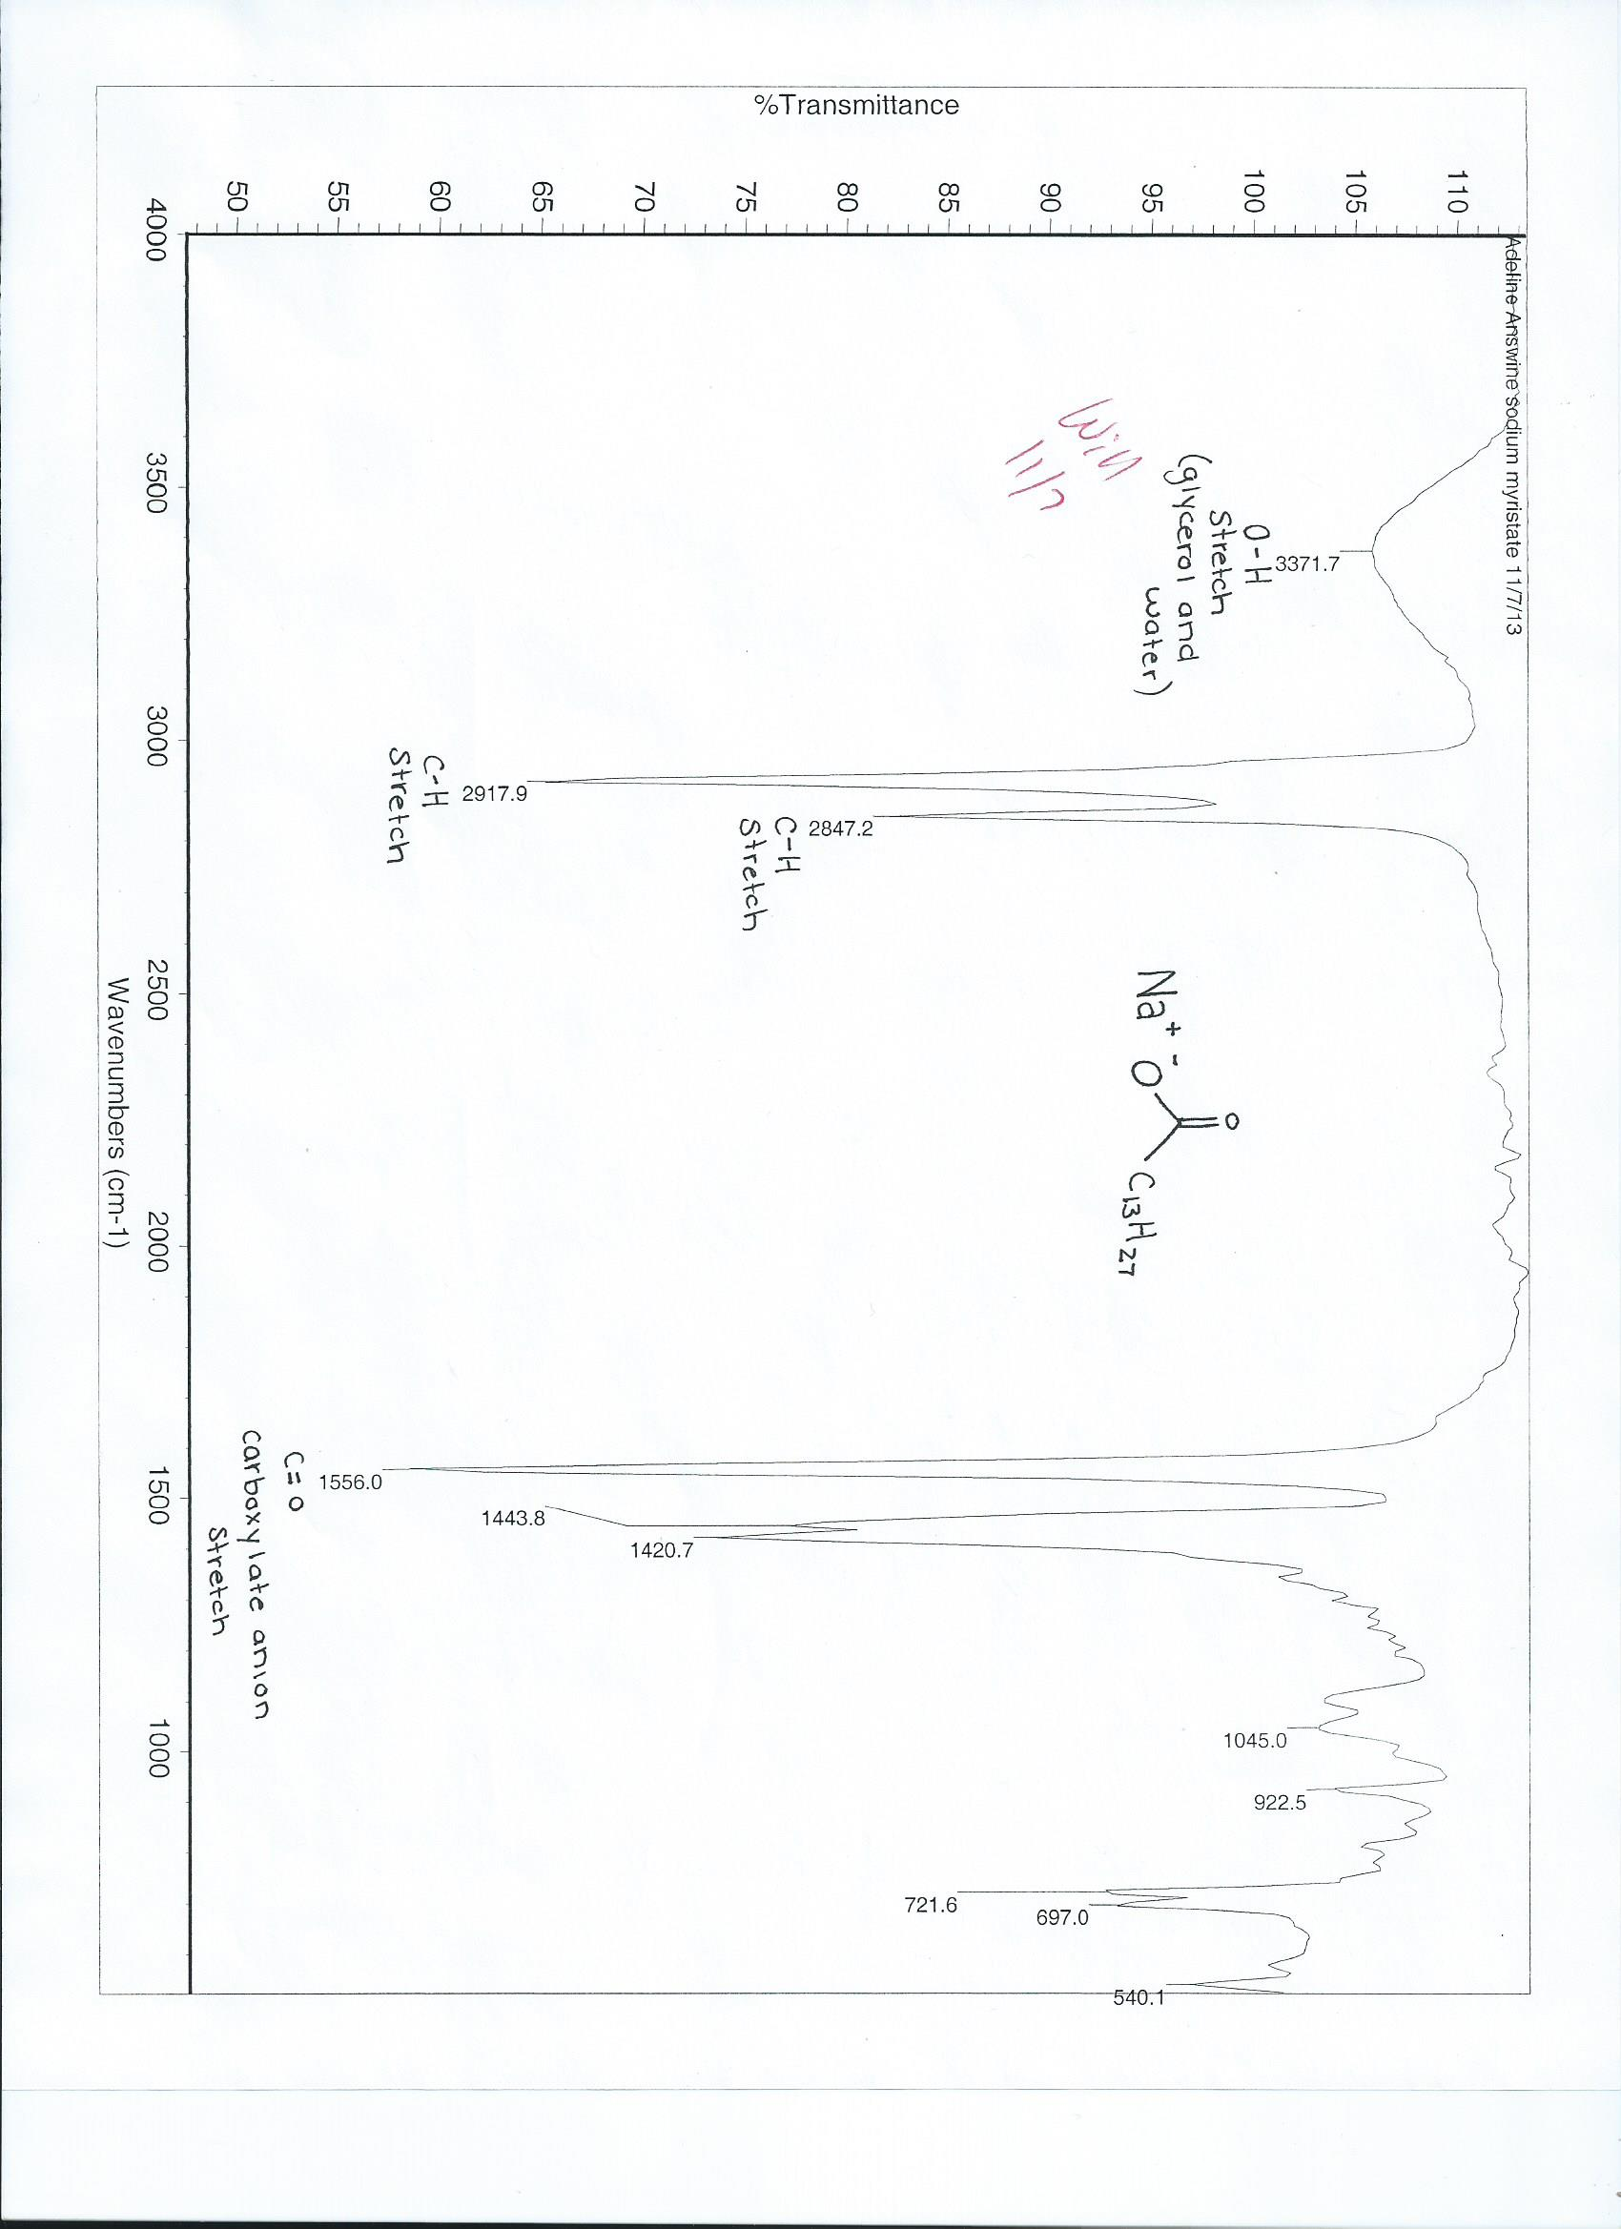
Figure 2. IR of Sodium Myristate

