Broock Weiss
Chem 213W-003
TA: Jared Kelly
4/26/18
Synthesis of 3-Carbethoxycoumarin via Pechmann Condensation

In organic chemistry, condensation reactions represent a very important class of chemical synthesis. Condensation reactions involve the combination of two simple molecules to form a more complex compound and water as a by-product⁴. On the biological level, they allow for the anabolic production of complex molecules such as carbohydrates and proteins⁵. Pechmann condensations represent a very important example of condensation reactions⁴. Pechmann condensations involve the reaction between a phenol and a beta-keto-ester to form heterocyclic compounds known as coumarins⁴.
Coumarins are heterocyclic compounds that have a wide variety of uses and they also have applications in the medical field. Coumarins are naturally found in plants, fruits, and vegetables and are often found in industrial food coloring⁵. Coumarins derived from amides illustrated anti-microbial activity, anti-oncogenic, and analgesic properties³. They have pharmaceutical applications in being used anti-coagulants and anti-edema drugs⁵. Other coumarin derivatives that have been studied exemplified inhibitory effects on α-chymotrypsin, monoamine oxidase, and γ-GAPDH³.
The Pechmann condensation of salicylaldehyde and diethyl malonate in piperidine and ethanol is a common method that can successfully synthesize the heterocyclic compound, 3-carbethoxycoumarin (figure 1).
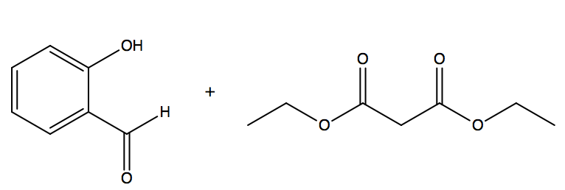
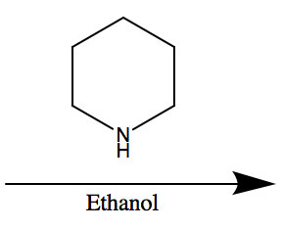
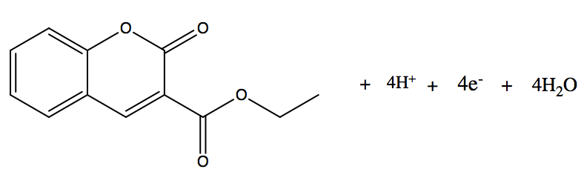
Figure 1: Reaction Scheme for the Synthesis of 3-Carbethoxycoumarin
1
2
3
Figure 1 above shows the reaction scheme for the synthesis of 3-carbethoxycoumarin (3) from starting material, salicylaldehyde (1) and excess diethyl malonate (2), in the presence of ethanol and piperidine.
The mechanism for the synthesis of 3 is initiated whenthe phenol group on 1 is deprotonated by piperidine. This deprotonation creates an enolate that acts as a nucleophile and attacks one of the carbonyls on 2. This nucleophilic attack creates a tetrahedral intermediate and a good leaving group in ethanolate. The electrons on the enolate drop down and kick off ethanolate which deprotonates piperidinium. Piperidine then deprotonates the alpha-carbon of 2 which results in a pi-bond at the alpha-carbon position and an enolate. The enolate electrons drop down to reform the carbonyl, which causes the pi-electrons at the alpha-carbon position to attack the carbonyl of the aldehyde group of 1; this attack forms an enolate and the second ring of 3. The enolate deprotonates piperidinium which allows piperidine to grab the hydrogen between the two carbonyls; this kicks off hydroxide completing the formation of the product 3. The last step is hydroxide deprotonates piperidinium to form the by-product, water⁴. This mechanism is shown in figure 2.
Figure 2: Electron-Pushing Mechanism for the Synthesis of 3-Carbethoxycoumarin

The objective for this experiment was to carry out a TLC-monitored Pechmann condensation reaction of salicylaldehyde and excess diethyl malonate in the presence of piperidine and ethanol to synthesize the final product, 3-carbethoxycoumarin. The product was isolated and purified via refluxing, vacuum filtration, and recrystallization then it was subjected to melting point analysis, IR, ¹H-NMR (60 and 400 MHz), and ¹³C-NMR (400 MHz). Recrystallization can be used to purify solids with trace amounts of impurities, based on a products’ unique polarity, to yield a high purity product¹.
Results and Discussion:
In this experiment, the product 3 was synthesized via a Pechmann condensation reaction between salicylaldehyde and excess diethyl malonate in piperidine and ethanol. The product was purified by vacuum filtration and recrystallization, then analyzed by melting point, IR, ¹³C-NMR, and H-NMR.
Piperidine was used as the primary solvent in this reaction to synthesize 3. Piperidine is the conjugate base of piperidinium (pka ~11.1) and has an amine functional group. Hydroxide is the conjugate base of water (pka ~15.7) and is much more polar than the amine functional group of piperidine¹. Piperidine is a weak base and does not fully dissociate in solution as hydroxide would¹. In addition, piperidine does not possess the nucleophilicity required to react with starting material 1 and 2 that hydroxide does³. This characteristic of piperidine allows for the formation of the Schiff base intermediate that is common in condensation synthesis of heterocyclic compounds such as 3³. In this reaction, it was important to use piperidine over water/hydroxide because if hydroxide was used there would have been unwanted deprotonation of starting material and the formation of undesired products³. Piperidine was capable of deprotonating 1 so that is could act as a nucleophile on 2 and initiate the desired synthesis of 3.
TLC was used to monitor the reaction until completion, evidenced by the disappearance of starting material (1) and presence of product (3) on the TLC plate. Diethyl malonate (2) was not UV-active therefore would not appear on the TLC plate. Salicylaldehyde (1) and 3-carboxycoumarin (3) were UV-active and would appear on the TLC plate. 1 had an aldehyde group and a phenol group attached to a benzene ring in close proximity. The close proximity of these polar substituents allowed for unique hydrogen bonding between them, which drastically reduced 1’s polarity. 3 had multiple ester groups which made the product much more polar than 1. This also allowed 3 to be easily identified against 1 on the TLC plate because more polar compounds do not migrate as far on the plate as less polar compounds.
Recrystallization was important in this experiment because it allowed for the purification and isolation of a highly pure solid product (3) from trace amounts of 1 and 2¹. Water was used as the solvent for recrystallization because it had a similar polarity to 3, but was unable to dissolve 3 at low temperatures¹. When the crude product was dissolved in water and cooled 1, 2, and other impurities would have remained dissolved in solution while solid 3 precipitated out of solution, which could then be collected via vacuum filtration. Successful recrystallization of 3 was verified by melting point and the presence of 3 in IR, H-NMR, and C-NMR spectra.
From recrystallization, 75% of the crude product was purified and recovered as translucent lite-yellow crystals (1.103g, 48% yield). Direct comparison to literature values revealed that the percent yield fell within the expected range of 45-65%. The percent recovery was a bit low. Since there should have been trace amounts of impurities, the expected percent recovery should be around 85-95%¹. However, not all the purified crystals were able to be removed from the beaker, which could have accounted for this lower percent recovery. Melting point analysis of the purified product 3 (92.3 – 92.8°C) fell exactly within the expected range for pure 3-carbethoxycoumarin (92-94°C)¹⁰. This indicated that recrystallization was successful in purifying the crude product to yield a highly pure product of 3. In addition to the presence of 3 via TLC and melting point determination; spectral analysis by IR, H-NMR and ¹³C-NMR also supported the successful synthesis of highly pure 3.
The IR spectrum provided evidence for the formation of 3 during the Pechmann condensation reaction. The aromatic and aliphatic hydrogen stretches were observed at 2914 -3059 cm⁻¹. The umbrella and scissor bend hydrogen signals were seen at 1448-1480 cm⁻¹ and 1373 cm⁻¹, respectively. The benzene and C-O ester bond stretches appeared at 1554 cm⁻¹ and 1126 cm⁻¹. The last two signals were observed at 1603 cm⁻¹ and 1736 cm⁻¹; they corresponded to the conjugated ketone group and the C=O ester bond on 3. Even though these signals would be expected in the IR for the starting material, the lack of the phenol peak indicated formation of 3 and no remaining 1 in the final product.
The ¹H-NMR (60MHz) also supported the formation of 3 by the signals which represented the ten hydrogens on the molecule. The umbrella bend (3H, t) and scissor bend (2H, q) hydrogens appeared at 1.234-1.559 and 4.243-4.648 ppm, respectively. Some aromatic hydrogens displayed similar shifts and integrated together into a single signal. These aromatic hydrogens (4H, m) were observed in the peak at 7.197-7.668 ppm. The last aromatic hydrogen (1H, s) apart of the ring with the attached oxygen atom was identified because it was the only singlet on the molecule and it was seen at 8.527 ppm. Two impurity peaks were observed at 5.3 and 2.17 ppm and were identified as dichloromethane and acetone.
The 400MHz H-NMR confirmed the signals seen in the 60MHz spectrum and also supported the successful synthesis and purification of 3. The umbrella and scissor bend hydrogens appeared at 1.417 and 4.421 ppm. The four aromatic hydrogens appeared at 7.29 ppm and 7.637 ppm. These four hydrogens were observed as two 2H peaks. The peak further downfield (7.637 ppm) corresponded the two hydrogens closer to the oxygen atoms on 3 because they experienced more de-shielding than the two hydrogens further away from these electron-withdrawing groups. The lone 1H singlet was observed at 8.535 ppm.
The final spectrum, 400MHz ¹³C-NMR, provided further evidence of the presence of highly pure 3 in the final product. Twelve signals were seen on this spectrum which corresponded to the twelve carbons on 3. The carbons with aliphatic hydrogens were seen at 14.299 ppm and 61.827 ppm. The carbon with the scissor bend hydrogens was closer to the electron-withdrawing oxygen atoms which accounted for its downfield shift. The aromatic carbons with a single hydrogen attached were observed at 116, 117, 118, 124, and 129 ppm. The carbons at 124 and 129 ppm experienced de-shielding effects due to their proximity to the oxygen atoms which accounted for their downfield shift. The two carbons that were connected to three other carbons appeared at 134 and 148 ppm. These carbons were fully conjugated which shifted them downfield, but the 148ppm signal was shifted down field even further due to its location between two ester groups, which caused significant de-shielding effects. The three signals seen most down-field were the fully-conjugated carbons connected directly to oxygen atoms. They were observed at 155, 156 and 163 ppm. The two carbons connected in the ester groups by a C=O bond were shifted most downfield (156 and 163 ppm) because they were connected to two oxygen atoms, therefore they experienced significant de-shielding effect. The carbon that connected the two-rings and was also a part of the C-O bond was least down-field (155 ppm) of the three since it was connected to only one oxygen and not two, therefore experienced less de-shielding.
In conclusion, the Pechmann condensation reaction between salicylaldehyde and diethyl malonate was successful in synthesizing the product, 3-carbethoxycoumarin (1.103 g, 48%). Melting point analysis (92.3 -92.8 °C) and spectral characterization by IR, ¹³C-NMR, and ¹H-NMR proved successful recrystallization by the presence and high purity of 3 in the final product. One source of error in this experiment was that some of the recrystallized product could not be removed from the flask, which accounted for the lower percent recovery compared to literature values. One way to improve this experiment would be using column chromatography. By taking advantage of the differences in polarity between 1, 2, and 3 they can be effectively separated with a mobile phase that is gradually increased in polarity. By gradually increasing the polarity, 1 would elute first, followed by 2 and then 3.
Experimental:
3-carbethoxycoumarin. A mixture of salicylaldehyde (1.1mL, 10.3mmol), diethyl malonate (1.7mL, 11.3mmol), glacial acetic acid (4 drops), and piperidine (20 drops) was stirred and refluxed over a tube of drierite for 75 minutes. The reaction was monitored by TLC (40% ethyl acetate in hexanes). Upon completion, the crude product was recrystallized in cold distilled water (8mL). Vacuum filtration afforded lite-yellow translucent crystals (1.103g, 48%), Mp: 92.3-92.8°C as the purified product. ¹H-NMR (60MHz, CDCl₃) δ (ppm): 1.234-1.559 (3H, t), 4.243-4.648 (2H, q), 7.197-7.668 (4H, m), 8.527 (1H, s). ¹H-NMR (400MHz, CDCl₃) δ (ppm): 1.417 (3H, t), 4.421 (2H, q), 7.29-7.347 (2H, m), 7.637 (2H, m), 8.535 (1H, s). ¹³C-NMR (60MHz, CDCl₃) δ (ppm): 14, 61, 116, 117, 118, 124, 129, 134, 148, 155, 156, 163. IR (1) (ATR) υ_{max} (cm⁻¹): 2914-3059, 1763, 1603, 1554, 1480-1448, 1373, 1126.

References:
- Dykstra, S., Beinswenger, K., Bischof, A., Lab Guide for Chemistry 213W, Introduction to Organic Chemistry Laboratory. Hayden-McNeil: 2017-2018.
- Al-awar, R.; Wahl, G.H. Microscale synthesis of heterocyclic compounds. J. Chem. Ed. 1990, 67, 265.
- Soni, J. N.; Soman, S.S. Reactions of coumarin-3-carboxylate, its crystallographic study and antimicrobial activity. Der Pharma Chemica, 2014, 6, 396-403.
- De, S.K.; Gibbs, R.A. An efficient and practical procedure synthesis of 4-substituted coumarins. Synthesis, 2005, 1231-1233.
- Chand, M.; Gupta, A.; Jain, S.C. Biological profile of coumarins (7-hydroxy-4-methyl-2H-benzopyran-2-ones. J. Online. 2017, 7, 1, 215-230.
- Salicylaldehyde. CAS No. 90-02-08; SciFinder, www.scifinder.cas.org (accessed 3/26/18).
- Salicylaldehyde. CSID No. 13863618; Chemspider, www.chemspider.com (accessed 3/26/18).
- Diethyl Malonate. CSID No. 13863636; Chemspider, www.chemspider.com (accessed 3/26/18).
- Piperidine. SDS No. P5881; Sigma Aldrich, www.sigmaaldrich.com (accessed 3/26/18).
- 3-carbethoxycoumarin. CAS No. 1846-76-0; SciFinder, www.scifinder.cas.org (accessed 3/26/18).

