Jack Bandy, Meghan Dellert, and Michael Lanzarone
Comm 100s: Mass Media & Society
The Pennsylvania State University – Professor Nichols
Case Study: “Share Your Ears"
Summer Session - July 19, 2018

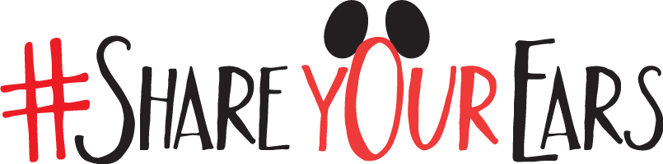

Table of Contents
Introduction…………………..……………..3
Goals and Objectives…………………..……3
Target Audiences…….…...……………..…..4
Research by the Companies………………...5
Planning…………...………………………..5-7
Execution………………………………….7
The Results………………………………….7-8
Evaluation…………………………………..8
Opinion Analysis…………………………..9
Conclusion………………………………....9-10
Works Cited………………………………..11

Introduction
For years, the Walt Disney Corporation and the Make-A-Wish Foundation have been key partners in making “dreams come true” for children across 50 different countries. After working together for 37 years and granting over 120,000 Disney-related wishes, the duo decided to celebrate their successes in a new and massive way. In 2016, the two establishments devised a fun and accessible fundraising campaign that all audiences could participate in. The problem that they wished to address was the funding to “grant the wish of every eligible child” (Make-A-Wish’s Vision Statement). The solution to this problem was found through the famous Share Your Ears campaign.
Goals and Objectives
The primary focus of Share Your Ears was to help grant children’s lifelong wishes, but also to create a positive brand image for the Walt Disney Corporation. The main goal was to fundraise so that Make-A-Wish could grant even more wishes for eligible children with life-threatening diseases. More specifically, Disney’s goal was to raise $1 million through the campaign for Make-A-Wish and, media-wise, the goal was to reach 100,000 hashtags. Another objective, which dealt with the public relations standpoint, was to generate good publicity for Disney, and to promote their beneficial relationship with the Make-A-Wish Foundation. Disney’s reputation has never really been called into question, being that it is the ‘happiest place on Earth’, but it was reassuring to see the corporation going out of their way to reestablish their positive impact in the world. By working with Make-A-Wish to fundraise for children with potentially fatal illnesses, the Walt Disney Corporation has marked its presence as a philanthropic force and further expand its inspiring actions.
Target Audiences
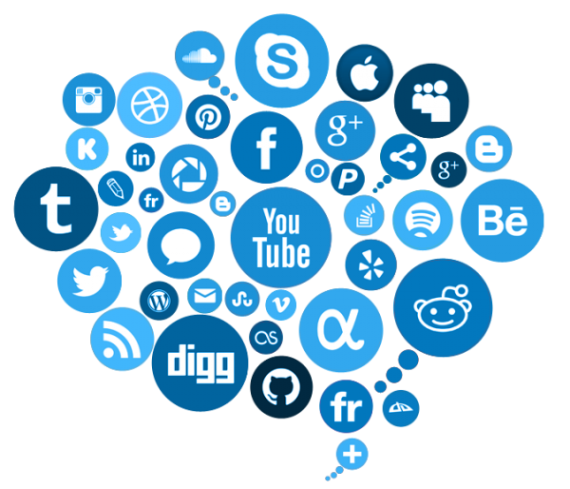
Major companies, such as the Walt Disney Corporation, reach so many diverse audiences and demographics that it is hard for them to focus on a single target audience. So, instead of targeting a specific race or ethnicity, Disney targeted social media users, Disney customers, and families who have been impacted by life-threatening diseases. The two corporations were genius in this approach to fundraising because they recognized that today’s society revolves around social media platforms, and that 81 percent of the American population is an active social media consumer (According to Statista.com). Therefore, this shows how the campaign was also targeted at tech-savvy consumers of sites such as Instagram, Twitter, and Facebook. The campaign was not targeted at a single racial group or specific gender, rather it was an open call for social users to share images with their own Mickey Mouse ears. However, when looking at the demographics of the Instagram entries, it seems that a majority of the posts are by white women between the ages of 18-30. That being said, young children were not a large part of the target audience because they do not usually have access to social networking sites. As a whole though, Disney and Make-A-Wish did not try to build their campaign to satisfy one perfect demographic group, rather they built the campaign in a way that satisfies a multitude of audiences.

Research by the Companies
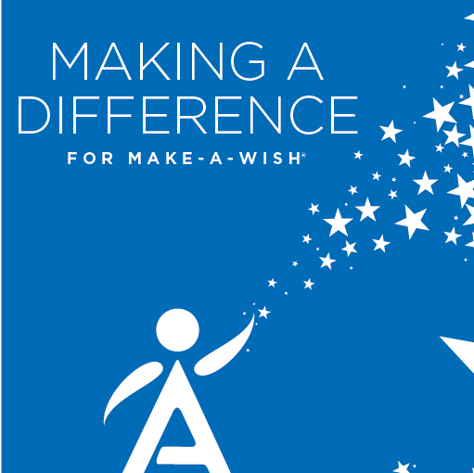
In order to make such a large impact through the campaign, Disney and Make-A-Wish had to do quite a bit of research prior to constructing their plan. As a bit of background, it is important to note that over 8,000 wishes each year are Disney related and that Make-A-Wish has granted over 334,000 wishes since they began—about 100,000 of those wishes were Disney affiliated. Last year alone the Walt Disney Corporation donated over $348 million to nonprofits, so philanthropy is not a new field for the major company. Moreover, by analyzing these statistics, Disney and Make-A-Wish decided to focus on the concept of sharing images of Mickey Mouse ears through social media. According to ‘The Good Celebrity’, each year over 2,500,000 Mickey Mouse ears are sold through Disney, at around $24.99 per pair, thus the idea of sharing ‘ears’ made the perfect campaign option.
Planning
Both the Walt Disney Corporation and Make-A-Wish are monumental industries alone, so when they work together their power is unmatched. This power is why it was a quick task to reach the original goal of raising up to $1,000,000 through the social media sharing. In a way this million-dollar mark was the only budgetary restriction placed on the campaign because Disney was giving $5 for each post. But in the end, Disney was astounded by the public engagement and decided to double the million-dollar donation regardless. Because the partnering corporations sent a heartwarming message that everyone has the power to raise funds for children in need, the public was attracted to the cause immediately.
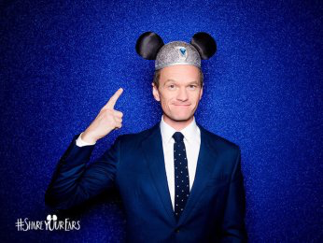
The idea for Share Your Ears to be a predominantly online campaign turned out favorably in the end. Media sites such as Instagram, Twitter, and Facebook collectively totaled 1.77 million photos posted with the hashtag Share Your Ears. Across all forms of media there were approximately 54 million media impressions worldwide. Another heavy source of media used was YouTube; Disney and Make-A-Wish promoted heavily through different Disney themed videos, wish stories, and campaign descriptions. This was extremely effective in gaining mainstream media attention and gaining new audiences because the videos were so interesting and innovative. Furthermore, Disney’s role as a parent company allowed the campaign to be a hot-topic on shows such as The View and have a lot of commercial time on Disney Channel. All of the media used implemented similar persuasive techniques to entice participation in the campaign. For instance, the use of celebrity endorsements played a large role in attracting participants. Stars such as Neil Patrick Harris, Candace Cameron-Bure, and Whoopi Goldberg all endorsed the campaign in their own way, therefore they introduced the program to each of their followings to gain an audience. Further, the largest persuasive technique used was definitely the sentimental appeals. The idea of helping grant the wishes of children with life-threatening illnesses appeals to the heartfelt emotions of love and pity. Whenever Share Your Ears advertised by showing an ill child, the campaign utilized pathos to coax social media consumers into participating in the cause.
Execution
The campaign was executed through social media. Disney and Make a Wish made posts that explained how there donations would work. First, you needed to post a picture with your “ears” and use the #shareyourears. For every post, Disney donated money to Make a Wish. The campaign took place from January 29 to March 14 in 2016. Pictures were shared from around the world and was covered by most major news companies. Even TV shows like The View promoted the #shareyourears campaign. Disney did this because it was the 60th anniversary of their Disneyland Resorts and they were honoring their 100,000 Disney wish.
The Results
The original donation from Disney was $1,000,000, but due to the rapid success of the campaign, they decided to double that amount to $2,000,000. They ended up shattering their social media goals as well. They ended up reaching 200,000 hashtags, double the original goal. This resulted in 54 million media impressions, and 420 million social media impressions. The campaign generated a 15% facebook audience increase, and a 13% Instagram audience increase for the Make-A-Wish Foundation. There was also a 330% increase in reach during the campaign, as well as a 554% increase in engagement during the campaign. Another outcome of the campaign was that Disneyland was able to make nearly $150,000 in revenue from selling the hats featured in each post.

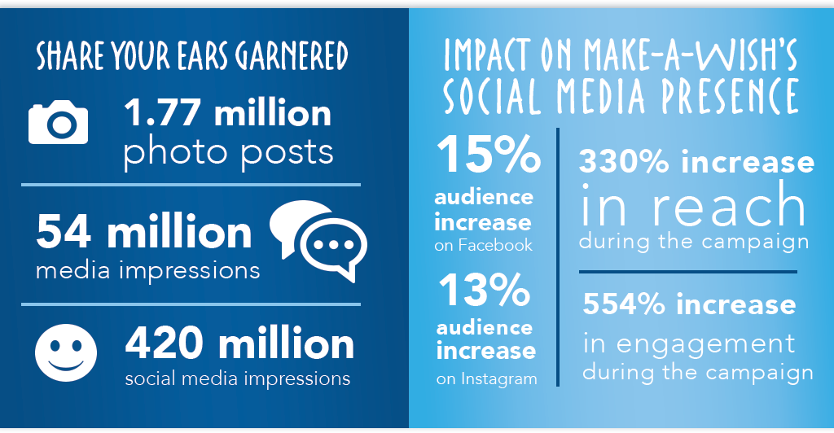

Evaluation
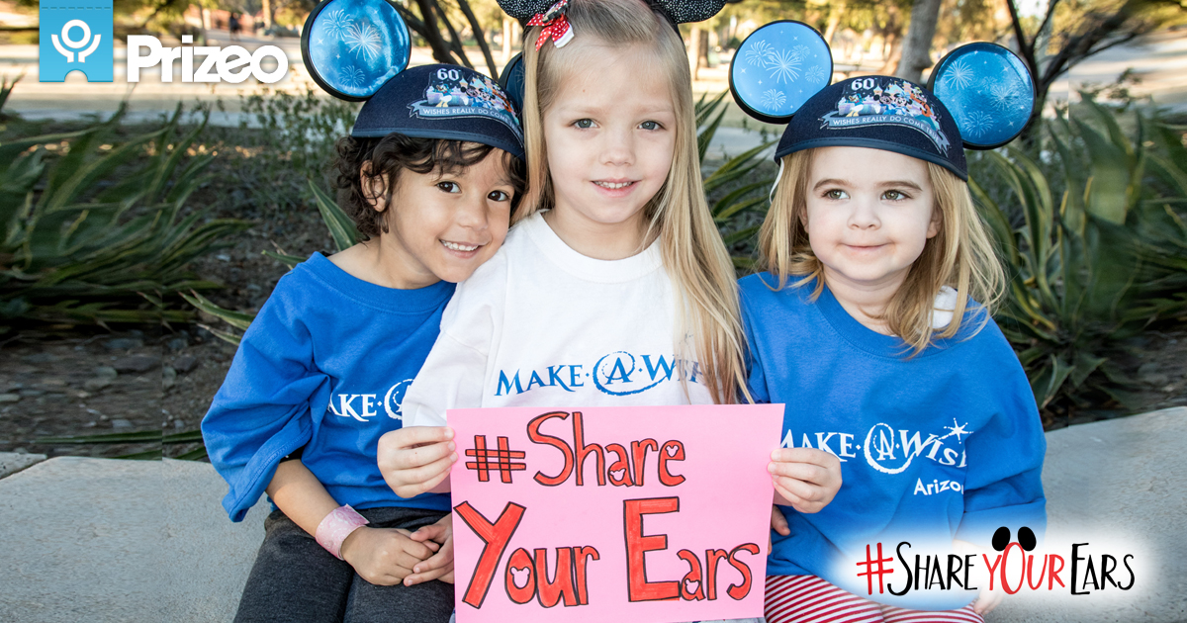
Overall, Disney donated two million dollars to Make-A-Wish. They originally intended on donating a million dollars but since the #ShareYourEars campaign was such a success, Disney decided to donate the extra million. The campaign was clearly a success and gained a huge amount of positive feedback. Through social media, #ShareYourEars was instantly trending on Facebook and over 200,000 people posted pictures on Instagram using the hashtag. The Make-A-Wish Twitter gained 213k followers and their Facebook page gained over 860k likes. Also, their YouTube gained over 65k subscribers and their Instagram over 144k followers. In total, the #ShareYourEars was shared over 1.77 million times. The campaign was reported by every major news channel, talk show, and online site-- generally speaking, the campaign was a global phenomenon.
Opinion Analysis
After an analysis of the Share Your Ears campaign, we can conclude that Disney and Make-A-Wish did an incredible job in creating an interactive and innovative campaign. Share Your Ears was run smoothly and its outcome came with extremely favorable results. Not only did Disney surpass its original goal of raising one million dollars, but this campaign also encouraged audiences around the world to interact with nonprofits such as Make-A-Wish. The public engagement and social media impressions skyrocketed quickly, and Share Your Ears helped raise awareness to a heartwarming cause. All things considered though, Disney did not capitalize their assets because they limited themselves to only Instagram, Twitter, and Facebook. In order to reach a wider audience, Share Your Ears should spread to Snapchat through stories, stickers, and filters, or through its own app or game to draw in more media attention. As a whole, this campaign encouraged us to pay closer attention to the minor details of different public relations tactics, and to recognize the significance of social networking in the media.
Conclusion
Several years ago, Disney took on a great challenge to help improve the lives of children who were in critical conditions. The Walt Disney Corporation wanted to do this with the help of Make-A-Wish and they believed that this partnership would be the way to accomplish their mighty task. The team came up with the #ShareYourEars campaign. The campaign would donate money when someone posted a picture with the #ShareYourEars and Disney would donate up to a million dollars. The trend became so popular that large amounts of celebrities and internet personalities were jumping on the trend. The campaign became so popular that Disney ended up doubling their initial offering by donating two million dollars instead. These funds would towards helping fulfill the dreams of eligible children who needed a spark of magic in their lives. Some of these wishes involved meeting their idols, visiting their dream locations, or having a magical time at Disney. For the past 37 years, Disney and Make-A-Wish have created a booming industry that revolves around making dreams come true. It is evident that #ShareYourEars not only helped Disney and Make-A-Wish, but it also helped the children that were in serious need of some magic in their lives.

Works Cited

Celebrity, Good. “Share Your Ears to Support Disney's $1 Million Make-A-Wish Campaign.” Positive Celebrity News, Good Celebrity Gossip, Positive Entertainment News | Good Celebrity, 6 June 2016, www.goodcelebrity.com/2016/02/26/share-your-ears-to-support-disneys-1-million-make-a-wish-campaign/.
“Disney Doubles Its Donation for #ShareYourEars Campaign Thanks To You!” Make-A-Wish® America, wish.org/content/disney/share-your-ears-2017?%3Fcid=NAWS-DISNEYSYE012018-LOCBANNER.
“Disney's Corporate Social Initiatives Honored with Halo Awards.” The Walt Disney Company, 6 Feb. 2018, www.thewaltdisneycompany.com/disneys-corporate-social-initiatives-honored-halo-awards/.
“Disney's Wish-Granting Program.” About Walt Disney World, aboutwaltdisneyworldresort.com/disneys-wish-granting-program/.
“Make A Wish International.” Wish.org, 2014, worldwish.org/sites/default/files/2014-Make-A-Wish-International-Fast-Facts-and-Backgrounder_July2014_website.pdf.
“Make-A-Wish: Share Your Ears.” Digital Pulp, www.digitalpulp.com/work/make-wish-share-your-ears.
“Philanthropy - Charitable Giving, News, Volunteering.” The Walt Disney Company, www.thewaltdisneycompany.com/philanthropy/.
“Share Your Ears.” Make-A-Wish® America, wish.org/content/disney/share-your-ears?cid=WBST-ShareYourEars-MICROSITE.

