**Claire Samolewicz**

**Synthetic Step 2 Formal Report - The Synthesis of Isoxazole**

**Introduction**

One of the major reaction mechanisms for organic syntheses is carbonyl addition reactions, in which a nucleophile undergoes addition to form a tetrahedral carbonyl compound. Ketone addition reactions are considered important as they enable conversion of carbonyls into a variety of functional groups. In acidic conditions, a lewis acid can react with the oxygen atom of a ketone to form a resonance stabilized cation. Protonation increases electron deficiency of the carbonyl carbon, increasing reactivity toward nucleophiles. Carbonyl carbon atoms are highly electrophilic due to partial positive charge from bond dipoles with a highly electronegative oxygen atom. Carbon can accommodate a new bond through the conversion of the pi bond system to a lone pair on oxygen, also known as a nucleophilic acyl addition. The pi bond of the carbonyl breaks as the nucleophile attacks, changing the hybridization from sp2 to sp3, while maintaining all four carbon bonds in the tetrahedral intermediate to form a new chiral center. If the starting material does not contain any chirality, the nucleophile will approach either side with equal probability to produce a racemic mixture.1 Ketone addition mechanisms can be used to create heterocycles, which are ring structures containing at least one heteroatom. Heterocycles are typically five or six membered rings containing nitrogen, oxygen, or sulfur atoms, common structures including pyridine, pyrrole, furan, and thiophene. Heterocyclic placement of localized and delocalized electron pairs affects acidity, thus changing final product applications.2 Delocalized electrons increase acidity by stabilizing the conjugate base, while localized electrons increase basicity by destabilizing the conjugate base.

Isoxazole derivates are important in the context of green chemistry for their biodegradability. The stable aromatic ring of heterocyclic isoxazole allows for the manipulation of substituents through the cleavage of nitrogen-oxygen bonds in acidic or reducing conditions. Thus, isoxazole proves to be a useful intermediate for detoxification of complex derivatives. This feature is particularly beneficial for the use of isoxazole derivates as an insecticide for managing the pulse beetle *Callosobruchus chinensis*. A wide range of biological features have been demonstrated in isoxazoles, including antiviral, anti-inflammatory, fungicidal, and herbicidal properties. Isoxazoles provide a safer alternative to harmful chemical protectants that are detrimental to health and the environment.3 Isoxazoles also demonstrate use as corrosion inhibitors on galvanized steel and copper nickel substrates. Corrosion inhibitors are mostly used to prevent damage and maintain functionality of water-cooling system equipment in various forms of infrastructure. The presence of electronegative heteroatoms nitrogen and oxygen, containing free pair electrons on an aromatic ring, play an important role in the ability to prevent corrosion.4 Metallic substances easily corrode over time from hard water highly concentrated with magnesium and calcium ions. Isoxazole derivates can assist in the long-lasting sustainability of these construction materials.

The synthesis of 5-(3-chlorophenyl)-3-(4-methoxyphenyl)-isoxazole (Scheme 1) occurs through eight elementary steps. First, the carbonyl of 2,3-dibromo-3-(3-chlorophenyl)-1-(4-methoxyphenyl) propan-1-one (**1**) is protonated by hydrochloric acid from hydroxylammonium chloride to form an carbonyl electrophile. The next step is nucleophilic addition of the nitrogen in hydroxylamine to the electrophilic carbonyl carbon previously formed. The alcohol in the tetrahedral intermediate then undergoes a proton transfer with the solvent to make a good leaving group of water. Electrophillic elimination occurs to form a carbon-nitrogen double bond, thus causing a loss of water as a leaving group. The oxime undergoes a proton transfer to reform the acid catalyst before proceeding. Sodium hydroxide is then added to function as a base to complete isoxazole formation, beginning with a proton transfer between oxime and hydroxide. The anionic oxygen formed undergoes a substitution reaction with the beta bromine to create a ring. Finally, elimination occurs when the benzylic proton is deprotonated to form a double bond, subsequently removing bromine as a leaving group, generating the product containing the isoxazole ring (**2**).5 Although carbonyl addition and heterocyclic ring formation of brominated chalcone is carried out via hydroxylammonium chloride, ethanol, water, and potassium hydroxide, the predicted yield is only 40%.5 Research suggests higher yields of up to 99% can be obtained through the treatment of terminal alkynes with n-BuLi and aldehydes, followed by oxidation with molecular iodine potassium carbonate.6 Another study suggests the condensation of phenyl-dione derivatives and hydroxylamine hydrochloride can be catalyzed by heteropolyanions (HPAs), including Keggin, Dawson, Preyssler, mixed addenda, and sandwich types. An ideal catalyst is H3PW11CuO40, which can synthesize isoxazole derivatives in high yields up to 99% with good selectivity.7 These methods may result in higher efficiency and effectiveness than the suggested experimental procedure.

**Results, Discussion, and Conclusions**

To begin synthesis of isoxazole, 0.5 g brominated chalcone in 25 mL ethanol was added to 0.16 g hydroxylammonium chloride and 1.2 mL water. A color change was observed during reflux, which turned the reaction mixture white to clear. After reflux, 4.0 mL 2M potassium hydroxide was added to the reaction and progress was monitored via TLC every 20-30 minutes until completion. Brominated chalcone is very nonpolar, containing polarity factors such as electronegative atoms and bond dipoles in ether, ketone, chloride, and bromide, as well as polarizability in all functional groups, including aromatic ring structures, two enlarged bromine atoms, and one chlorine atom. Isoxazole is more polar due to electronegative atoms and bond dipoles present in ether, chloride, and the ring structure, as well as polarizability in all functional groups, including aromatic ring structures and one enlarged chlorine atom. Since nonpolar compounds have higher Rf values than polar compounds, the brominated chalcone starting material had a higher Rf value than the isoxazole product, thus the top reactant spot was expected to disappear in the reaction mixture lane upon product formation. Over 35 minutes, the top reactant spot gradually decreased in intensity, while the bottom product spot increased in intensity. After 35 minutes, the starting material had fully disappeared, and the product was at full intensity, demonstrating full reaction completion.

After reaction completion, a workup commenced. Under acidic conditions, a quench was not required because the products were already protonated during the reaction. Instead, the reaction was partitioned with 20 mL dichloromethane (DCM) and 20 mL water into two layers. Since DCM is denser than water, acting as a solvent for organic compounds, the organic layer appeared on the bottom as a clear color, and the aqueous layer displayed on top as yellow and translucent. Next, the organic layer was extracted from the aqueous layer twice using 15 mL DCM. DCM removes charged particles such as hydroxylammonium chloride, potassium hydroxide, and water into the aqueous layer, which is observed experimentally when the organic layer turned yellow, and the aqueous layer turned light yellow. Uncharged particles remain in the organic layer, including ethanol, DCM, and isoxazole. Water and sodium chloride (15 mL) were used next to wash the organic layer. Water removes charged ions such as potassium cations, alcohol anions, chloride anions from the organic layer by creating a concentration gradient, leaving behind DCM, and isoxazole. Sodium chloride was used to wash a second time to begin the drying process and remove excess water from the organic layer via complexation. Washing is observed experimentally when the organic layer turned light yellow, and the aqueous layer became clear and transparent. Finally, the organic layer was dried over sodium sulfate. Sodium sulfate creates a complex with water, removing excess water from the organic product, observed by dampening of sodium sulfate.

Following the workup, column chromatography was performed. An ideal mobile phase for column chromatography is less polar than the stationary silica phase. Therefore, a mixture of 5% ethyl acetate/95% hexane was used. Hexane is very non-polar from polarizable benzene, and ethyl acetate is slightly polar due to dipole bonds present from electronegative ester. The polarity of the mobile phase was increased 5% every five fractions until a mixture of 25% ethyl acetate was attained. Column chromatography was ineffective at separating all compounds present in the reaction mixture. In column chromatography, less polar compounds elute first, having a high Rf value, and more polar compounds elute last, having a low Rf value. Isoxazole product was predicted to elute last due to possessing high polarity, expected to display a low Rf value. TLC monitoring was ineffective at determining elution order, as every top spot was in line with the standard, composed of crude product dissolved in DCM. Fractions 9-15 displayed significant overlapping of compounds. Additionally, fractions 2, 19-20, and 21 showed up as blanks. Therefore, fractions 1-13, 14-21, and 22-25 were separated into different flasks to split up the overlapping fractions as evenly as possible. Effective separation is indicated by no overlap of compounds in any fraction and blank containing only solvent between elution. Experimental observations demonstrate ineffective separation, as multiple fractions containing overlapping compounds on TLC. Ultimately, this attempt was unsuccessful, as the first and second containers were the only flasks to evaporate the product. The reaction and purification of isoxazole was poor according to a yield and recovery of 1%. Literature data identifies good yield for this synthesis as being above 40%.5 Low yield and recovery could be improved by increasing the solvent polarity. Using a higher ratio of ethyl acetate compared to hexane may separate isoxazole product from crude more effectively, thus producing more purified product. Product purity can be assessed by properties such as appearance and melting point. Impurities affect melting points and physical appearance by changing the physical and chemical properties of a substance. The presence of impurities lowers a compound’s melting point by a few degrees and broadens the melting point range. The observed melting point for isoxazole was 119.1-130.0°C, lower than the expected literature melting point of 128-130°C.5 Additionally, literature suggests isoxazole should have a white crystalline solid appearance, however the observed appearance was yellow and oily.5 Therefore, since melting point data and physical appearance did not match literature values, crude product is likely present in the purified isoxazole product.

Isoxazole HNMR (Figure 3) indicates successful synthesis and purification of product via column chromatography. Aromatic protons A, B, C, D, E, and F were predicted from 6.5-8.0 ppm. Proton A was predicted as a singlet integrating to 1, shown as expected at 7.820 ppm, downfield and deshielded from electron withdrawing isoxazole and chlorine inductivity. Protons B and D were predicted as doublets integrating to 1, unexpectedly integrating to 2. B was a doublet at 7.804, downfield and deshielded due to strong electron withdrawing effects of isoxazole. D was a doublet at 7.428 ppm, upfield and shielded from weak electron withdrawing effects of chlorine. Protons C and F were predicted as doublets integrating to 2. C, unexpectedly, was a multiplet integrating to 1 from 7.716-7.737 ppm, downfield and deshielded from electron withdrawing isoxazole. F was shown as expected at 7.007 ppm, upfield and shielded from electron donating ether. Proton E was predicted as a triplet integrating to 1, overlapping instead with proton D as a doublet integrating to 2 at 7.428 ppm, upfield and meta to electron withdrawing isoxazole and chlorine. Proton G was predicted from 4.5-6.5 ppm as a singlet integrating to 1, shown downfield instead at 7.007 ppm, deshielded from alkene resonance. Proton H was predicted from 3.2-3.8 ppm as a singlet integrating to 3, shown as expected at 3.875 ppm, upfield and shielded by electronegative oxygen. Slight impurities were observed from tube cleaning, such as CdCl3 at 7.261 ppm, and water at 1.549 ppm. No starting materials were present in HNMR data, proving conversion to product by accuracy to literature values.8 If brominated chalcone starting material was present, key bromide alkyl halide peaks would appear from 2.1-2.4 ppm and 2.0-4.1 ppm. Key isoxazole product alkene peaks are present from 4.5-6.5 ppm.

Isoxazole CNMR (Figure 4) indicates successful synthesis and purification of desired product. Key peaks expected in isoxazole CNMR include C=N from 150-170 ppm, C=C-H from 120-100 ppm, and C=C aromatic from 110-150 ppm. Signal 1 represents C=C aromatic, unexpectedly more downfield at 168.624 ppm, deshielded from electronegative oxygen. Signal 2 represents C=N, shown as expected at 162.633 ppm, deshielded from electronegative nitrogen. Signal 13 represents C=C-H, shown as expected at 98.078, upfield and shielded from alkene resonance. Fourteen total peaks were observed for isoxazole CNMR data as expected, with ten aromatic peaks (signals 3-12) appearing from 161.136-114.413 ppm. Additionally, ether signal 14 appeared at 55.410 ppm. If starting material was present, fourteen peaks would still be shown, containing two C-Br signals appearing from 25-65 ppm, and a C=O signal from 185-220 ppm. Slight impurities were observed from NMR tube cleaning, such as CdCl3 from 77.339-76.704 ppm. Lack of starting material peaks proves product conversion by accuracy to literature values.5

Isoxazole IR (Figure 5) indicates successful synthesis and purification of product via column chromatography. The aromatic ring had 3 predicted signals, C-H from 3150-3050 cm-1, C-H aliphatic from 3000-2850 cm-1, and C=C at 1600, 1580, 1500, and 1450 cm-1, all shown as expected. C-H aromatic appeared at 3071.36 cm-1, and C-H aliphatic had 3 peaks at 2967.17, 2938.69, and 2841.21 cm-1. C=C aromatic displayed 4 peaks at 1569.94, 1508.56, 1471.09, and 1420.53 cm-1. The isoxazole ring had 4 predicted signals, C-H alkene from 3100-3000 cm-1, C=N imine from 1690-1650 cm-1, C=C trisub. alkene (conj.) from 1640-1600 cm-1, and C-O ring from 1300-1000 cm-1, all shown as expected. C-H alkene appeared at 3071.36 cm-1, C=N at 1672.83 cm-1, C=C trisub. alkene (conj.) at 1598.33 cm-1, and C-O ring at 1299.13 and 1253.55 cm-1. Ether had 2 predicted signals, CH3 umbrella bend at 1450 and 1375 cm-1, and C-O ether (conj.) from 1300-1000 cm-1, all shown as expected. The CH3 umbrella bend appeared at 1368.71 cm-1, and C-O ether at 1219.32, 1180.03, and 1131.85 cm-1. C-Cl (aryl) was predicted from 1100-1035 cm-1, shown as expected at 1082.60 and 1027.94 cm-1. Slight impurities were present in IR, such as OH alcohol from water at 2646.33 and 2580.94 cm-1. All IR signals match literature data, proving product conversion.9 If starting material were present, C-Br aliphatic would appear from 650-510 cm-1. Key signals proving isoxazole product conversion are C-H alkene from 3100-3000 cm-1, C=N imine from 1690-1650 cm-1, C=C trisub. alkene (conj.) from 1640-1600 cm-1, and C-O ring from 1300-1000 cm-1.

In conclusion, the synthesis purification of 5-(3-chlorophenyl)-3-(4-methoxyphenyl)-isoxazole by column chromatography was successful. Initial TLC monitoring plates displayed full reaction completion, however TLC plates monitoring fraction elution lacked proper separation of crude and purified product. Additionally, observed melting point values 119.1-130.0°C did not match literature values of 128-130°C. Predicted literature physical appearance of white crystalline solid did not the observed appearance of yellow oily product. Even though experimental observations indicate impure product, Isoxazole HNMR, CNMR, and IR contained no starting material impurities, proving product formation. Overall, column chromatography was an effective purification method for the synthesis of isoxazole. Low yield and recovery of 1% may have been due to using a solvent that is too nonpolar during column chromatography, which would have caused less effective separation, thus less purified product. Product separation could be improved by increasing the polarity of the solvent to a higher percentage of ethyl acetate than hexane. Another way to improve purification of product is to increase the number of fractions to produce higher accuracy TLC plates, thus increasing purity of product.

**References**

1. Brown, W. H.; Iverson, B. L.; Anslyn, E. V.; Foote, C. S. Chapter 16- Aldehydes and Ketones. *Organic Chemistry*, **2018**, *8*, 241-283.
2. Katritzky, A. R.; Ramsden, C. A.; Joule, J. A.; Zhdankin, V. V. Chapter 2- The Structure of Heterocycles. *The Handbook of Heterocyclic Chemistry*, **2010**, *3*, 29-236.
3. Upadhyay, A.; Gopal, M.; Srivastava, C.; Pandey, N. D. Isoxazole derivatives as a potential insecticide for managing Callosobruchus chinensis*. J. Pestic. Sci*., **2010**, *35*, 464-469.
4. Domínguez-Crespo, M. A.; Zepeda-Vallejo, L. G.; Torres-Huerta, A. M.; Brachetti-Sibaja, S. B.; Palma-Ramirez, D.; Rodriguez-Salazar, A. E.; Ontiveros-de la Torre, D. E. New Triazole and Isoxazole Compounds as Corrosion Inhibitors for Cu-Ni (90/10) Alloy and Galvanized Steel Substrates. *Metall Mater Trans A*, **2020**, *51*, 1822–1845.
5. Dykstra, S.; Williams. R.; Mahon, C. Synthetic Project 2, Step 2: Synthesis of an Isoxazole from a Brominated Chalcone. *Penn State Chemistry Department*, **2023**, *1*, 1-3.
6. Harigae, R.; Moriyama, K.; Togo, H. Preparation of 3,5-Disubstituted Pyrazoles and Isoxazoles from Terminal Alkynes, Aldehydes, Hydrazines, and Hydroxylamine. *J. Org. Chem*., **2014**, *79*, 2049−2058.
7. Heravi, M. M.; Derikvand, F.; Haeri, A.; Oskooie, H. A.; Bamoharram, F. F. Heteropolyacids as Green and Reusable Catalysts for the Synthesis of Isoxazole Derivatives. *Synthetic Communications*, **2008**, *38*, 135–140.
8. Stephens, C. E.; Arafa, R. K. 3,5-Diarylisoxazoles: Individualized Three-Step Synthesis and Isomer Determination Using 13C NMR or Mass Spectroscopy. *Journal of Chemical Education*, **2006**, *83*, 1336-1330.
9. Chanda, K.; Rej, S.; Huang, M. H. Investigation of facet effects on the catalytic activity of Cu2O nanocrystals for efficient regioselective synthesis of 3,5-disubstituted isoxazoles. *Nanoscale*, **2013**, *5*, 12494-12501.

**Spectral Data**

Figure 2: Proton NMR (60 MHz), annotated

Figure 3: Proton NMR (400 MHz), annotated

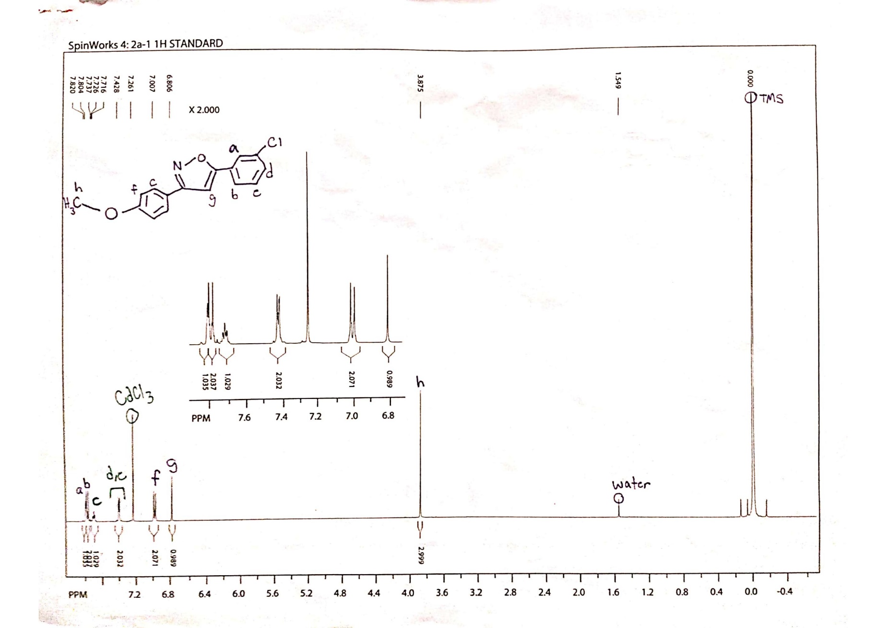

Figure 4: Carbon-13 NMR (100 MHz), annotated

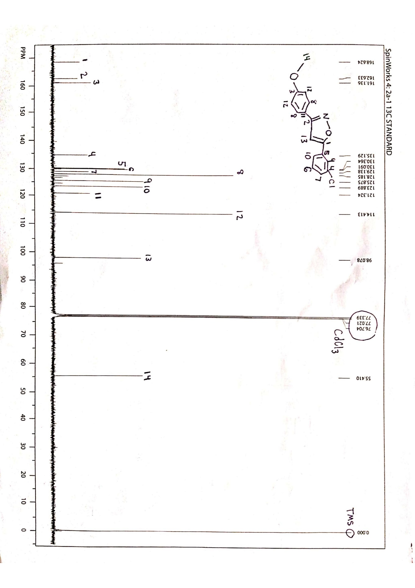

Figure 5: IR, annotated

