Coder: Elizabeth Masgarha

Territorial Contender Codesheet
TC Vital Statistics:
Territorial Contender (name(s) of TC): South Ossetia, a.k.a. South Ossetian Supreme Soviet
Year of birth:
September 20, 1990 (Sammut and Cvetkovski, 1996).
How born: Declaration of Independence
The South Ossetian Autonomous Oblast declared independence from Georgia with the intention of entering the Soviet Union as an independent unit (Sammut and Cvetkovski, 1996).
Year of death: N/A
How died: Still in existence
Connection to Other TCs (e.g. splinter group):
Hosts (“official state” to which TC’s assets incorrectly/eventually assigned):
The Republic of Georgia
TC “country” code (filled in by Lemke):

TC Physical/Political Characteristics:
Geographic Area of TC (estimates, with years):
South Ossetia lies beneath North Ossetia separated by the Greater Caucasus Mountain Range. The remainder of the state’s borders are completely surrounded by Georgia, occupying approximately 3,900 km (Georgia-South Ossetia, 2009).
See maps at end of codesheets
Characteristics of Area (mountains, jungles, etc):
The state has very little flatland and the region is comprised of mountain spurs, which increase into the steep slopes of the Caucasus Mountain Range. The majority of the region is forested and only 1/10th of the land is suitable for agriculture, harvesting grain and fruit for export. Several rivers cut through South Ossetia and more recently, developments in technology have been invested to harness energy from hydroelectric power (South Ossetia, 2013).
Population of TC (estimates, with years): I use the following numbers, interpolating between them to fill in missing years. A declining population through the 1990s makes sense, given the history as many Georgians leave South Ossetia and many Ossetians use their Russian passports to emigrate to Russia or elsewhere.
1989 - 98,500
• 66.61% - South Ossetians
• 29.44% - Georgians
• 4% - Russians, Armenians and Jews (Sammut and Cvetkovski, 1996)
2001 - est. 70,000 - 80,000 (King, 2001)
2007 - est. 55,000 - 57,000 (Crisis Group Europe Report, 2007)
2010 - est. 51,000 (Toal, 2009)
Regime Type Characteristics of TC: Authoritarian with elections?
Freedom House rates South Ossetia as “Not Free” (7 and 6) for 2009 and 2010, with no reports earlier. King (2001) does not describe South Ossetia as democratic. Kleptocratic is closer to his sense.
The Executive: The President
The president is directly elected by universal suffrage, serving no more than two consecutive 5-year terms (Crisis Group Europe Report, 2007).
The Legislature:
Consists of a 33-seat parliament and members serve 5-year terms. Seats are allocated through proportional representation but a party must exceed a threshold of 7% before being allowed to enter government (South Ossetia, 2012).
Characteristics of TC’s military:
The International Institute for Strategic Studies’ Military Balance (various years) lists South Ossetia as possessing 2000 troops 1996 thru 2004 (presumably it was similarly sized on either end of that string of data).
December 2009
• South Ossetian participates in a joint military effort with Russia, maintaining between 20,000 - 30,000 ground troops inside South Ossetia. Of that figure, between 2,000-3,000 of those soldiers are South Ossetian (Bukkvoll, 2009).
2000-2001
• Supports 2,000 military personnel (King, 2001).
Achieved Sovereign Recognition (list by whom: other TCs, IOs, etc.):
Recognition as a De-Facto State:
• Russia - August 26, 2008 (UNPO.org, 2009)
Wikipedia claims South Ossetia is recognized by Russian, Nicaragua, Venezuela, Nauru, Tuvalu, and the other Caucasian Territorial Contenders: Abkhazia, Nagorno-Karabakh, and Transnistria (King 2001 validates the recognition by the three other Territorial Contenders).
Miscellaneous Information about TC:
The native language is Ossetian, using a Cyrillic alphabet completely unrelated to the Georgian alphabet. Ossetians have Indo-European and Iranian origins, sharing an identical ethnic identity with North Ossetians located within the Russian Federation. A very small number of Georgians live in the territory, but both groups have a: “high level of interaction...this can be seen in the high rate of intermarriages,” (Sammut and Cvetkovski, 1996 pp. 5).

TC “International” Relations:
Wars/Conflicts (names, dates, opponents) TC Fought:
COW does not have any listing for conflicts involving this Territorial Contender. UCDP lists 134 fatalities in 1992, 27 in 2004, and 621 in 2008, all between South Ossetia and Georgia. So in the dataset I list three one year wars corresponding to these three dates. For outcome it seems each of these conflicts just falls below fatality thresholds, thus no one enjoys victories or suffers defeats.
Alliances (names, dates, partners) TC Forged:
Military Alliance between South Ossetia and Russia (I assume this is for the entire period of independence since no modifier is given)
• Russia signs a 49-year renewable agreement with South Ossetia, establishing a military base is Tskhinvali with a plan to open 20 more posts military posts in the following years on September 9, 2010 (Toal, 2009).
Treaties (names, dates, partners) TC Signed:
The Yeltsin-Shevardnadze Agreement: Principles of Regulating the Georgian-Ossetian Conflict
• Signed on July 14, 1992 in Sochi, Russia by Georgia, Russia, North and South Ossetia, explaining the rules of a ceasefire between all combatants within the conflict zone and deployment of peacekeeping forces (Parastaev, 2010).
Arms Transfers (partners, dates) TC experienced:
Summer of 1989 - Winter of 1992
The two primary sources of weapons came from Chechnya and South Ossetian forces utilized illegal channels to purchase arms directly from Russian troops in North Ossetia as well (Parastaev, 2010).
July 7, 2004
Georgian troops seize 9 trucks disguised with Russian peacekeepers filled with arms and ammunition sent from Moscow to South Ossetia (Georgia-South Ossetia, 2009).
Consistent Trade Partners (dates, commodities):
“South Ossetia remains economically tied to Russia rather than to their recognized central government, because local goods and services are purchased using rubles rather than national currencies,” (King, 2001 pp. 541).
South Ossetia reportedly draws in 1 million dollars per year through the highway trafficking of goods. However the OSCE believes that figure is around 60-70 million dollar per year. All goods moving to and from the North Ossetian capital of Vladikavkaz must pass through a customs checkpoint in Tskhinvali, where revenue is received as South Ossetian police monitor a number of transit goods (King, 2001).

Descriptive Narrative of TC:
The Dispute:
The conflict that exists between South Ossetia and Georgia is primarily an argument over historical homelands. The Ossetian people claim to have a long concentrated history living in South Ossetia: “they and the Georgians have lived side by side for more than two thousand years,” (Sammut and Cvetkovski, 1996 pp. 7).
Georgians believe the South Ossetians have inhabited their land for the last two or three centuries; however, this argument fails to legitimize their right to the territory as the boundaries outlining the Georgian state were in existence centuries before that (Sammut and Cvetkovski, 1996). Unlike Abkhazia, South Ossetia does not have a credible established history of statehood and its first international recognition by Russia on May 7, 1920 describes South Ossetia to be a region inside the country of Georgia (Sammut and Cvetkovski, 1996).
August 1989
Georgia’s desire eventually to separate from Soviet communist rule inspired a nationalist movement that came “at the expense of the minority groups of Georgia,” (Sammut and Cvetkovski, 1996 pp. 10).
Georgian was already the official language of the Republic, but minority languages held equal status in minority regions. A series of reforms were passed recognizing the superiority of the Georgian language and culture; such that the government mandated Georgian be the only language used in schools and in businesses (Sammut and Cvetkovski, 1996).
August 1990 - December 1990
The Supreme Council of Georgia passed an election law stating all political parties that function in only specific regions in Georgia were no longer allowed to participate in parliamentary elections (Sammut and Cvetkovski, 1996).
On September 20, 1990 the South Ossetian leadership declared independence as the South Ossetian Democratic Soviet Republic and held their own elections to parliament in December. Georgia immediately rejected the election results and adopted a resolution terminating the status of the South Ossetian Autonomous Oblast as a separate administrative unit on December 11, 1990. Soviet and Georgian troops entered South Ossetia the very next day and began dismantling the militia (Sammut and Cvetkovski, 1996).
January 5, 1991 - July 4, 1992
Violence ensued after several thousand Georgian troops were sent into Tskhinvali, capturing the city and the surrounding regions. The Georgian military withdrew from inside Tskhinvali in February of 1991 but maintained a blockade that disconnected the city from food and electricity, while violence continued in other South Ossetian villages.
•Chairman of Supreme Soviet of South Ossetia was invited for peace talks but was then arrested and put in jail in Tbilisi (Sammut and Cvetkovski, 1996).
In May of 1991 the Soviet of South Ossetia voted to abolish its regime and the leadership self-proclaimed the new government to be the South Ossetia Democratic Soviet Republic. This act was also rejected by the Supreme Soviet of Georgia (Sammut and Cvetkovski, 1996).
The war ended with Russia, Georgia and North and South Ossetia signing a ceasefire agreement. The Joint Control Commission deployed a peacekeeping force in South Ossetia by the end of May (Sammut and Cvetkovski, 1996).
January 1994 - January 2004
South Ossetia and Georgia witnessed 12 years of peace with zero military interactions (Crisis Group Europe Report, 2007).
January 2004 - August 2004
Newly elected Georgian president Mikheil Saakashvili entered office in January with a commitment to settle the conflict with South Ossetia. On May 26th the Georgian President offered a resolution proposing an autonomous South Ossetia within a sovereign Georgia. Days later, South Ossetia reiterated that it was already a sovereign state as foreign prime minister Murad Djioev indicated a unified state would never be a possible outcome. Following South Ossetia’s response, 300 interior ministry troops were deployed into the Georgian populated town of Tkviavi on May 31st (Georgia-South Ossetia, 2009).
•An additional 600 troops were sent into South Ossetia’s Java district on July 16th (Georgia-South Ossetia, 2009).
Multiple incidences of violence, including several bombings, took place between Georgian and South Ossetian forces from July 13th - August 31st in South Ossetia. Peacekeepers in the region reported substantial amounts of artillery were used on both sides, yet neither Georgia nor South Ossetia admitted to have been the cause initiating any of the violence (Georgia-South Ossetia, 2009). Georgian President Mikhail Saakashvili publicly announced war with Russia to be a very serious possibility and asked Georgian citizens to prepare for possible attack (Georgia-South Ossetia, 2009).
January 6, 2005
South Ossetian President Eduard Kokoity rejected a peace initiative from Georgian President Saakashvili, stating reunification with North Ossetia is their primary focus (Georgia-South Ossetia, 2009). However, negotiations between South Ossetia and Georgia continued to take place, but no progress was made despite multiple resolution proposals (Georgia-South Ossetia, 2009).
November 12, 2006
Two separate presidential elections take place, one in Tskhinvali and one in the Georgian village of Eredvi, confirming two different candidates to have won the de facto presidential elections in South Ossetia (Crisis Group Europe Report, 2007).
•Eduard Kokoity won 98.1 percent of the vote out of 55,163 registered voters
The alternative poll organized by the "Salvation Union of Ossetia" in Eredvi, reported 96 percent of 57,000 voters participated in the elections and Dmitri Sanakoev received 94 percent of those votes (Crisis Group Europe Report, 2007).
•The Salvation Union of Ossetia refused to have the Georgian NGO, Multinational Georgia, monitor the elections and referendum results (Crisis Group Europe Report, 2007).

Dmitri Sanakoev was previously an official in the Kokoity administration but left before the 2006 elections to run his own presidential campaign. Sanakoev's base of support is located five miles away from the capital of Tskhinvali in Kurta. His administrative unit holds a staff of 113 people, which make up 12 different ministries. By April 11, 2007 a military camp with a special forces unit of 150 troops had also been established in Kurta. Sanakoev claims to control the Georgian villages in South Ossetia, governing between 20,000 - 25,000 people (Crisis Group Europe Report, 2007).

MAJOR PROBLEMS WITH THIS GUY
Aside from the narrative describing Sanakoev's rise to power, there are a number of other issues infecting the legitimacy of the governing authority he claims to have. Sanakoev states that he has the support of Georgians living in South Ossetia but he fails to hold political significance: "since the international community and especially Russia see Kokoity as a player," (Crisis Group Europe Report, 2007 p. 5).
Outside observers view Sanakoev to be a puppet working for the Georgian government in an attempt to de-legitimize Kokoity and push a pro-Georgian agenda. Sanakoev even "admits Georgian help was key, and he openly co-operates with Tbilisi," (Crisis Group Europe Report, 2007 p. 5) in order to encourage Georgians in South Ossetia to work with his administration and establish his credibility (Crisis Group Europe Report, 2007).
November 12, 2007
South Ossetia holds a referendum vote and claims 90% of citizens are in favor of "self-rule" and confirm Eduard Kokoity as the new president of South Ossetia. However, not a single country recognizes the referendum for independence and the European Council within the EU goes further to state the results were: "unhelpful, unnecessary and unfair," (Georgia-South Ossetia, 2009: Latest Timeline 13 November 2007).
August 8, 2008 - August 16, 2008
South Ossetia comes under heavy artillery between Georgian and Russian troops. Russia reports a total of 1,600 Ossetian civilians have died during the conflict but Georgian reports only 200. A ceasefire agreement is brokered between South Ossetia and Georgia, officially being signed on August 15th. Russia signs the same agreement on August 16th (Georgia-South Ossetia, 2009).
2009-2012
Peace talks between Georgia and South Ossetian leaders remain ongoing but no major resolutions have been agreed upon by both parties. However, both countries maintain a commitment towards maintaining nonviolent interactions (Georgia-South Ossetia, 2009).

References:
Bukkvoll, Tom. 2009. "Russia's Military Performance in Georgia." Military Review Archive.
Norwegian Defense Research Establishment. Retrieved from
http://usacac.army.mil/CAC2/MilitaryReview/Archives/English/MilitaryReview_200912
31_art009.pdf
Crisis Group Europe Report. 2007. "Georgia's South Ossetia Conflict: Make Haste Slowly."
Eupore Report N183. International Criss Group
Dzhindzhikhashvil, Misha. 2012. "Leonid Tibilov, Ex-KGB Boss, Wins Presidential Election In
South Ossetia." Huffington Post. Last modified 9 April 2013. Date accessed 2 April 2013
http://www.huffingtonpost.com/2012/04/09/leonid-tibilov-south-ossetia_n_1411686.html
The Guardian. 2013. "Eduard Kokoity Profile." Last modified 2013. Date accessed 1 April 2013.
http://www.guardian.co.uk/profile/eduard-kokoity
Georgia-South Ossetia. 2009. “Georgia (South Ossetia) Historical Background.” The
International Institute for Strategic Studies Armed Conflict Database.
<http://acd.iiss.org/armedconflict/Mainpages/dsp_ConflictBackground.asp?ConflictID=1
52>
Georgia-South Ossetia. 2009. "Georiga-South Ossetia Latest Timelines.” The International
Institute for Strategic Studies Armed Conflict Database. Retrieved from
<http://acd.iiss.org/armedconflict/Mainpages/dsp_ConflictBackground.asp?ConflictID=1
52>
South Ossetia. 2012. "South Ossetia Political Rights and Civil Liberties." FreedomHouse.org.
Date accessed 1 April, 2013. http://www.freedomhouse.org/report/freedom-
world/2012/south-ossetia
South Ossetia. 2013. “South Ossetia Background.” Global Security Military: War: Georgia-
South Ossetia. Web. Retrieved from
<http://www.globalsecurity.org/military/world/war/south-ossetia-3.htm>
King, Charles. 2001 “The Benefits of Ethnic War: Understanding Eurasia’s Unrecognized
States.” World Politics, Vol. (53):4 pp. 524-552.
Parastaev, Alan. 2010. “Chapter 6 The Caucasus: Armed and Divided North and South Ossetia.”
Safeworld Arms and Security Programme. The Caucasus: Armed and Divided – Small
arms and light weapons proliferation and humanitarian consequences in the Caucasus.
Retrieved from <http://www.saferworld.org.uk/downloads/pubdocs/ArmedOssetia.pdf>
Sammut, Dennis and Cvetkovski, Nikola. 1996. “Confidence-Building Matters: The Georgia-
South Ossetia Conflict.” Verification Technology Information Center. Retrieved from
<http://www.vertic.org/media/Archived_Publications/Matters/Confidence_Building_Mat
ters_No6.pdf>
South Ossetia. 2013. Encyclopædia Britannica Online. Retrieved 30 March, 2013, from
http://www.britannica.com/EBchecked/topic/556319/South-Ossetia
Toal, Gerard 0. 2009. “The Critical Geopolitics of the August War Over South Ossetia.” School
of Public and International Affairs at Virginia Tech University. Eurasian Geography and
Economics, Vol. (50):1 pp. 3-4.

MAP OF GEORGIA

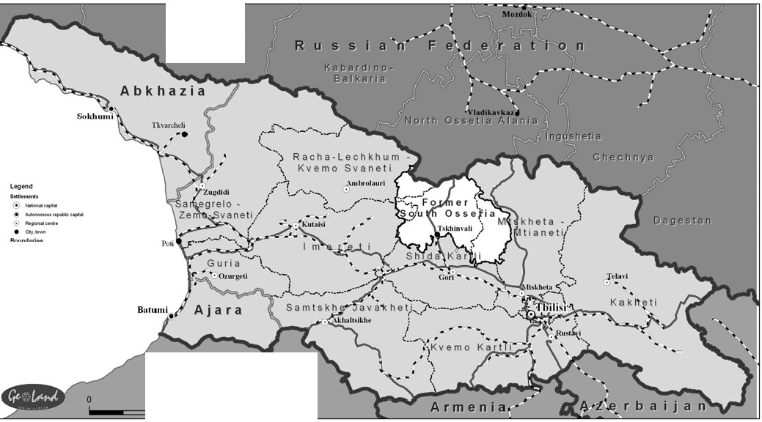

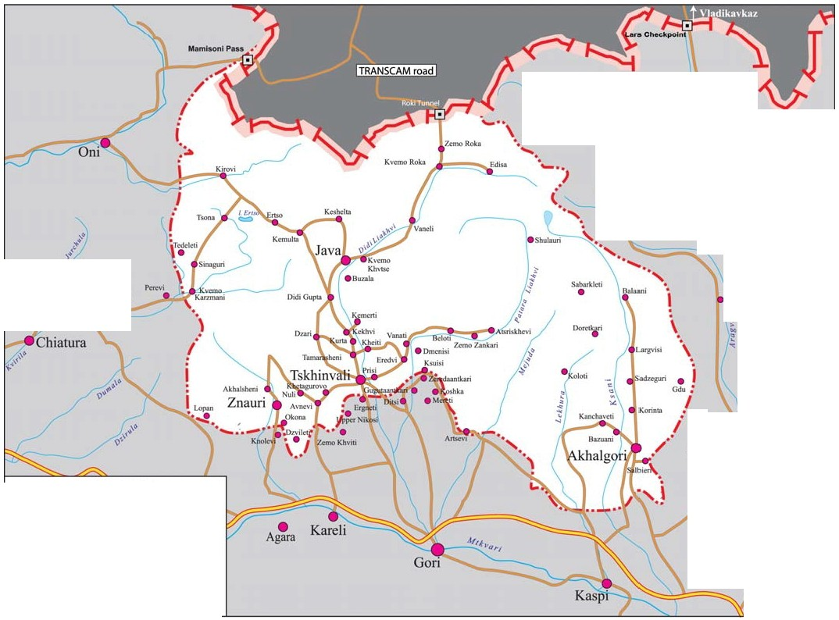



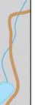

\;-Map of South Ossetia

Source for both maps = Crisis Group Report.

