What is taxomony? __________________________________________________________________________________________________________________________________________________________________________________________________
What does it mean to have a common ancestor? __________________________________________________________________________________________________________________________________________________________________________________________________
What is a trait?_______________________________________________________________________________
What is a shared trait?_______________________________________________________________________
What is a derived trait?______________________________________________________________________
Tree of life web project (http://www.tolweb.org) - Fill in the blanks and check the boxes as we retrace the evolutionary history of humans.

☐ Terrestrial vertebrates - _________________________________
 ☐ Amniota – Ability to lay eggs on land without them drying out.
  ☐ Synapsida – Single opening in skull.
   ☐ Therapsida – Appearance of upright posture.
    ☐ Mammalia – Presence of hair.
     ☐ Eutheria – Presence of a placenta.
      ☐ Primates -________________________________________________
       ☐ Catarrhini – Downward-facing nostrils.
☐ Homonidae – Reduced hair
         ☐ Homo – Large braincase.
Common ancestry and synapomorphies: Write the number of the option that best describes where traits evolve on the following tree.
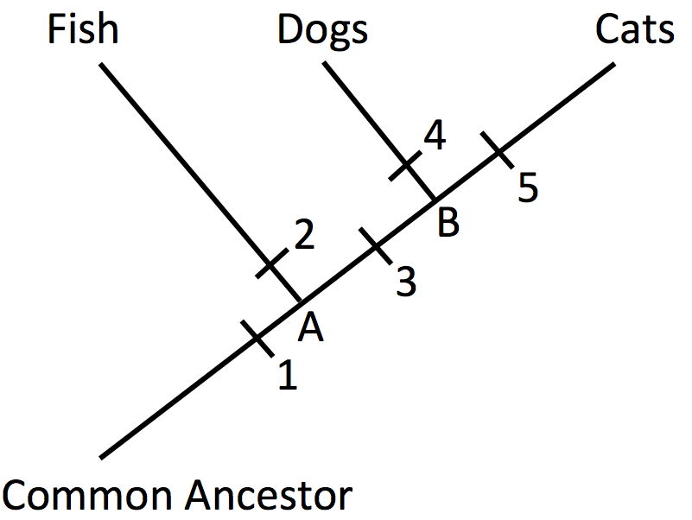
Where did paws evolve? _____

Where did fins evolve? _____

Where did eyes evolve? _____

What letter would
represent the common
ancestor for dogs and cats? _____

What letter would
represent the common
ancestor for all three
groups of animals? _____

