EXTRA INSTRUCTIONS: GPS Mapping Activity

In groups of two or three you will use a smart phone and a computer to create a map of Watsonville High School with thematic features of your choice.

Thematic features are simply things that we find on the surface of the earth

Step One: Decide what features you will map
The Thematic Map

- Get into groups of two or three people.
  - Make sure each group has a person with a smart phone.
  - Connect the phone to the WHS wireless network.

- Decide what you will map.
  - Our group will map _____________________________________ because we are interested in _______________________________________________________ ____________________________________________________________________________________________________________________________________
  - Teacher approval (get signature) _________________________

- Make a data collection sheet on your activity handout.
  - You will need at least three columns: latitude, longitude, and feature name.
  - You will need at least five rows for a minimum of five features on your map.

Step Two: Set up your phone
The GPS Receiver

- Install the Trimble Outdoors Navigator App (free).
  - Search for “trimble” in the app store.

- Run the app and create a user account.
  - Do not use the same password as your email!!
  - Remember your password! We will need it later in the computer lab

REMEMBER: while the app is free, the data service is not. Make sure you are connected to the WHS wireless network so you are not charged for data on your cellular plan!!!
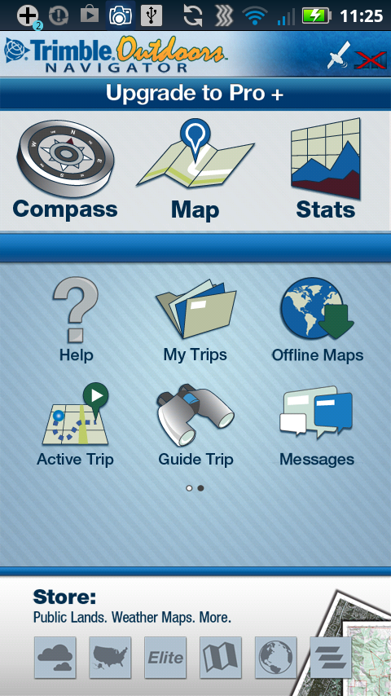 | You should see the screen to the left after creating the account and logging in.  Explore for a few minutes. Notice the following:  Compass: Shows north. Change between “magnetic” and “true” north. What is the difference?  Map: Look for the “layers” button and then change the default USGS topological map. Try to switch to satellite images (Arial Bing).  Stats: This only works if you start a “TRACK.” This is a small trip computer. It will calculate your distance travelled, the time of the “trip,” your speed and average speed (and more; touch the stats screen and you will see a list of other calculations).
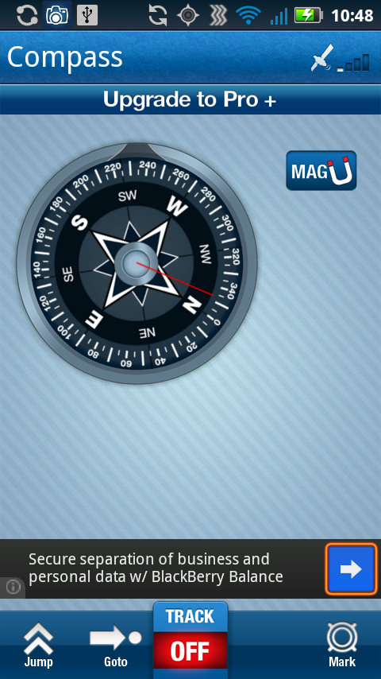 | 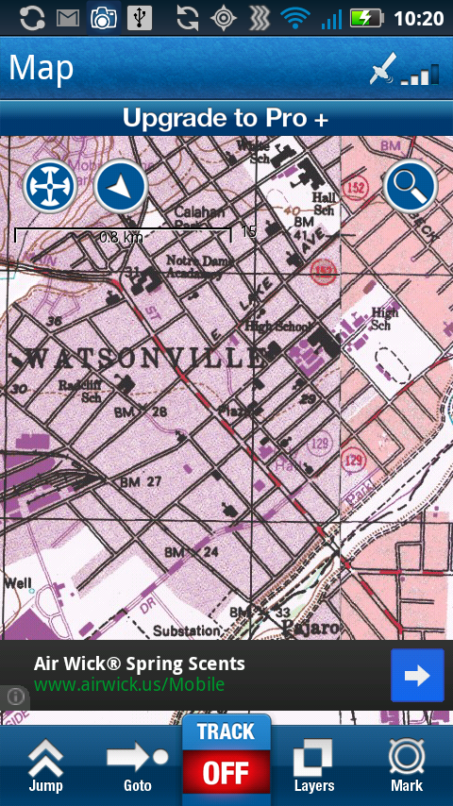 | 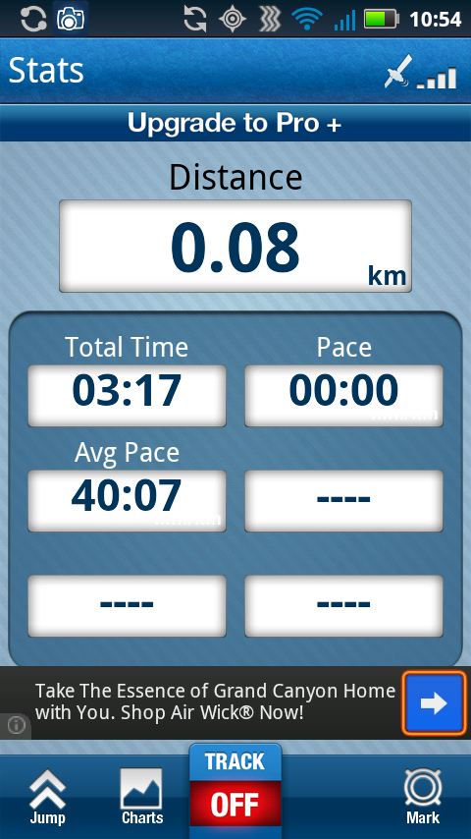

Note that all three screens have the “TRACK” switch currently set to “OFF”

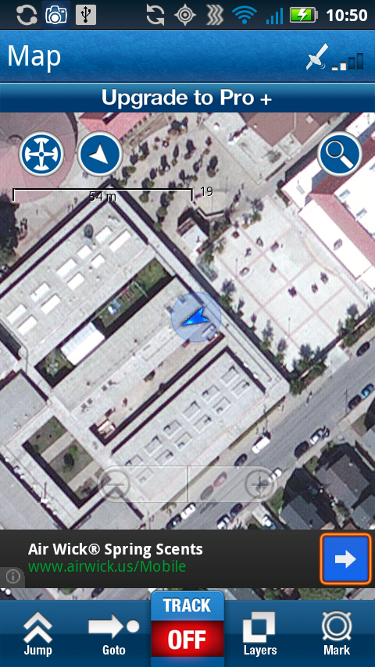
“AUTO-SCALE” button. Use this to see both your position and the active trip
Map Screen

“SEARCH” button

“MARK” button for WAYPOINTS and PHOTOS
“AUTO_FOLLOW” button. Use this to see your position on the map

“LAYERS” button to change the style of map

Active Trip Screen

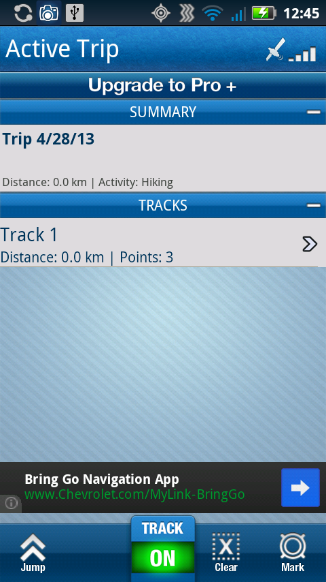
no
Step Three: Recording a Track
Saving Latitude and Longitude Information on your smart phone

- Go to the Map Screen
  - Pull the “TRACK” switch down to “ON”
  - Enter a name that makes sense for your track, then press “START”
  - You are now saving data to the phone

- Walk outside with your group and find your first feature
- Stand still and wait for two minutes to get a better “fix” on your position

- Marking a point
- From the map view, press the “MARK” button
- Choose “WAYPOINT”
- Enter a name for the point (you can also leave it as POI 1 – Point of Interest 1)
- Note the latitude and longitude on your data sheet
- Press “SAVE”

Walk to your next feature that you want to map

- Taking a picture
  - From the map view, press the “MARK” button
  - Choose “PHOTO”
  - Take the picture, accept the photo, and accept the permission to save
  - Give the photo a name that makes sense
  - Note the latitude and longitude on your data sheet
  - Press “SAVE”

Walk to your next feature that you want to map

- Continue to mark the rest of the features that you are mapping
- Make sure to record the Latitude and Longitude of each data point on your data sheet.
- Make sure each data sheet entry has the name of the feature.

Step Four: Finishing a Track
Saving the finished track for computer access

- Go to the Map Screen
  - Pull the “TRACK” switch down to “OFF”
  - Goto the “HOME” screen and
iPhone  - press the “ACTIVE TRIP” button  - press the “CLOSE” button (screen bottom) | Android  - Press the “Stop” button  - When asked, close the trip
- Elect a sharing option (you do not need to share) and press “CONTINUE”
- Your track is now available through the Trimble website with your login
Step Five: Making a Map
Access your track on a computer in the computer lab

- Login to Trimbleoutdoors.com
  - Open a web browser (Internet Explorer, Google Chrome, Mozilla Firefox, etc.)
  - Goto: http://www.trimbleoutdoors.com/ (you can google “trimble outdoors”)
  - At the top right of the page, click the “Login” button and enter your username and password from step 2.

- Download your track to the computer
  - Once you are logged in, at the top right of the page click “My Dashboard”
  - You will see your track name, date recorded, distance and other information at the top of the page.
  - At the far right click the “Options” menu and choose “Download”
  - Click “KML,” you will notice that the download starts. Click the “Close” button.

- View a simple map in the web browser
  - From your “Dashboard” click on the link for your track name
  - You will see a simple map in the web browser

Trees of Watsonville Highschool

- Place the map in Microsoft Word
- With the web browser active (front window), press [ctrl][shift][prnt scrn] (Windows) or [cmd][shift][3] (Mac) all at the same time to copy the screen image to the computer’s memory.
- Open Microsoft Word and in the new document goto the “Edit” menu and choose “paste.” The map should appear in your document.
- Click on the image and then select the “Picture Tools/Format” tab in the menu ribbon at the top. Find the “Crop” tool and click it. Black guides will appear on the image.
- Click and adjust the black guides on the image until you have just the map. Press “Enter”
- Add a title

- Open the map in Google Earth
- With the web browser active, double click the downloaded KML file from step 2.
- The map will open in Google Earth. From the “View” menu select “Grid.”
- Click on your Waypoints. Double check that the Latitude and Longitude for your waypoints and photos match the values you recorded on your data sheet.

- Change the appearance of your map in Google Earth
- In Google Earth find the “Places” tab on the left side of the map. Make sure it is expanded.
- In the “Places” tab find the “Temporary Places” and the “Trimble Outdoors Trips.”
- Click on the “+” sign next to “Trimble Outdoors Trips,” and then on the “+” next to your track name. You should see folders that say “Photos,” “Points,” and “Tracks”
- Right-click on the folder “Points” and choose “Properties” from the menu. You should see a small blue flag to the top right of the window.
- Click the flag and choose a different icon. Click OK.
- Change the icon for the photos and the start point as well.
- Right-click on the folder “Tracks” and choose “Properties” from the menu.
- Click on the “Style, Color” tab. You can change the color and width of the line here. Click OK.

Trees of Watsonville High School

- Place the map in Microsoft Word
- Use the instructions from step 4 to place the Google Earth map in Microsoft Word.

