GPS, Latitude and Longitude: Notes Taking Guide
- GPS is short for ____________________________________________.
- We use GPS to find the _______________________ and _________________________ of a position on the earth’s surface.
- Latitude / Longitude (circle one) indicates North or _______________ of the equator.
- Latitude / Longitude (circle one) indicates _________ or West of the prime meridian.
- Label the globe:
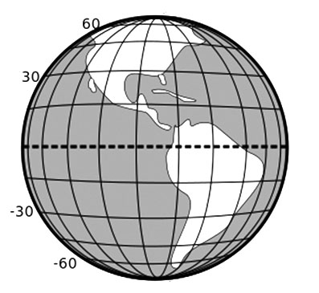
- North Pole / South Pole
- Equator
- Lines of Latitude
- 90° / -90° / 0°

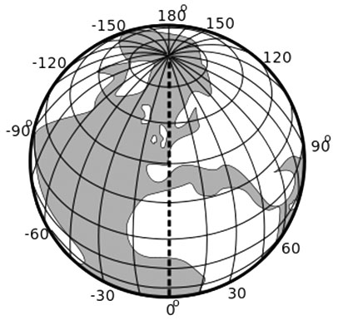

- Label the globe
  - Lines of Longitude
  - Prime Meridian

- The Equator is the line of 0° degrees _____________________________ and divides the earth into the northern and southern ________________________.
- The _______________________________ is the line of 0° degrees Longitude and divides the globe into the ______________________ and ______________________ hemispheres.
- The North Pole is _________ degrees latitude north of the equator.
- The global positioning system uses GPS satellites and __________________________ to find latitude and longitude.
- The GPS receiver uses _________________________ (a kind of geometry) to calculate the latitude and longitude.
- GPS was first tested in 1960 but needed ____________ hour(s) to calculate the position.
- GPS was invented by the military, but was made public in ___________ to prevent accidents.
- Now there are ____________ GPS satellites in orbit around the earth and a smart phone can calculate a position that is accurate to about 10 meters in ____________ minutes.
- The GPS receiver uses the speed of light, which is ________________________, to calculate the distance between the satellite and the receiver.
- a. If Los Angeles is 330 miles from Watsonville and you drive at 55 miles/hour, how long does it take you to get to Los Angeles? _______________________
b. If New York is 3000 miles from Watsonville and you drive at 60 miles/hour, how long does it take to drive to New York? _________________________
- Calculation of time of travel
Speed of Light ~ ____________________

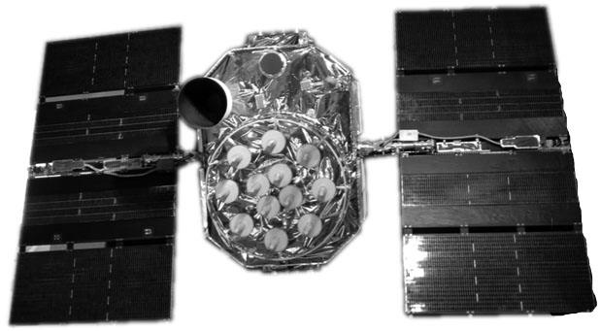
Altitude (distance) ~ ____________________

How long does it take a radio signal (same speed as light) to travel from the satellite to the surface of the earth (hint: time = distance ÷ speed)???

- What could you use GPS for? Today? In a future job?

