Name: ______________________
Period: ______
A Matter of Human Proportions

Objectives
In this lab, you will collect evidence to see if the proportions displayed in Leonardo da Vinci’s Vitruvian Man drawing accurately reflect how people are composed. You will the test your own hypotheses about ratios that could exist between parts of the body.
What is the Vitruvian Man?
Leonardo da Vinci, a famous Italian renaissance inventor and painter, was greatly influenced by the work of a man named Vitruvius. Vitruvius was a Roman architect who lived during the first century B.C. who created a model of what he thought were ideal proportions for the human body. In da Vinci’s Vitruvian Man drawing, a human figure represents the proportions described by Vitruvius. Da Vinci’s drawing, which was made in 1490, remains one of the most referenced and reproduced images in the world, appearing in books, films, and even coins.
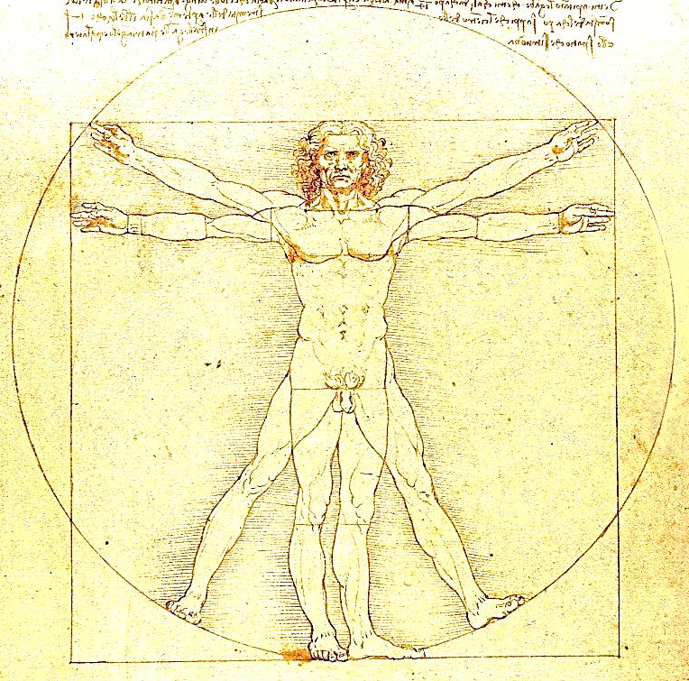
Y
X
Z
Figure 1 A Representation of Leonardo da Vinci's Vitruvian Man. The linear distances measured in Part 1 of the activity are also shown. Distance X indicates arm span, Y indicates height, and Z indicates the distance from the bottom of the kneecap to the bottom of the foot. All measurements should be taken while standing.
The drawing shows a man standing in a square, as well as inside a circle. The man has two pair of outstretched arms and two pair of outstretched legs. There are many proportions that the body of the Vitruvian Man displays. The two on which we will focus today are:
- The span of the man’s arms is equal to his height.
- The distance from the bottom of his knee to the bottom of his foot is one-fourth of his height.
The Activity
Materials
- Tape measure
- Meter stick

Procedure
Part 1: Analyze da Vinci’s Vitruvian Man
You and your group will take measurements to examine one of the proportions displayed in Leonardo da Vinci’s Vitruvian Man. As a class, you will then test the hypothesis that these proportions accurately describe the human body. Place a check mark next to the specific proportion your teacher has assigned to your group:
_____ Proportion A: The span of the man’s arms is equal to his height.
_____ Proportion B: The distance from the bottom of his knee to the bottom of his foot is one-fourth of his height.

  - Take turns marking your height on the butcher paper attached to the wall. Your height should be recorded with your shoes off. When each member of your group has finished marking his/her height, use the meter sticks or metric rulers to measure each group member’s height to the nearest 0.1 centimeter (cm). Record these in the second column of the data table on the next page (which is labeled “Height (cm)”).
  - Based on the heights of your group’s members, calculate the predicted value of the other (a.k.a. non-height) measurement, based on the Vitruvian proportion you were assigned. Record this value in the third column of the data table (which is labeled “Predicted Value of Measurement (cm)”).
  - Take the remaining measurement that you need. While taking these measurements, try to stand as straight as possible, mimicking the posture of the Vitruvian Man. Any measurements involving your feet should be taken with your shoes off. Your measurements should also be taken to the nearest 0.1 centimeter (cm) and recorded in the fourth column of the data table (which is labeled “Actual Value of Measurement (cm)”).
  - In the fifth column of the data table, calculate the difference between the expected value of your measurement and its actual value. Record this in 0.1 centimeters (cm).
  - Have one member of your group share your group’s data with your teacher, who will put together data tables that describe your class.
Data for Part 1 – Analyze da Vinci’s Vitruvian Man
Subject’s Name | Height (cm) | Predicted Value of Measurement (cm) | Actual Value of Measurement (cm) | Difference Between Predicted and Actual (cm)

Look at your data for Part 1: Did your measurements generally agree with what you predicted them to be, or were there big differences (+/- 2 cm)? ____________________
______________________________________________________________________
______________________________________________________________________
Part 2. Test Your Own Hypotheses about Proportions in the Body
You and your group will now conduct investigations of proportions that might exist in the human body. This is your chance to examine a few regions of the body to see if scaling patterns are consistent across individuals. It is extremely likely that you will not have a sense of what the proportions might be, so in each case do not worry about making a hypothesis about the magnitude of the proportion itself. You will instead test the hypotheses that these proportions exist across various individuals. Thus, your goal is to merely examine whether patterns exist after you analyze at the data you collect.

You and your group will explore two such patterns. For each case, you will want to measure at least 12 individuals from your class to ensure that you have collected enough data to make a reasonable conclusion.

For the sake of simplicity, all measurements should be taken as linear distances. In other words, avoid measurements of surface area or mass. Remember to take each measurement to the nearest 0.1 cm.

Here are a few examples you might consider investigating:
- The length of the foot vs. the length from the wrist to the elbow
- The width of the shoulders vs. the length of the legs

Be creative! Brainstorm a few proportions you would like to investigate and list them here:
- Body Region X:______________________ Body Region Y:_______________________
- Body Region X:______________________ Body Region Y:_______________________
Data for Part 2 – Your Investigations
Investigation 1
Proportion to examine: ______________________________________________________
Subject’s Name | Body Region X (cm) | Body Region Y (cm) | Ratio of X:Y

Investigation 2
Proportion to examine: ______________________________________________________
Subject’s Name | Body Region X (cm) | Body Region Y (cm) | Ratio of X:Y

Analysis and Conclusions
Part 1
Your teacher will demonstrate how scatterplots are created in Excel by entering all the data you gathered as a class for Part 1 of this activity. Follow along as your teacher then creates separate scatterplots for Proportion A and Proportion B. Once each of these scatterplots is created, your teacher will show you how to title and label the axes of each scatterplot. Pay careful attention to which variable is assigned to each axis. Finally, your teacher will add a trend line to each scatterplot, and will give you the equation for the line as well as the associated R² value.

Write down the equations for the trend lines and their R² values here:

Proportion A: The span of the man’s arms is equal to his height.
Equation: _____________
R² value: ________

Proportion B: The distance from the bottom of his knee to the bottom of his foot is one-fourth of his height.
Equation: _____________
R² value: ________

Recall that when we get an R² value greater than or equal to 0.9, it indicates a strong association between the variables. Based on this, decide whether you accept or reject the hypotheses that these proportions accurately describe the human body. Be sure to consider both the slope of the line as well as the R² value you obtained.

Proportion A: __________________________________________________________
_____________________________________________________________________
_____________________________________________________________________
_____________________________________________________________________
_____________________________________________________________________

Proportion B: __________________________________________________________
_____________________________________________________________________
_____________________________________________________________________
_____________________________________________________________________
_____________________________________________________________________
Part 2
Follow the instructions your teacher provides you to enter the data you collected for Part 2 into separate tables in Microsoft Excel. For each table of data, create a scatterplot depicting the relationships between the two body regions you measured. Think carefully about which variable belongs on each axis of each scatterplot. Finally, add trendlines to your scatterplot and write down the equations for the trendlines and their R² values below. Once you are satisfied with the way your scatterplots look (remember to label the axes and give the graphs titles!), print them out.

Investigation 1:
Proportion Examined: ___________________________________________________
Equation: _____________
R² value: ________

Investigation 2:
Proportion Examined: ___________________________________________________
Equation: _____________
R² value: ________

Recall that when we get an R² value greater than or equal to 0.9, it indicates a strong association between the variables. Based on this, decide whether you accept or reject the hypotheses that these proportions accurately describe the human body. Be sure to consider both the slope of the line as well as the R² value you obtained.

Investigation 1:_________________________________________________________
_____________________________________________________________________
_____________________________________________________________________
_____________________________________________________________________
_____________________________________________________________________

Investigation 2:_________________________________________________________
_____________________________________________________________________
_____________________________________________________________________
_____________________________________________________________________
_____________________________________________________________________

