Name:
Period:
What’s Stomata With You?
Objectives
In this lab, you will learn about leaf stomata, form hypotheses, and count the number of stomata on each side of a leaf.
Pre-Lab Questions
1. Use the word bank to fill in the blanks. Each word will be used only once.
WORD BANK
carbon dioxide (CO₂) | open | water (H₂O)
close | oxygen (O₂) | turgid
epidermis | flaccid | transpiration
guard cells | pores
Stomata are microscopic in the of leaves where enters and exits during photosynthesis. also exits the leaf through stomata due to evaporation in a process called .
Specialized cells called control the opening and closing of stomata. When these cells fill with water, they become and the stoma . When water leaves these cells, they become and the stoma .
2. The two major functions of stomata are:
1)
2)
3. On the drawing below, label the following:
- epidermal cells
- guard cells
- stoma
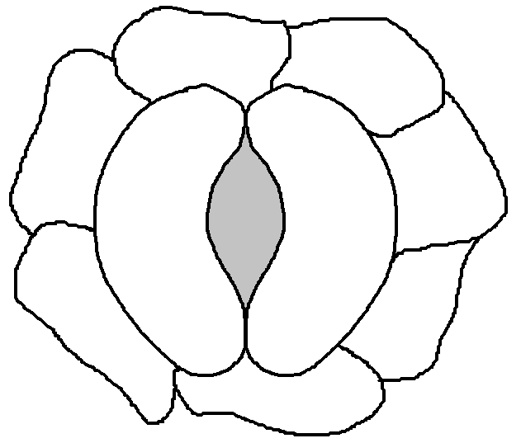
4. Name five factors that cause stomata to open or close.
1)
2)
3)
4)
5)

5. What challenge do plants face that might affect their stomata?

Activity: Leaf Impressions
Materials

- Tradescantia zebrina plant
- Forceps
- Microscope
- Microscope slides
- Slide coverslips
- Beaker of water with dropper
- Temperature gun

What part of a leaf would be warmest and driest? Why? (Hint: Think about a very hot, sunny day.)

Form a hypothesis about stomata on the top and bottom of a leaf. Do you think one side has more stomata than the other, or that both sides are the same? Why?

Steps
1. Measure the temperature of the upper and lower surfaces of a leaf on the Zebrina plant. Record your data here. Don’t forget to include the units!
Leaf Temperature

Upper
________________________
Lower
________________________

2. Take a leaf from the Zebrina plant from the ice water.
3. Gently bend the leaf until you hear a light snap.
4. Use the forceps to gently peel off the first layer of the leaf epidermis.
5. Place the leaf peel on a microscope slide. Add a drop of water and a cover slip. Label the slide with “top” or “bottom” corresponding to the side of the leaf that the peel came from.
6. Repeat steps 3-5 with the other side of the leaf.
7. Look at the leaf peels under the microscope at 400x.
8. Count the number of stomata in your field of view and record the number in your data table below. Then, without changing the magnification settings, move the slide to another area of the leaf peel and count the stomata again. Do this a total of three times. Then, calculate an average number of stomata for each side of the leaf.
Plant name: _________________________ | Top of leaf | Bottom of leaf
Number of stomata in field 1
Number of stomata in field 2
Number of stomata in field 3
Average number of stomata

9. Draw (in color) what you saw under the microscope from the “top” and “bottom” leaf peel. Label the stoma and guard cells.
TOP | BOTTOM

10. Is there a difference in average number of stomata on the top and bottom of the leaf?

11. Explain whether your findings supported or refuted your hypothesis using evidence from the data you collected.

