Name: __________________
Date: __________________
Period: __________________
What’s your walk score?
Walkable neighborhoods as healthy, social, and safe communities
I. Background
A. Before there were cars in every driveway and gas stations on every corner, and before Henry Ford designed the “horseless carriage”, traditional towns and cities were created on a human scale. Walking was the practical transportation mode of choice for most Americans, people’s age, ethnicity and class didn’t matter. Compact, mixed-use development allowed most business and recreation trips to be made by foot.
The most obvious advantage of a walkable community for individuals is the health benefit of ____________________. It is no coincidence that the rise in obesity in the United States has coincided with decades of development patterns that have made walking difficult or impossible. According to the Centers for Disease Control and Prevention, 30 percent of U.S. adults 20 years of age and older (that’s over 60 million people!) are obese. The percentage of young people who are overweight has more than tripled since 1980. Among youth between 6 and 19 years old, 16 percent (over nine million young people!) are considered overweight. Being overweight or obese puts people at risk for cardiovascular disease, diabetes, hypertension, high cholesterol, cancer, and higher rates of anxiety and depression.
Many American families have become dependent on the automobile. At the same time, technological innovations, like televisions and personal computers, and the decline of jobs requiring physical labor have made America less walkable and reduced our social interactions. It’s now common to go through the day without walking more than a few hundred feet—from the kitchen to the garage, the parking lot to the office, the school steps to the curb, the parking space to the store, and the driveway back to the house. Walkable communities with universal access for the young, old, disabled and under-employed promote ________________________ by allowing people to connect with each other on the sidewalk or in the store, at work or in the park, and thereby build a sense of community.
Sometimes people avoid walking because they don’t feel that the walking routes are safe or convenient. ______________ routes to school or work are routes where there is little graffiti, trash or sidewalk maintenance issues and thus very little threat of crime or threat to one's personal health. Walkable communities promote access to urban services through pedestrian infrastructure that can be used by the entire community, including the young, old, and disabled.
Walkability allows you to assess how walkable your neighborhood is with physical fitness, social interaction and safety in mind. A walk score can help you measure walkability. While initially developed for real estate, the concepts are equally valuable for surveying the campus of a school or the neighborhood surrounding your home.
B. Write a paragraph about how walkability relates to physical exercise, social interaction, and safety.
____________________________________________________________________________________________________________________________________________________________________________________________________________________________________________________________________________________________________________________________________________________________________________________________________________________________________
II. Directions
1. Decide, through observation, what the most likely pedestrian routes are between each location of interest (e.g. library, cafeteria, class, gym, etc.) at your school campus. Use the map below to draw and label three routes. (Note: We will choose a route to complete together as a class for the first route).
2. Begin with your first route, and use the checklist below to rank each feature using the descriptions provided. There are no right or wrong answers, just pick the number that most accurately represents your understanding of the walking route. Use the chart below to fill in your walk scores.
3. On your own time as homework, survey an additional two routes on your campus so that you have gone through the walk score checklist for a total of three routes.
4. Use the formula in the box halfway through the walk score chart to create a weighted score for each route that favors safety as the highest priority. Calculate scores for all three routes of your map.
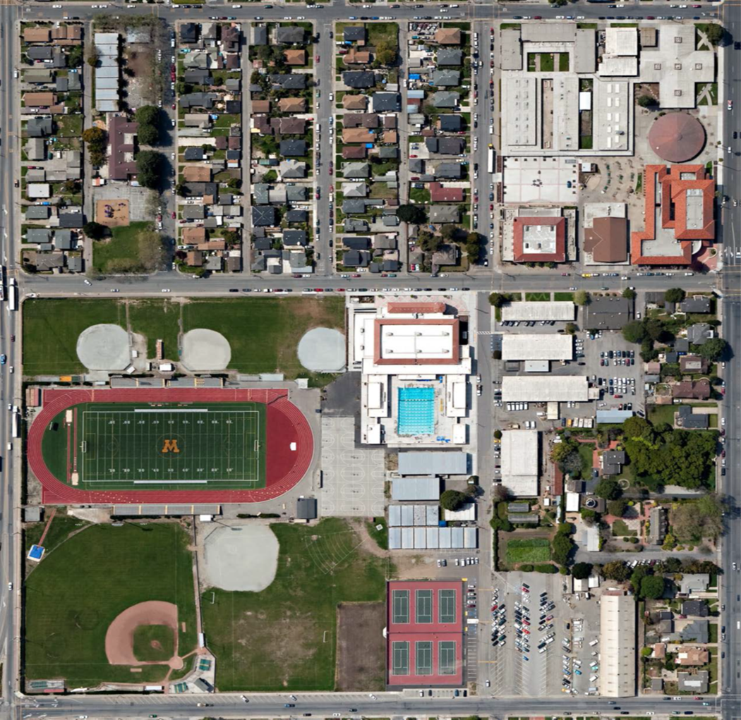
III. Walk Score Survey:
1. Walk Score Prediction
A. Do you think your school campus is walkable?
_____________________________________________________________________________________
B. Which of the below factors do you think will most contribute to your walk score prediction?
_____________________________________________________________________________________
2. Walk score factors
Use different shapes for each route you survey (Route 1 use , Route 2 use , Route 3 use ).
A. Pedestrian Facilities (High importance): presence of a suitable walking surface, such as a sidewalk/path.
No permanent facilities, pedestrians in roads 1 2 3 4 5 Sidewalk on one side of road
B. Pedestrian Conflicts (High importance): potential for conflict with motor vehicle traffic due to driveway and loading dock crossings, speed and volume of traffic, large intersections, low pedestrian visibility.
High conflict potential 1 2 3 4 5 Low conflict potential
C. Crosswalks (High importance): presence and visibility of crosswalks on roads intersecting the route. Traffic signals meet pedestrian needs with separate ‘walk’ lights that provide sufficient crossing time.
Crosswalks not present 1 2 3 4 5 No intersections on route
D. Maintenance (Medium importance): cracking, buckling, overgrown vegetation, standing water, etc. on or near walking path. Does not include temporary deficiencies likely to soon be resolved (e.g. tall grass).
Major or frequent problems 1 2 3 4 5 No Problems
E. Path Size (Medium importance): measure of path width, accounting for barriers along pathway.
No permanent facilities 1 2 3 4 5 > 5 feet wide, barrier free
F. Buffer (Medium importance): the space or width separating path from adjacent roadway.
No buffer from roadway 1 2 3 4 5 Not adjacent to roadway
G. Universal Accessibility (Medium importance): ease of access for the mobility impaired. Look for ramps and handrails accompanying steps, curb cuts, etc.
Completely impassible for wheelchairs 1 2 3 4 5 Designed to facilitate wheelchairs
H. Aesthetics (Medium importance): includes proximity of construction zones, fences, buildings, noise pollution, quality of landscaping, and pedestrian-oriented features, such as benches and water fountains.
Uninviting 1 2 3 4 5 Pleasant
I. Shade (Low importance): amount of shade, accounting for different times of day.
No shade 1 2 3 4 5 Full shade

3. Assessment
From your chosen routes, which do you think will have the highest walk score?
_______________________________________________________________________________________

 | Walk Scores
 | Route 1 |  |  | Route 2 |  |  | Route 3
A. Facilities |  | X 3 | = |  | X 3 | = |  | X 3 | =
B. Conflicts |  | X 3 | = |  | X 3 | = |  | X 3 | =
C. Crosswalks |  | X 3 | = |  | X 3 | = |  | X 3 | =
D. Maintenance |  | X 2 | = |  | X 2 | = |  | X 2 | =
E. Size |  | X 2 | = |  | X 2 | = |  | X 2 | =
F. Buffer |  | X 2 | = |  | X 2 | = |  | X 2 | =
G. Access |  | X 2 | = |  | X 2 | = |  | X 2 | =
H. Aesthetics |  | X 2 | = |  | X 2 | = |  | X 2 | =
I. Shade |  | X 1 | = |  | X 1 | = |  | X 1 | =
Weighted Total |  |  | ______ 100 |  |  | _____ 100 |  |  | ______ 100

4. Reflection
A. Was there a low (0-40), medium (41-80) or high (81-100) level of walkability on your school campus?
Route 1? ______________________ Route 2? ______________________ Route 3? ___________________
B. For routes with a high walk score, what factors were present? For routes with a low walk score, what factors were absent? ______________________________________________________________________
_______________________________________________________________________________________
_______________________________________________________________________________________
C. What factors would you like to see improved on your campus and in your neighborhood? ________________________________________________________________________________________________________________________________________________________________________
________________________________________________________________________________________________________________________________________________________________________
________________________________________________________________________________________________________________________________________________________________________
________________________________________________________________________________________________________________________________________________________________________

