NAME: ________________________________
What’s that Sound?
Sound is especially important for marine mammals. In today’s activity, you’ll learn about bioacoustics, properties of sound waves, and the characteristics of marine mammal sound. You’ll learn enough to identify the species of your own marine mammal mystery sound!

- Acoustics is the study of ___sound_____.

- Bioacoustics combines __biology____ and _accoustics_.

- Provide three reasons why marine mammals use sound underwater.
      - Locating Food
      - Reproduction
      - Predation

- Sound is a _wave__ that travels 5 times_faster___ in water than air.

Change in pressure from peak to trough; the loudness of a sound
- Label and define the following:
Amplitude

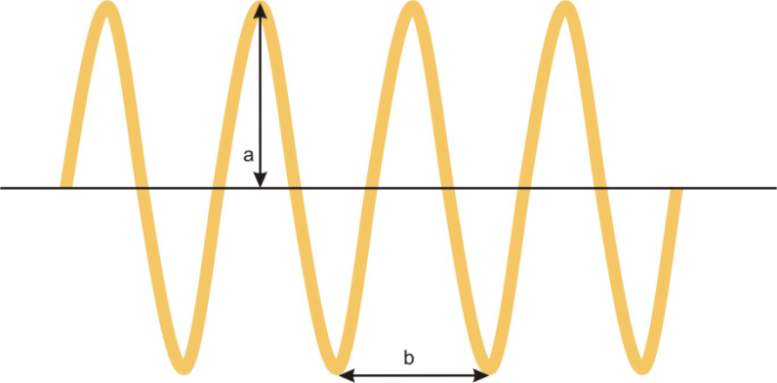
Distance from one crest to the next or one trough to the next
Wavelength

- Frequency is the number of _wavelengths__ per __second___.

- Which wavelength has the highest frequency? Lowest? The most energy? The last amount of energy?

Long wavelength = high / low frequency = high / low energy
Short wavelength = high / low frequency = high / low energy

- Low frequency sounds travel __farther_____than high frequency sounds underwater.

- A waveform (example below) shows _pressure___ fluctuations over _time__, with amplitude indicating _loudness_____.

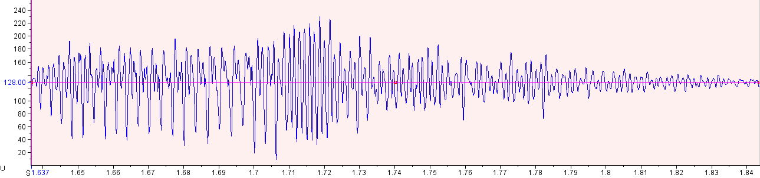
Pressure (db)
Time (seconds)

- A spectrogram (example below) shows _frequency_ over__time__, with color indicating _loudness____, or ___intensity____.

Time (seconds)
Frequency (kHz)

- Peak Frequency is the frequency with the most _power__.

- Marine Mammal Bioacoustics Review Table
Marine Mammal Group | Example | Common Frequencies | Use
Mysticetes  (baleen whales) | blue whale | Low frequency | Communication
Odontocetes  (toothed whales) | Bottlenose dolphin | Mid –high freq.  Very high freq. | Communication  Sonar
Pinnipeds  (seals & sea lions) | CA sea lion | Low-high freq. | Reproduction and communication

