TITLE: What’s that sound?
Subtitle: Quantifying and describing marine mammal sounds

Authors: Kimberly Goetz, PhD Candidate, Ecology and Evolutionary Biology, UCSC, CA.
Caleb Bryce, PhD Student, Ecology and Evolutionary Biology, UCSC, CA
Burnne Yew, Biology Teacher, Watsonville High School, Watsonville, CA.

Field tested: 11th grade Biology, Watsonville High School, Watsonville, CA (Spring 2014)

Module Type: Lecture and lab activity

Duration: One 2-hour class period (Lecture and Lab activity)

Key materials:
- Computer/projector
- Computer lab with Raven Lite 1.0 installed (Free download http://www.birds.cornell.edu/brp/raven/RavenVersions.html#RavenLite)
- Sound files
- Headphones (1 per student)
- Optional: tuning fork (http://www.amazon.com/ADC-Aluminum-Alloy-Tuning-Fork/dp/B000QV1OZI)

Concepts: Bioacoustics, acoustics, sound, waveform, frequency, peak frequency, spectrogram, power, amplitude, pressure, wavelength, hertz, decibels, mysticete, odontocete, pinniped

Skills: Interpreting waveforms and spectrographs, understanding the properties of sound, learning the differences between sounds produced by different marine mammal species

Science Education Standards:

- NGSS:
  - HS-LS2 Ecosystems: Interactions, Energy, and Dynamics
  - HS-PS4 Waves and Their Applications in Technologies for Information Transfer

Overview:
This project is an opportunity for students to learn:

- Basic sound properties
- How to interpret spectrograms and waveforms
- Why marine mammals use sound
- How to describe (quantitatively and qualitatively) the diversity of sounds produced by marine mammals

Navigate: Background Materials &Time Starting Point Procedures Standards Supplemental

Background for Teachers

Why this matters
This module is exciting because students are introduced to the properties of sound by quantifying and describing sounds from several types of marine mammals (toothed whales, baleen whales, sea lions, and true seals). Students examine differences in sounds between marine mammal species in order to predict the source of a mystery sound.

Assumed background
Very little knowledge is required for this activity. Students should know that animals use sound for a variety of reasons and some knowledge of sound properties would be advantageous but not required.

Special context
Marine mammals use sound for feeding, communication, predator avoidance, and navigation. By learning about basic sound properties, this module helps students understand how and why using sound is advantageous in certain environments. While this module does not focus on noise pollution, teachers may choose to discuss how man-made noise can interfere with marine mammal behavior.

Scaffolding supplements
- Bryce_Goetz_BioSound_Pres.ppt – this presentation describes bioacoustics, sound properties, and the importance of sound for marine mammals. This presentation also provides many examples of marine mammal sounds and a helpful YouTube video:
https://www.youtube.com/watch?v=GkNJvZINSEY

- Bryce_Goetz_BioSound_Pres_Worksheet.docx – this worksheet follows along with the presentation. The students will be required to fill in information they learn during the presentation that will help them in the lab activity.

- Bryce_Goetz_BioSound_Pres_Worksheet_ANS.docx – this is the answer key for : Bryce_Goetz_BioSound_Pres_Worksheet.docx

- Bryce_Goetz_BioSound_Lab_Worksheet.docx – this worksheet contains directions for the lab activity and the worksheet that is to be filled out during the lab.

- Bryce_Goetz_BioSound_Lab_Worksheet_ANS.xls– this is the key for: Bryce_Goetz_BioSound_Lab_Worksheet.docx

Module Description

Materials
- PowerPoint Lecture
- Computer/projector
- Computer lab with Raven Lite 1.0 installed (Free download http://www.birds.cornell.edu/brp/raven/RavenVersions.html#RavenLite) – must submit online form to get license file.
- Optional: Tuning fork for demo (http://www.amazon.com/ADC-Aluminum-Alloy-Tuning-Fork/dp/B000QV1OZI)
- Sound files of marine mammals (worksheet and mystery sounds)
- Headphones/ear buds (one per student)
- Follow-along presentation worksheet
- Lab worksheet

Preparation
- Raven Lite 1.0 needs to be installed on all computers before this lab (Free download http://www.birds.cornell.edu/brp/raven/RavenVersions.html#RavenLite) – be sure to enter free license number on each computer in advance.
- Load marine mammal sound files on all computers in advance
- Copy worksheets
- Confirm that sound clips are embedded in PowerPoint lecture

Timeline
- PowerPoint Lecture Part I: 45 mins.
- Tuning for example: 5 mins.
- PowerPoint Lecture Part II: 10 mins.
- Ravel Lite Demo: 10 mins.
- Sound analysis in computer lab 50 mins.
- Answer inquiry questions on worksheet 20 mins.

Starting Point For Inquiry
Why is sound so important to marine mammals? In short, light is absorbed rapidly underwater and visual communication is not practical over large spatial scales, but sound travels faster and farther due to the higher density of water. Marine mammals use sound for feeding, communication, predator avoidance, and navigation. In fact, the different taxa of marine mammals (odontocete (toothed whales), mystecetes (baleen whales), and pinnipeds (seals and sea lions) use different bioacoustic strategies, from beeps and whistles to low-frequency groans and even complex songs. Because sound is so important to marine mammals, they are highly susceptible to altered acoustic environments. Many recent studies have shown how anthropogenic disturbances from transportation, dredging, construction, oil & gas drilling, sonars, geophysical surveys, and explosions can cause altered (or avoidance) behavior in marine mammals.
In order to investigate the bioacoustic diversity of marine mammals, students view an introductory presentation on the subject, and then engage in an inquiry activity in which they identify a “mystery sound” using a sound analysis program. The basic use of this free sound analysis program (Raven Lite 1.0) will be demonstrated by the instructor prior to the inquiry activity in the computer lab. Students will also develop familiarity with Raven Lite by using the software to identify key bioacoustics parameters (e.g. peak frequency, power, and duration) of eight diverse marine mammals (California sea lion, northern fur seal, beluga whale, killer whale, blue whale, humpback whale, Weddell seal and harbor seal) prior to trying to identify their mystery sound.

Detailed Procedure
Step 1
Teachers should first go through and understand the material in the PowerPoint in advance (we were careful to write notes on each slide). It is also critical that teacher’s verify that the audio links embedded in the PowerPoint work since that is the main focus of the lecture. The PowerPoint is divided into two parts; Part I is an introduction to acoustics, sound properties, and marine mammal sound (slides 1-18).

Step 2 (optional)
At the end of Part I, the teacher can use a tuning fork to demonstrate how marine mammals hear underwater. Ask for two student volunteers and have them come to the front of the class. Have one student cover their ears while the other student lightly taps the tuning fork on the desk and holds the base of the fork to their partner’s chin. The student should be able to hear the tuning fork, even with their ears plugged. Note that the sound will be different than if heard without the ears covered because sound travels faster through solid materials (bone) than air. Tell the rest of the students that they are welcome to do the tuning fork demo if there is time at the end of class.

Steps 3 and 4
If teachers decide to do the lab activity, they should go through Part II of the PowerPoint (slides 19-end). Part II describes the lab activity and allows the teacher an opportunity to demonstrate how to analyze the data included in the lab. Teachers may want to show this part of the presentation in the computer lab so that students can follow along during the example. Teachers should stop at slide 21 and open Ravel Lite software where they will demonstrate how to analyze a call of a male California sea lion, the first sound on their worksheet. More specific directions are on the first 4 pages of the lab worksheet handout. After the demonstration, the teacher should continue on slide 22 of the PowerPoint which summarized the methods used to analyze the call.

Steps 5 and 6
In the computer lab, the teacher should assign each student a mystery sound file (files 1-8) and have them record the file number on their worksheet. Students will analyze 8 known marine mammal calls and their assigned mystery sound. Using the sound properties from the calls of different marine mammal species (usually power and frequency at peak power are the best comparisons), they will determine which species produced their mystery sound. The student will answer the open ended questions on their worksheet, using sound properties to justify their answers. If there is no time to complete the questions, teachers can assign them for homework, or continue into a future class period.

Assessment Methods
Student understanding will be assessed in several capacities: 1) His/her ability to determine bioacoustics parameters for each of the eight marine mammal sounds 2) Correct or “close” identification of his/her mystery sound and most importantly, 3) His/her ability to reason through the “what did you learn” short answer questions following the mystery sound identification.

Possible pitfalls
This lesson largely depends on the expectations placed on students to remain focused and stay on-task, as well as the depth/breadth of background material (ex: simple properties of sound, marine mammal diversity, etc) the students may or may not have. After testing the module in the lab – we highly recommend not passing around the tuning fork during class but rather give students the opportunity to try the demonstration after class.
Also, it is crucial that the software be installed and license key entered on each computer beforehand. Students should bring head phones or teachers should supply them. Sounds can be played through computer speakers but will be distracting to others.
The teacher should go through Part II of PowerPoint in the computer lab so students can follow along on their own computer.

Glossary

Acoustics: Pertaining to the sense of hearing, sound or the science of sound

Amplitude: The change in pressure caused by a sound wave; the loudness of a sound

Bioacoustics: Cross-disciplinary science that combines biology and acoustics

Decibel (db): A logarithmic unit used to measure sound pressure

Frequency: Cycles (or number of complete pressure waves)/second - measured in Hz or kHz

Hertz: Unit of frequency; equals the number of cycles per second

Mysticete: A baleen whale

Odontocete: A toothed whale

Peak Frequency: Frequency where the power is the greatest

Pinniped: A seal or sea lion

Power: Amount of energy in the sound, measured in db (Note: A louder sound has more power
Spectrogram Graph: A spectral (forming an image) representation of sound/pressure waves per unit time. The horizontal axis represents time, the vertical axis is frequency (Hz or kHZ); the amplitude of a particular frequency at a particular time is represented by the intensity or color of each point in the image.

Frequency (Hz, or KHz)
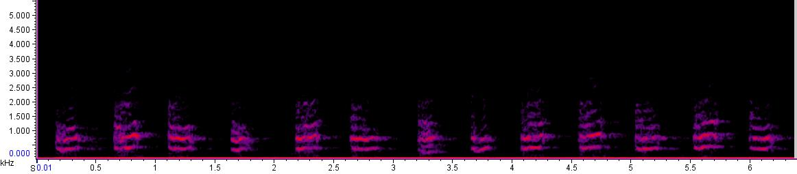

Time (s)

Waveform Graph: Shows pressure fluctuations (y axis) over time (x-axis). The waveform gives you a general idea of how loud or soft a sound is. The loudest part of the sound is at the highest amplitude value.

Amplitude/pressure
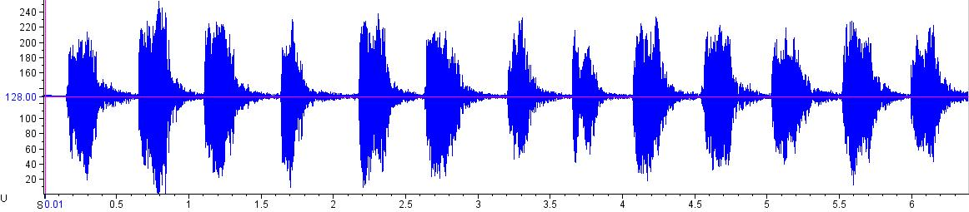
Time (s)

Wavelength: the distance from one crest to the next or one trough to the next (one cycle of a wave), usually measured in meters

Science Education Standards
- NGSS:
  - HS-LS2 Ecosystems: Interactions, Energy, and Dynamics
    - HS-LS2-8. Evaluate the evidence for the role of group behavior on individual and species’ chances to survive and reproduce
  - HS-PS4 Waves and Their Applications in Technologies for Information Transfer
    - HS-PS4-1. Use mathematical representations to support a claim regarding relationships among the frequency, wavelength, and speed of waves traveling in various media.
- CCSS:
  - Physics – Waves
  - Biological/Life Sciences – Ecology
  - Investigation and Experimentation

