Name:________________

Period:_______________

Size Matters:
Understanding the Surface Area-to-Volume Ratio
Ever wonder why cells are so small? Living cells require food, water, and oxygen and must excrete waste. This happens though a process called diffusion, or the movement of molecules across a membrane from an area of high concentration to an area of lower concentration. In the same way, oxygen enters a cell and carbon dioxide exits the cell. Cells are dependent upon diffusion and the surface area must be large enough to expel waste material at a rate to sustain metabolism.

Surface area (SA) is the area of material that would be needed to cover an object (e.g. the amount of wrapping paper to wrap a really expensive gift for your science teacher).
Volume (V) is the amount of space inside an object (e.g. how much water in a mug.
Surface area-to-volume ratio (SA:V) is the proportion of area of a material covering an object to the amount of material inside the object.

Cubes by definition, have 6 sides, each of the same length (length = s).
SA = s² * 6 (# sides) for a cube.
V = s³ or l x w x h (length x width x height, all side length s) for a cube

Calculate the SA, V, and SA:V for each cube:
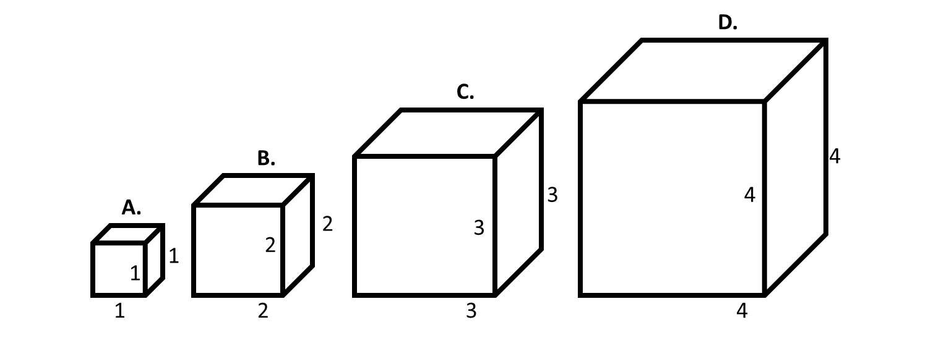

Cube A Cube B Cube C Cube D

SA _______6______ SA ______24_____ SA ______54_____ SA ____96_______

V________1_______ V________8______ V_______27_____ V_____64________

SA:V _____6/1=6___ SA:V ___24/8=3___ SA:V ___54/27=2_ SA:V _96/64=1.5__

What happens to the SA:V ratio as the cube gets larger?

SA:V gets smaller as cube gets larger

Do cells in your body need a high or low surface area to volume ratio? Why?

High SA:Vol because they need to constantly exchange gases, nutrients, waster, etc with the environment surrounding the cell.

If these cubes were cells in your body, which one would have the highest rates of diffusion? Why?

Cube A because it has the largest SA:V ratio

As a cell grows in size, what happens to the volume of its cytoplasm relative to the surface area of its plasma membrane? (hint: is the rate of increase faster of slower?)

Volume increases at a faster rate than the surface area

What is one challenge that a cell might have if it has a large volume of a cytoplasm relative to its surface area?

Ex: Its plasma membrane is too small relative to its volume to absorb the amount of nutrients the growing cell requires or excrete the increasing amount of waste it produces.

