Exit Poll DemoGRAPHics
Collecting, graphing, and interpreting exit poll data

Authors:
Elissa Olimpi, PhD Candidate, ENVS Dept, UC Santa Cruz; Santa Cruz, CA
Jenny Lovell, PhD Candidate, ENVS Dept, UC Santa Cruz; Santa Cruz, CA
Chrissy MacLean, Gov & Econ Teacher, Watsonville High School; Watsonville, CA

Field tested: 11th grade Gov, Watsonville High School, Watsonville, CA (Fall, 2014)

Module Type: Field project and computer graphing exercise

Duration: 4 hrs (two, 2-hr class sessions)

Key materials:
- Computer and projector for teacher
- Printed exit polls, clipboards, and pencils for each pair of students
- Access to computer for each student
- Art supplies and paper for posters

Concepts: Exit Polls, Swing Voters, Demographic Data, Hypothesis Testing, and Interpreting Graphs

Skills: Students will learn how to conduct polls, generate graphical hypotheses, interpret graphs, and create graphs.

NGSS Practices:
1. Asking questions (for science) and defining problems (for engineering)
4. Analyzing and interpreting data
6. Constructing explanations (for science) and designing solutions (for engineering)

Overview:
This module is designed so students can poll voters on Election Day at local voting venues. Students collect data, pool their responses using Google Forms, and explore summary statistics in Google Sheets. Students learn:

- What ballot measures are important to members of their community
- How demographic variables relate to voting preferences in their community
- How to poll the public
- How to generate graphical hypotheses
- How to interpret graphs
- How to create graphs in Google Sheets

Navigate: Background Materials &Time Starting Point Procedures Standards Supplemental
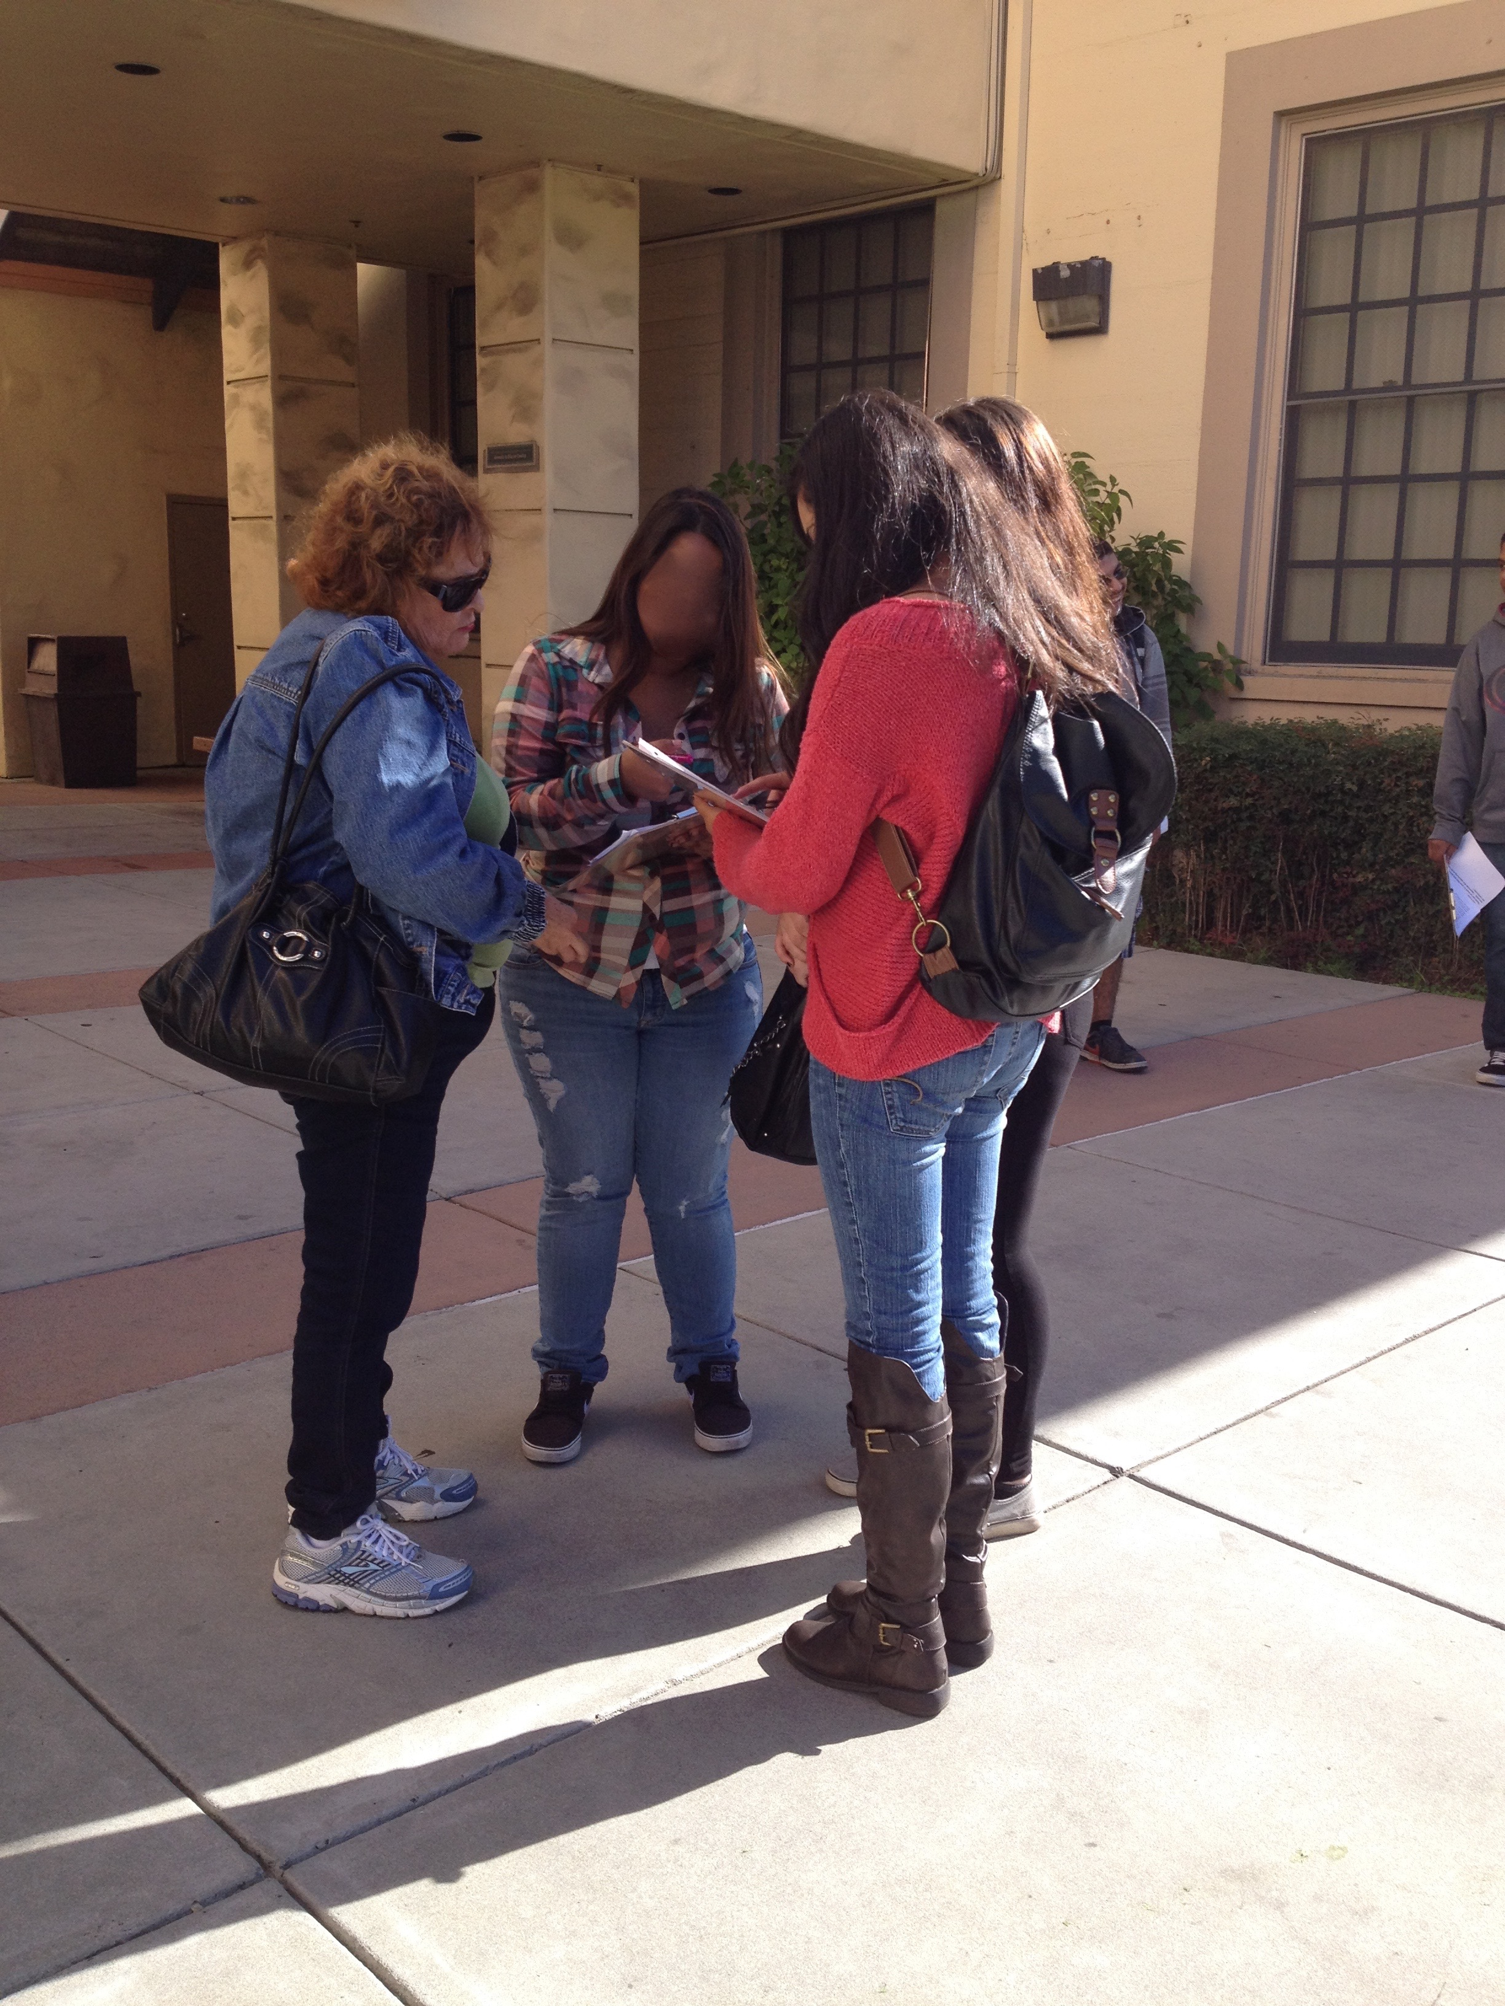
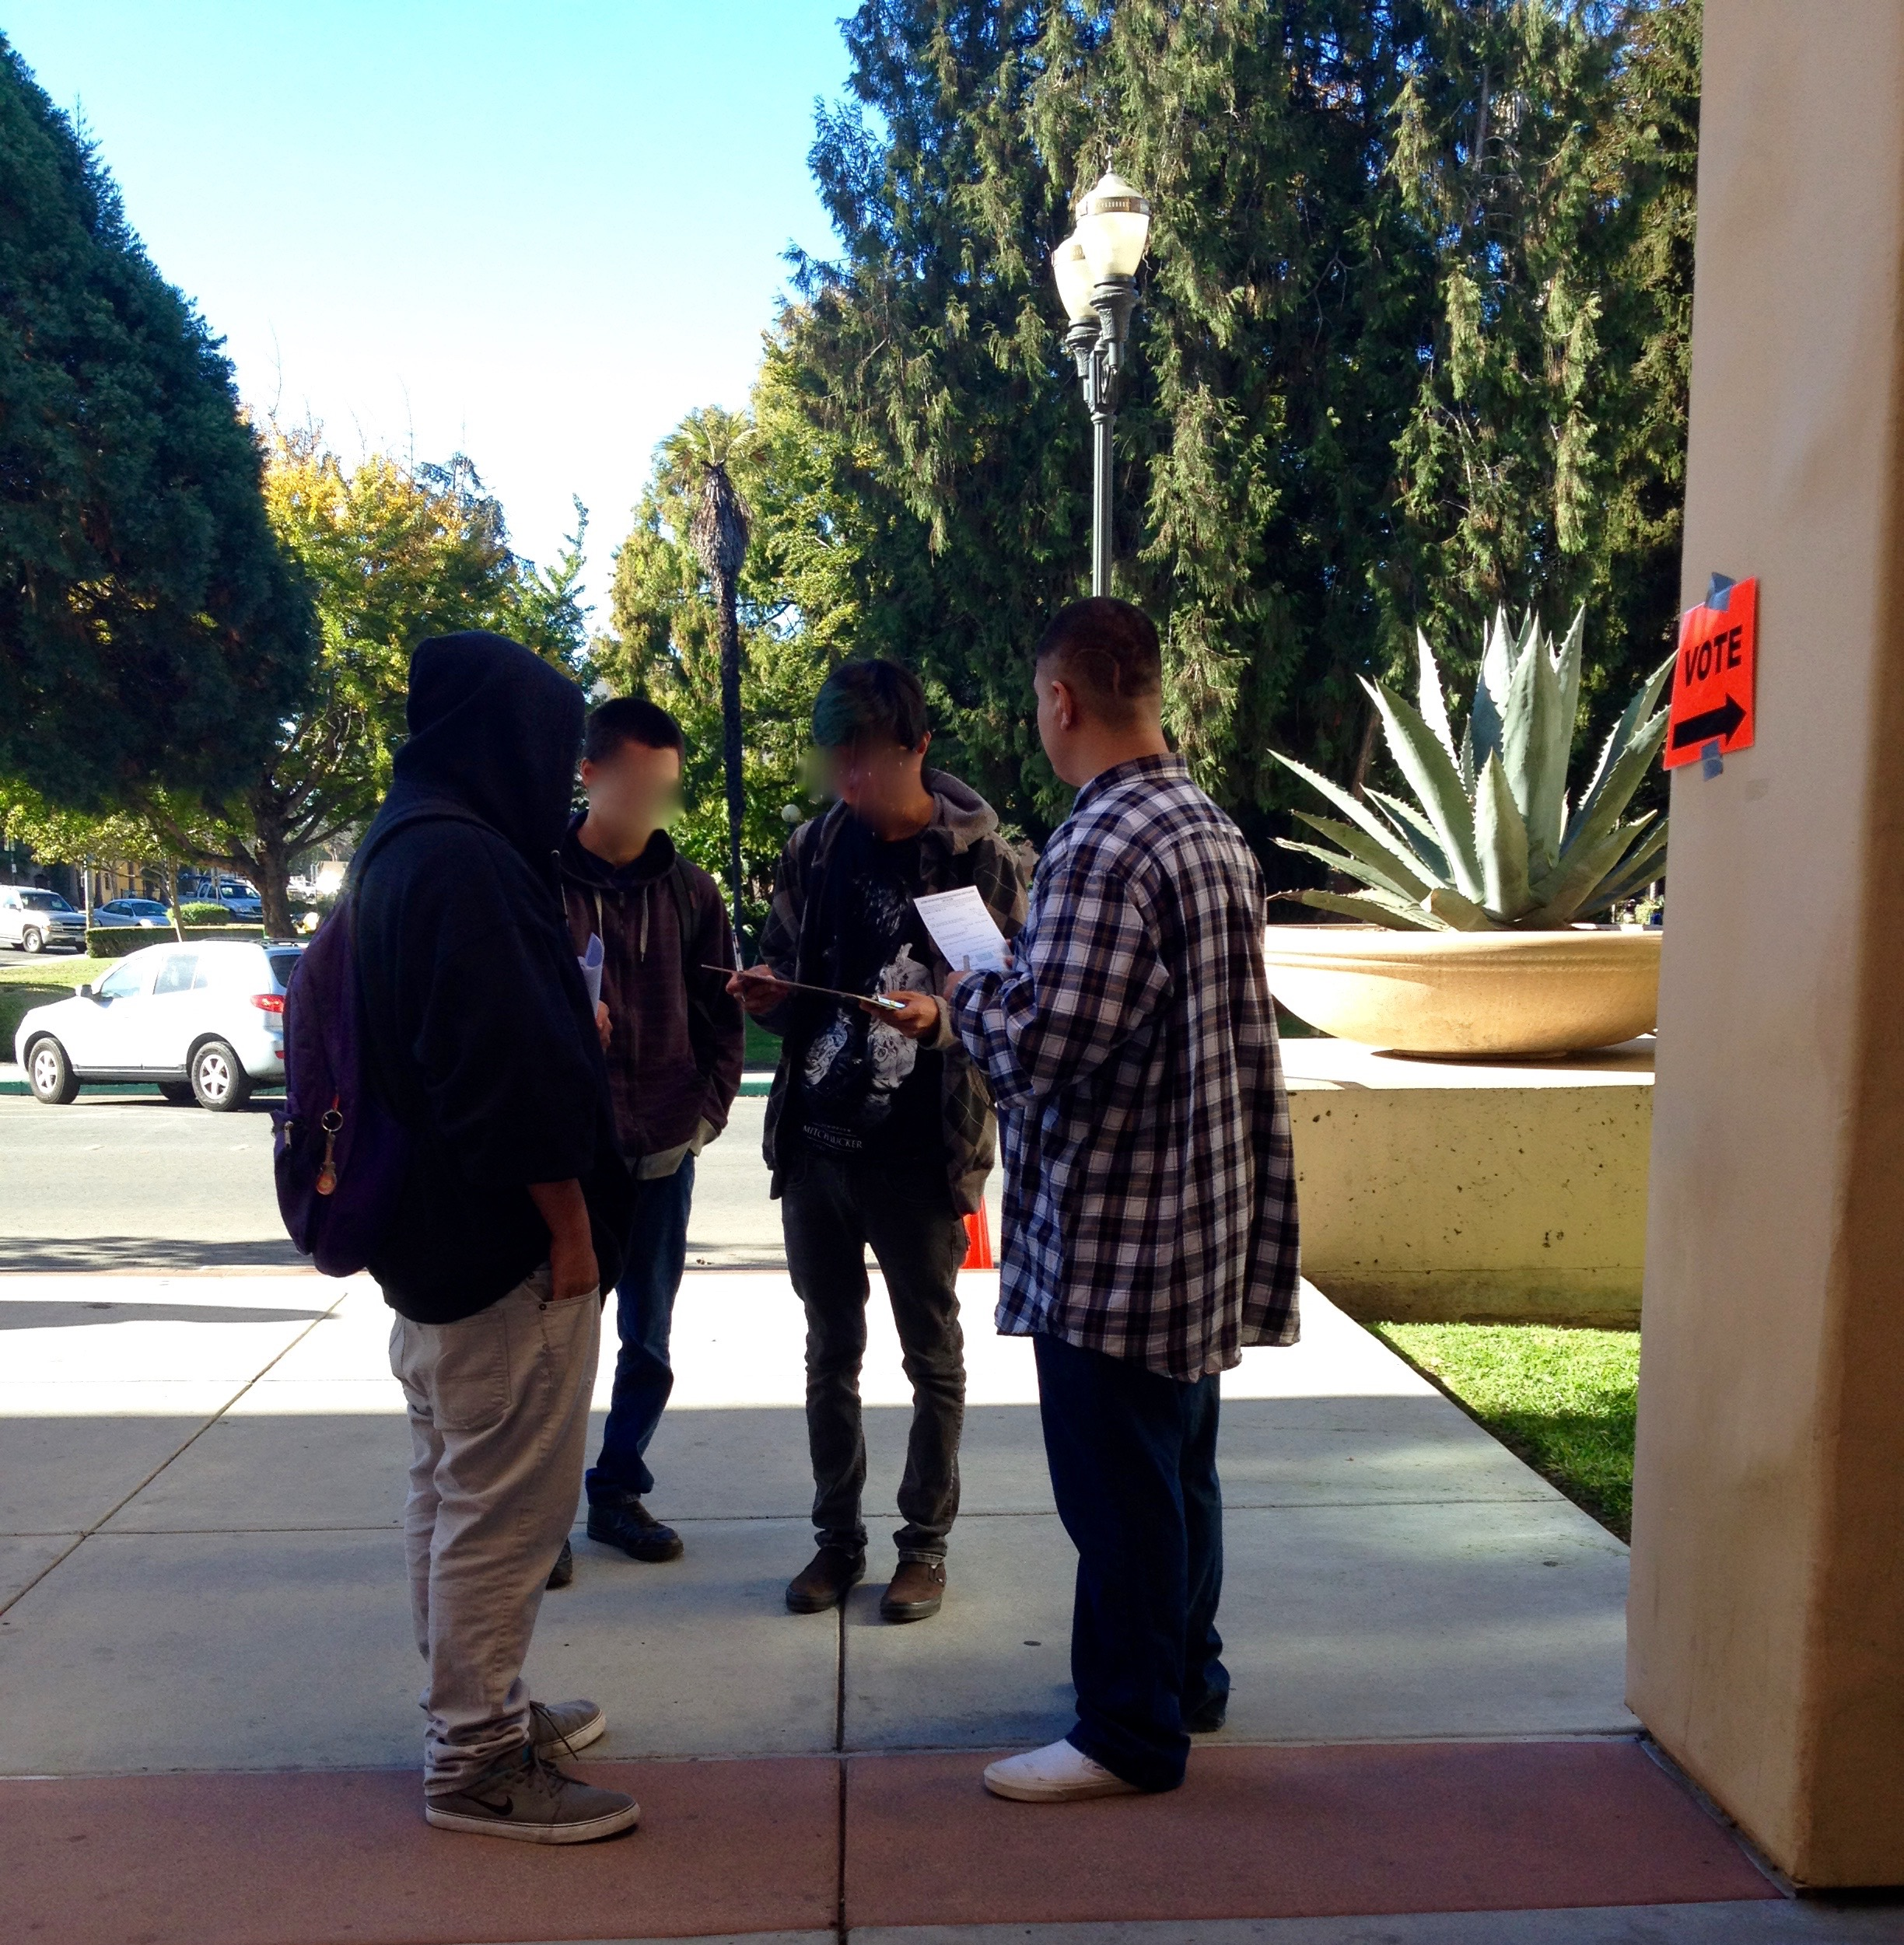

Background for Teachers

Why this matters: This module engages students in a field experiment that puts exit polling to the test. Students interact with fellow citizens and gain first-hand experience about issues of local, state, and national politics. This is a great way to encourage young adults to be participatory citizens, as well as a fun lesson to teach students how to analyze data to test a hypothesis.
Assumed background: Students should have a working knowledge of the major propositions on the ballot. A basic understanding of demographic categories (age, income, nationality, etc.) is also helpful.
Special context: Exit polls are used to determine or predict what people believe, how they feel about something, or in what way they will act. This module is designed to lead students through the process of designing an exit poll to answer a hypothesis about a local, state, or national election. The data they collect can be compiled and analyzed as if the poll were being presented on the news. In this way, students can gain a deep understanding of one part of the process of the legislative process.
Scaffolding supplements: The exit poll video describes the context for the module. It does not include how to form a hypothesis, gather data, or analyze your results.

Module Description

Materials:
- Computer and projector for teacher
- Printed exit polls, clipboards, and pencils for each pair of students
- Access to computers for data entry and analysis for each student
- Art supplies and paper for posters

Preparation:
- Create and print exit poll surveys. See the exit poll form (Olimpi_Poll_form.docx).
- Create a Google Form that matches the exit poll questions (you need a gmail email address to do this). Make sure that you allow users to make multiple entries. Send this link to students and have them enter their data, which will automatically be pooled in a main spreadsheet.
- Print evidence organizers (Olimpi_Poll_organizer.docx) for each student.

Timeline:
Day 1
- Exit poll video & discussion (20 min)
- Ballot measures poster preparation (1 hr)
- Ballot measures gallery walk (30 min)
- Wrap up (10 min)
Day 2
- Introduce activity (15 min)
- Exit poll data collection & travel time (1 hr 45 min)
Day 3
- Enter data into Google Forms (30 min)
- Explore, interpret, and discuss summary statistics (1 hr 30 min)

Starting Point For Inquiry:
Often, polls are used to influence what kind of cars people drive, what people watch on TV, and what kind of food people eat. They can also be used to sway elections. Television coverage that includes exit poll data on Election Day can influence swing voters.
It is important to explain exit polls for the students before starting the hypothesis formation. Key factors for students to think about when watching exit poll data include:

- Who was interviewed? Did the people conducting the poll interview people that represent the group they are making statements about? For example, if you’re trying to find out how people in Watsonville were voting on an issue, but they only interviewed people over 65, that wouldn’t represent all people in Watsonville.

- When was the poll conducted? Polls are meant to reflect how a certain group views a situation at a certain time. Old polls might not apply to current events.

- What were the conditions of the study? The poll has to be open enough to reflect the variety of responses that you could get. For example, if you are asking someone how they might vote on an issue and you only include the answers “yes” or “no,” then they cannot tell you they are undecided.

- Who conducted the poll? You need to feel confident that the person taking the poll is playing by all the rules we just talked about.

Detailed Procedure:
Day 1: Getting to know ballot measures
- Show video to explain the importance of exit polls.
- In the class before Election Day, provide handouts (e.g., from the voter guide) or links to other information on the most important ballots. Divide students into small groups and assign each group a ballot measure. Each group will create a poster for their ballot measure that lists what they perceive to be the pros and cons of the ballot.
- Have students do a gallery walk where one student from the group stays at the poster, and the other group member visit other posters to lean about other ballot measures. Rotate so that students that were presenting their posters get a chance to do the gallery walk. Each student should complete an evidence organizer with points that they see as pros and cons of each measure.

Day 2: Exit polls
- Provide students with printed exit poll forms, clipboards, and pencils.
- Model for students how to politely ask voters to take the survey without harassing voters or biasing results.
- Walk to exit poll venues and have students work in pairs to complete 3-5 surveys.

Day 3: Data analysis & graphing
- Have students use the Google Form that you created to enter exit poll data. When you create your own Google Form, it automatically tracks the number of responses, or exit polls that your students have entered in the Responses tab. In the pull-down menu from the Responses tab, you can select Summary of responses to see basic graphs describing your data. Students will also have the option to view this after they enter data.
- Have students practice interpreting graphs using the summary responses and facilitate a discussion of the results. Alternatively, before students enter data, have them create graphical hypothesis describing the exit poll data.
- After a brief discussion of the summary statistics, have students break into small groups and formulate more specific questions, such as how a specific demographic variable is related to party affiliation or support for a specific ballot measure. Example questions could include: How did Hispanics vote on Prop X? What percentage of people over 60 voted yes on Prop X? What age group supports Prop X the most?
- In small groups, have students generate graphical hypotheses about their question (e.g., have them sketch a graph that answers their question, such as a simple bar graph showing the number of Hispanic voters that voted for and against Prop X). Google provides simple tutorials for making graphs in Google Sheets, and there are also many helpful instructional videos on YouTube.
- Based on time and support available, have groups volunteers to share their question and hypothesis, create a graph to answer their question for them, and discuss as a class. Alternatively, if students have some experience with graphs and/or other instructors are available to help facilitate, have each group create their own graphs, and discuss results as a class.

Assessment Methods:
The poster is the primary assessment method for mastery of the concepts and practices in this lesson. However, other items that the students create will also indicate their understanding and are chances for the instructor to correct the learner’s path. For example, the evidence organizer is used early in the lesson and can help the teacher see if the students are grasping how to create a hypothesis.

Possible pitfalls:
The students may need extra encouragement to interview people in the community. Some students may be shy or inexperienced in talking to adults in a professional manner. It is best to explain the data gathering with encouragement and some sort of system in which group members take turns asking the exit poll questions or approaching voters.

Glossary:
Swing Voter: a person who is undecided regarding how they will vote on a ballot measure or candidate.
Demographic Data: individual information (e.g. income, nationality, gender, age)
Exit Poll Form: survey designed by the class to gather demographic and voting data (example included).
Evidence Organizer: a worksheet used to assist students in brainstorming variables and forming hypotheses (example included).
Poster: the poster is a 3’ x 4’ display of each group’s hypothesis, methods, data, results, and conclusion. The poster is the primary tool used in this module for assessing the student’s learning.
Gallery Walk: the gallery walk includes time periods for each individual member of the group to stand by their poster and introduce their findings to students in the class. If students are in groups of 3, for example, the gallery walk would be broken up into three time periods so that group members could take turns presenting. The other group members would walk around to other posters during this time. The gallery walk is a secondary tool for students to demonstrate their learning by verbally explaining their poster to fellow students and teachers.

NGSS Standards Addressed

Science & Engineering Practices
1. Asking questions (for science) and defining problems (for engineering)
4. Analyzing and interpreting data
6. Constructing explanations (for science) and designing solutions (for engineering)

Guide to supplemental materials

Exit Poll Form (Olimpi_Poll_form.docx)
Use a similar design in creating the exit poll form for your students.

Exit Poll Organizer (Olimpi_Poll_organizer.docx)
Students use this table to take notes on ballot measure posters as they do the gallery walk on Day 1.

Videos
https://www.youtube.com/watch?v=QlLcXcbSZ8Y

