The Cast of the Missing Balances
Suspect List

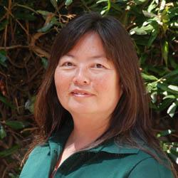
Ms. Q is the chemistry teacher. A believer in vampires, Ms. Q carries salt with her wherever she goes.

Pen found in her backpack: Zebra Zgrip

Mr. Clederman is the integrated science instructor. He is coffee addict and always has instant coffee and packets of sugar with him.

Pen found in his backpack: Bic Round Stic Grip

Ms. Minandro is the marine biology teacher. She is known for her “old school” teaching style, still using chalkboards in the classroom.

Pen found in her purse: Office Max Ballpoint

Mr. Fallaclan is a chemistry teacher. He LOVES seafood, especially oysters, and eats it every day for lunch. To be sure his seafood isn’t bland, he always carries salt with him.

Pen found in his laptop bag: Office Max Ballpoint

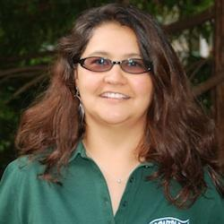
Ms. Jerradora is an engineering and chemistry teacher. She is an avid gardener, often going straight from school to one of her garden plots. She was found with some orchid fertilizer in her bag.

Pen found in her purse: Papermate ballpoint Flex Grip elite

Mr. Jostone is a high school biology teacher. Before he became a teacher, he worked at a hospital. Due to his medical expertise, many teachers come to him for health advice. They say that he uses boric acid for an antiseptic!

Pen found in his wallet: Papermate Gel

Ms. Gardener is a high school anatomy and physiology teacher. She recently conducted a health lab where students were given pure sugar to eat before testing their blood sugar.

Pen found in her car: Papermate ballpoint Flex Grip Elite

Mr. Zuckter is a physics teacher. He has an ant problem in his classroom and has been using boric acid (a known insecticide) to get rid of them!

Pen found in his teaching bag: Zebra Zgrip

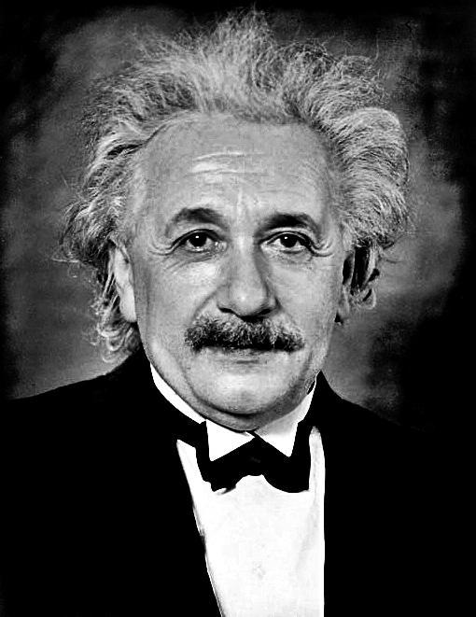
Dr. Feinstein (known in town as “Mad Dr. Feinstein”) is the lead scientist at the Driscoll Berry Laboratory in Watsonville. He always carries fertilizer from the berry field with him. Dr. Feinstein has been known to gamble on the berry crop and may have stolen the balances to pay his debts.

Pen found at the lab: Bic Round Stic Grip

