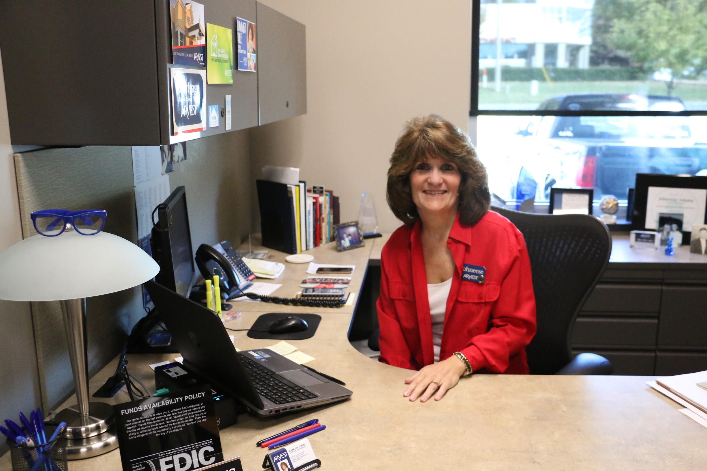
Arvest Mortgage Lender Johneese Adams poses in her office at the Fayetteville Township branch Nov. 11.

I did a quick spot check of the audio and the transcript is incomplete. David asked a number of questions and they are not here. There is material around the 21 minute point of the file that isn’t transcribed. I’m holding off on posting the grade until the transcript is completed; get it done by 5 pm Sunday, Nov 27.

Arvest Interview with Johneese Adams, Mortgage Lender at location at 2389 N. College Ave.

Isabel: First I wanted to ask you a little bit about you. I saw that you’re the senior vice president of mortgage lending. So what does that mean and what do you do every day?

Johneese Adams: Well, the title, I don’t put much stock in titles. It’s more, I’ve been here a really long time. I started at the bank when I was 19. I worked with the bank in bentonville for a while when I was in high school and then I came down here and Arvest has grown. We originated in Bentonville with the Bank of Bentonville in the 1960s. So, um we’ve grown from there of course and we turned into Arvest and we’re part of the Walton conglomeration. We used to be part of the McIlroy bank. I don’t know if any of you are old enough, McIlroy was one of the oldest banks in the state of Arkansas and it was here in Fayetteville. We were owned by the McIlroy family. And then we were purchased by the Walton family in 1986 and became part of the Arvest Group. So very interesting history if ya’ll ever want to Google it. Get out there and find all kinds of information about it but um banking is all I’ve ever known. I started here at the bank as a teller and then I went to work in the credit room. We used to have credit folders on every borrower that we did. It was way before imaging or anything. I’m really not that old. (Muffled under laughter) Before we had imagining we would actually make a credit folder on each borrower as we worked with that borrower we pulled their credit file, make notes, that’s what we did and then put that file back. That’s how we worked on it. Now of course we do everything digitally by email and PDF and everything so but just worked my way up from there and became a consumer lender. Did consumer lending for a while and decided mortgage lending was where my interest truly lied. Started doing mortgage loans back in 19–let’s see–it would’ve been 1989 to 1990. I’ve been doing it ever since. Love it. It’s a great business. If ya’ll ever want a good career it’s a wonderful career.

Isabel: Could you tell us about the types of loans that originate out of Arvest in this branch.

Adams: Sure. We do two different avenues of financing. We kind of break down our financing in secondary market loans which are loans that we can sell to Fannie Mae and Freddie Mac. And then we have loans that are considered our in-house portfolio. Which is money that is just the bank’s money that we loan here and keep internally with Arvest. So we kinda have two different avenues we go. The reason we do that is because we can help more of our customers that way. Um, you may have an unusual property that doesn’t fit necessarily into the secondary market guidelines or you might have a borrower whose financial needs don’t quite meet the secondary market guidelines, and because we have internal programs we can offer them, we’ll work on the bank side to help them versus going through the mortgage company side. So everybody that comes in we kind of look at your special situation. Your specifics as far as your financials and everything. We kind of look at layout options for you and then let you pick the option that you think fits best for what you’re trying to achieve financially.

Isabel: And just to make sure these are home loans, these aren’t commercial loans?

Adams: All home loans. We offer FHA, VA, conventional fixed-rate loans which are like your 30 year and 15 years. Then we’ve got rural development which is a really great program. Rural development means you’re in a population of 25,000 or less so like if you were in Lincoln or Farmington or Elkins, as a first time homebuyer ya’ll would be able to get 100 percent financing. It’s a very opportunistic program um that does have some income limitations to it but the income limitations usually fit you know a lot of first time homebuyers aren’t, they’re not to their highest earning potential yet so it’s a great way for people to get started to buying a house.

Isabel: Of all of those which is the most popular?

Adams: I would say right now in the market that we’re in the most popular program that we have is our conventional financing. And conventional financing they don’t have, they have debt-to-income restrictions as far as standard guidelines that Fannie and Freddie set out, but what that the majority of people fall into that category. You know they can come up with three to five percent down payment which is what that program requires. They have a credit score that is higher than a 620. It also requires that. And they have a debt-to-income of 45 percent of less. So if you kind of fall into those three categories, most people go the conventional route.

Isabel: Are there any popular home loan purposes. So do you see first-time buyers more or refinancing or?

Adams: Yeah. We see a lot. It’s funny our population this year has not been as many first time buyers. We’ve had purchase money market. It’s been a huge purchase money market, but it hasn’t necessarily been first time homebuyers simply because the rates have been historically low in the last 12 months. We’ve had a lot of refinances, which are people who already own their home and they’re just taking the current mortgage they have that’s at a higher rate and refinancing to a lower rate. We’ve seen a ton of that, but the purchase market in Northwest Arkansas has been very strong. It’s not necessarily the first time home buyers market. We are seeing a huge pick up in first-time homebuyers because I think that um younger people now are starting out in higher paying jobs and because of that they’re looking to invest their money faster which encourages them to buy a home faster instead of rent.

Isabel: Who would be in the purchase market who’s not a first-time homebuyer?

Adams: Um you have a lot of people that would be they already own their home and maybe they’re selling it and deciding to buy a new one. So, even though you’re saying, you know, they’re in the purchase market, they’re not a first-time homebuyer because they’ve previously owned a home. So they’re gonna sell the house they live in and move up. A lot of move up in 2016. A lot.

Isabel: Why do you think that it?

Adams: It’s just the low interest rates. When rates are low and the market’s good people take advantage to either go up in size of home, buy better quality of home or make that move. An average homeowner stays in their house anywhere from five to seven years so you have a pretty good turnover every five to seven years. People get tired of their surroundings. Or else they decide now’s a good opportunity, I’ve saved, I’ve saved, I’ve built up a little bit more equity in this property. I can sell it and move into the next property with a little bit more equity. So people do it really regularly.

Isabel: Based on our research, you guys are the biggest lender in this area.

Adams: We are. We love it. We’re so blessed. We’re very thankful for it. Very thankful. We have been, the thing about Arvest is we operate nationally. We’re not just an Arkansas lender even though our roots started here and we’re very ingrained in Arkansas we have kind of a four state footprint where our banks are located, but we also can loan across the United States. I’ve done home loans in, I mean we do Texas, we do New York, we do California, Florida, wherever you want to buy and normally what we see is those people are buying second homes or they’re relocating with companies. You know we’re really blessed to have like Wal-mart, JB Hunt, Tyson. We have a lot of people who bank with us but relocate. So as they relocate we actually help them to buy those next homes. So we are big. We enjoy it. We are blessed because we kind of look at our relationship as a full service relationship with our customer. We don’t want you, I don’t know where you bank at, but when you bank, we want to fully bank you. We want to give you a home loan, we want to be your consumer lender as far as your consumer needs and we want to have your banking relationship and we want to do that anywhere you are here that makes sense for you.

Isabel: Can you give us an idea of who your clientele is in this area and the people you service?

Adams: We have approximately 17,000 households in Arkansas, we have a very large market base in Arkansas. Mortgage wise we are quite large because we do loan all across the nation. A lot of companies to don’t serve loans, Arvest not only makes the loan but we handle the servicing of it. So when you deal with us your loan is handled here locally. So even though we get our money the Fannie Mae and Freddie Mac we handle the servicing rights on that loan. So even though we have sold the loan to them, they are the ones that technically are the vendor behind that loan. We actually take care of the monthly servicing, so when you make your monthly payment, you make your payment to Arvest. So what we did is we kind of
capitalized on that focus , you know we want to service your loan and have all of your full service banking. So we are kind of a one stop shop for everybody. Since we don’t sell our loans off , some companies sell their loans off and don’t retain the servicing , so they don’t retain the relationship with the customer. So that is how we really run to become the biggest bank.

Isabel: Are there any programs or anything that you guys do specifically for low income applicants?

Adams: Yes, definitely, definitely. We have your loan that is an income based program. So you have to meet with a lower income to develop. We also have an addy loan, it's the [American] dream downpayment initiative, and what it is is for people who can’t come up with their closing cost and down payments, as long as they’re within the income limits that go along with that program, we can get help and assistance for them for down payments and closing costs as long as they can qualify debt to income wise we can help them get the loan. So we offer those, ADFA, they have a program, too, the ADFA bond, we have a bond program. And there are income limitations to it, and it also has homebuyer assistance, and we participate in all of those programs. We want to help as many people as we can.

Isabel: One of the things we’ve looked at in class is the large marshallese population here in town, probably located more in springdale, but is there anything specific to that community that you guys do?

Adams: There’s really not. We don’t target a specific demographic in terms of individuals, we want to serve everybody. So when a person comes in what we want to do is look at their personal financial situation and help them determine which route they need to go. Earlier, like I was saying, we lay out examples. You know, when I sit with a customer, the first thing I do is try and get to know them and what they want out of it. You know, do you have a specific payment in mind. And most people have budgeted and know what they can pay monthly. So, it’s really not based upon a demographic of people, it’s everybody. We want to help everybody get to home affordability, and we hope that all the products that we offer are gonna be something that fits one of them in some way. So, there is the home mortgage disclosure act, HMDA, as you were talking about. So what that does is on the basis of our GMI information that we gather on our applications, it’s gonna give you the demographics of people that make their loans, but it doesn’t matter to us. The demographics are really- as far as individual people it’s not what we’re looking at. I look at both of my clients the same when they come in- I want to get to what their target need is, and then create the product around them. Instead of worrying about that person and how I have to develop to a specific group of people. Because, every person’s situation is different. Both of you may come in to see me and I look at your financial pictures and say well, this product fits you, this product fits you, but it may not fit the both of you. So, we kind of hope that we have enough different products that we can make them fit what your needs are.

Isabel: Could you talk a little bit about the factors that go into what’s most important for a home loan applicant? That could be credit, or income…

Adams: Sure. I would say for everybody your biggest picture- I especially tell younger people- is your credit. I mean, it’s so important that you have a workable credit score, and I know this sounds terrible, because most companies have a minimum credit score that they’ll deal with because we have investor guidelines that we have to meet. At arvest, it’s a 620. So, when people say, they might come in and say I don’t have a very good credit score. And I’ll say Tell me what your situation is, let’s review your credit, because even if it doesn’t meet right now, we want to tell you “here are some options of things that you can do to fix your credit, repair your credit. And we also have the CCOA here in fayetteville, I don’t know if y’all have researched them at all, Credit Counseling of Arkansas. Great program for people who can’t necessarily qualify right now, but they look to qualify at a later time. So what we do is review for every customer that comes in, if they don’t meet certain criteria right now-- which, I feel like credit and credit score are two of the biggest factors. Because like I said, you may not have the down payment, but if you want to live in a rural area and you have a great credit score and good income, I can get you qualified in another program where you might not need down payment, or you could get down payment assistance from family, or one of the programs we have with down payment assistance, but as long as you have good credit, that’s kind of where it all starts from. And after credit, we look at income, because we want to see that there's a stability to their income. We have a lot of folks that’ll come in and they work a part time job. Or maybe they’ve worked five or six jobs in a two year period. There’s an instability there, and that’s a hard thing to overcome. So you want to see a stable income, a good credit score, and with those two things we can normally tailor a program or make one of our products, you know, they’ve been designed to help just about everybody.

Isabel: Would you say credit is the largest obstacle for people who can’t get home loans?

Adams: It is, it definitely is. Credit is so big, because, everyone starts young, you know? I remember when I first got credit cards and the first time you ever get problems with credit cards you go-- why did I do this? But once you do it, you learn and you either get stunned and you learn and you get your credit fixed, or you have those habits for a long time. And it’s hard to get over those, it’s hard to get it fixed and back on track. And that’s why programs like CCOA are so important. I’ve met with people, it’s so funny, what’s really gratifying to me is, I’ve met with people a year or two before and said, okay, here’s the plan, here’s how we’re going to fix it. And they’ll come back to see me in twelve months and they’ve done exactly what we said. They’ve repaired their credit, they got their credit score up and they’ve got a good history and we’re off and running getting them a home loan. So, that’s a really big thing for people.

Isabel: I haven’t heard anyone else talk about that, I think that’s so interesting.

Adams: I think that’s one of the reasons, you were asking earlier why arvest is so big. I think it’s because it doesn’t matter who you are or what your circumstances are, I think we help you get to the point where something can happen if you’re willing to take that coaching or information and use it to work on your credit, you come back around and those people are really grateful for our help. We have so many people come in, I had a lady that came in the other day, sweet, sweet lady, I loved her. A little difficult to understand, we were having a little bit of a communication problem, but when we finally did understand each other she was so excited because no one else had told her how to get to CCOA, or a couple of things to improve her credit to get her to where we could work with her, and so I fully expect to see her back in two to three months and we’ll be able to look at her situation and develop that.

Isabel: In addition to referring people to CCOA, what kind of things would you tell them?

Adams: I would talk mainly about, we have a lot of people who are young and don’t have established credit, and I would talk about getting possibly-- I don’t want to say that I encourage credit card debt, but, healthy use of a credit card, you know, get a credit card in your name. Maybe go to eat once a month, or buy something once a month but you pay it off regularly. They have now what’s called “trending credit”, and it’s a very big thing in the credit world now. And what it is, is when you pay off your credit, you have a credit card, let’s say you use it for fifty dollars of the month. You know, go out and eat or something, or have a really nice evening out or whatever and if you pay it off the next month, that looks really positive and it boosts your credit score. Because it shows that you used credit, you payed it off, you knew that there was a debt there that needed to be paid off. And you brought yourself right back down to being even and not owing anything. And when people use trending credit that way, it really promotes a higher credit score. That’s becoming a really big thing. In young people, I would suggest getting a credit card and one other form of credit. You know, if you finance a car you can do what’s called CD secured loans, that’s a certificate of deposit that you create at the bank, you actually put your money into a CD. So let’s say if you had 500 or 1000 dollars and you put it in a CD, you save with that money, but we’re going to loan against it and create a loan. Well, as you’re paying that off, it’s building credit for you. So, between the credit card that you’ve used and the certificate of deposit loan, once you’ve paid that certificate of deposit loan off, which is usually a twelve to eighteen month period, you’ve established a great credit score because you’ve developed different kinds of credit. So, like I said, I don’t encourage credit card debt at all, I mean it has to be used. We’re in a world of credit. And I do have people come in, which I absolutely love, we have a lot of first-time home buyers, again, that don’t have any type of credit, but we help them build what’s called nontraditional credit. So if you have like rented before and you have utilities in your name, as long as you’ve paid those histories as agreed, let’s say you have twenty-four months and you have lived in an apartment you’ve paid rent on time, we can take those credits like your rent and utilities and we can convert those to the credit bureaus as a history that allows us to through FHA. So it’s called non traditional loans credit, were actually building your first credit file and then when we do that and you get your home loan, mortgage is your first great credit. So as you pay your credit and you pay your mortgage on time you’ve built a great credit score. And you are kind of off and running with a good credit history. So there are kind of a few ways we can get people started and we do that a lot here at Arvest. I think that’s a lot of our growth honestly, people know they can get help.

