Home Loan Qualification More Meticulous Than Most Expect
By David Thomas and Isabel Dobrin

The biggest hang-up for first-time loan applicants in Northwest Arkansas is the amount of documents that a firm requires them to submit before sending the application through, a home lender in the area said.

Borrowers are not informed about the process of getting a loan or the requirements needed to get one, said Susan Lipscomb, a sales manager for Wells Fargo in Rogers. Lipscomb meets with applicants who oftentimes don’t understand the extent of the vetting process.

Scrutiny over qualifying for a home loan was buckled down after the 2008 financial crisis, and now it’s “much more of an arduous process for someone who’s trying to get a loan,” Lipscomb said.

As one of only two lenders for Wells Fargo in the Northwest Arkansas area, she now looks more closely at applications, asking for detailed explanations for things like gaps in employment history. Wells Fargo typically asks for 30 days of pay stubs, two months of bank statements and the applicant’s most recent W2 form.

“Some people think we get really personal, wanting to know everything about them,” Lipscomb said.

For her, though, when looking into giving a loan for a large sum of money, it’s essential to know if her applicant has the means to pay it back. In some cases, down payments are allowed to be covered by gifts from others to the applicant.

Lipscomb says in these cases, her firm even needs copies of the donor’s bank statements as well.

Another misconception lenders tend to encounter is applicants’ lack of understanding about how their credit score is figured.
“There’s so much that goes into it,” Lipscomb said.

Credit scores play a key role in the lending process.

“(It) kinda varies a little with loan program, but that’s a big thing,” Lipscomb said. “Not only credit score, but credit patterns, credit history, you know, what’s the likelihood that somebody’s going to repay the loan?”

In 2014, banks denied 35 percent of all home loan applicants based on credit history, according to Home Mortgage Disclosure Act data.

Wells Fargo offers alternative ways of building credit for those applicants with nothing to show on their report. Lipscomb said that bad credit can be better than no credit. Applicants who don’t have credit history can overcome that obstacle if they have a strong history of paying for car insurance, rental properties, or cell phone bills.

The Wells Fargo Home Mortgage office in Rogers, the only one in the area, services about 60 loans a year, Lipscomb said. Sometimes the office’s lone employee, she has passed along around half of the branch’s applications herself. As the only one to get the chance to talk face-to-face with the applicant, Lipscomb said she considers herself an advocate for the borrower.

“Part of what I do is to really present the borrower in the best possible light,” she said. “The underwriter doesn’t get to talk to them or meet them. I get to hear their story and meet them and really get to put a face with the name where they don’t.”
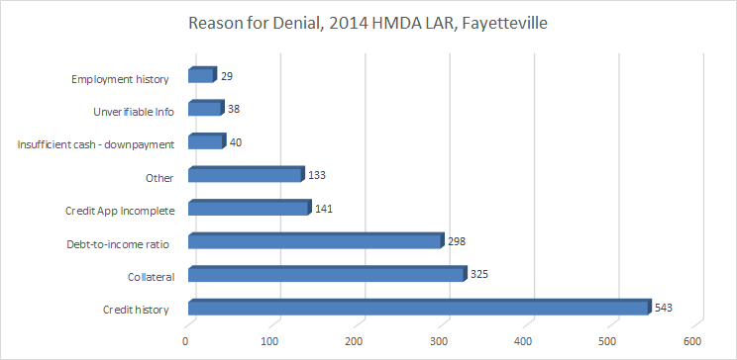
Group work: David wrote the story and made the graphic, Isabel added a couple of graphs and edited for AP style.

