Fayetteville VA SAIL Ratings Discussed

Taylor Klusman

In the span of a year, 2015 to 2016, the Fayetteville VA’s Strategic Analytics for Improvement and Learning (SAIL) rating, a quality rating for veteran health system hospitals, or VAs, increased from two stars to five.

The Little Rock and Shreveport, Louisiana VAs each increased by one star, though Little Rock, the second highest rated of the four, still had only three stars in 2016. The Memphis, Tennessee VA system remained at one star for both years.

Veterans who have been patients at the Fayetteville VA hospital had varying opinions on the service received, though, for the most part, the reactions were positive.

“I’ve been going to the VA for years, so you could say I’ve been there a lot. It’s one of the best VAs in the country,” 60-year-old veteran Rodney Hicks, whose hometown is Fayetteville, said. “I came from Waco, and they have a good one down there, but I like this VA better.”

Survey of Healthcare Experiences of Patients (SHEP) data is incorporated into the SAIL ratings which include veteran perspectives on access quality measures as well as health measures, Melinda Warren, group practice manager of the Fayetteville VA, said.

Hicks is a regular at the hospital due to his medical needs.

“I’m a dialysis patient so between the VA and the outside care they provide, they take good care of me. It was bad back in the day but it’s improved tremendously,” Hicks said.

Hicks credits the high SAIL ratings to this advancement of the facility and care.

“You get seen quicker now. If you have a problem, now they make a call and they’re a little more responsive to your needs. It’s very clean, the pharmacy used to be a nightmare and now they’ve taken care of that and the whole place is just clean and easy to get around,” Hicks said.

Part of keeping up SAIL ratings and the satisfaction of veterans is just stepping up your game and providing better care to the patients, Warren said.

Chuck Adkins, 61, is a veteran and commander for the Military Order of the Purple Heart of Arkansas and a Fayetteville resident.

“My doctor is Dr. Sharma, and I will tell you I love that woman, she is a great doctor, she’s got a good team, she cares, she actually listens to her patients and if it’s something she can’t handle in her area she refers you out to the specialist to get the help you need,” Adkins said.

While the Fayetteville VA seems highly regarded when looking at SAIL ratings, it can be confusing to examine the SHEP scores and find it to be the lowest of the four hospitals.

“SHEP results come from after appointments are completed,” Warren said. “The scores are based on complexity and we’re not as complex as Little Rock.”

Not all veterans felt as though the Fayetteville VA deserved five stars, however, and some may agree more with the Fayetteville VA’s SHEP scores. Derrick Calhoun, president of student veterans at the University of Arkansas and a veteran himself, said that although the Fayetteville VA is one of the better ones due to its central location, he had experienced long wait times during his visits.

Wanda Shull, public affairs manager of the Fayetteville VA, said the wait times have improved.

“Every now and then there’s a measure where there’s only so much we can do, but we’re always working on what we can do to make access better,” said Shull.

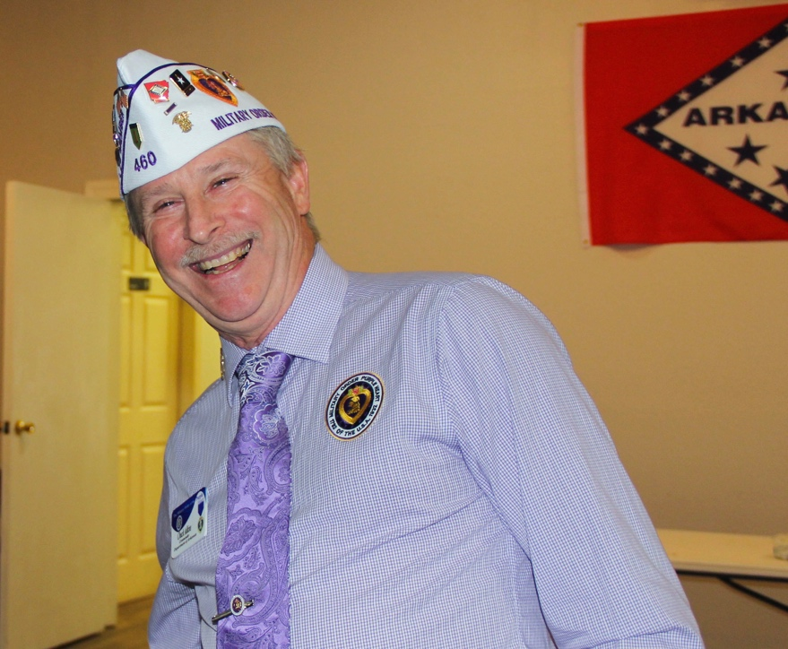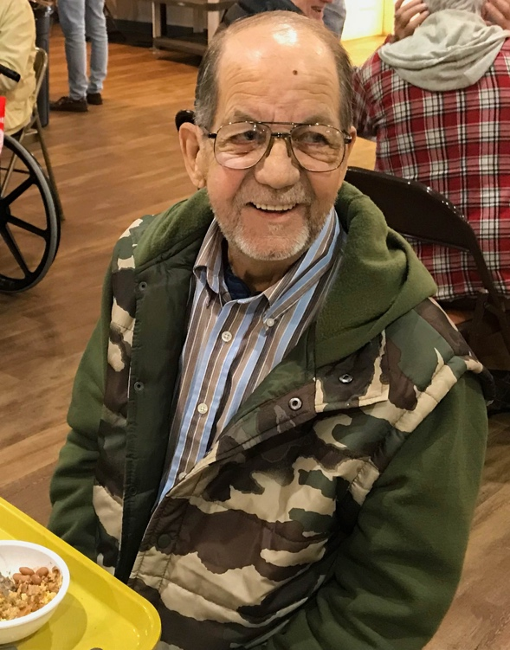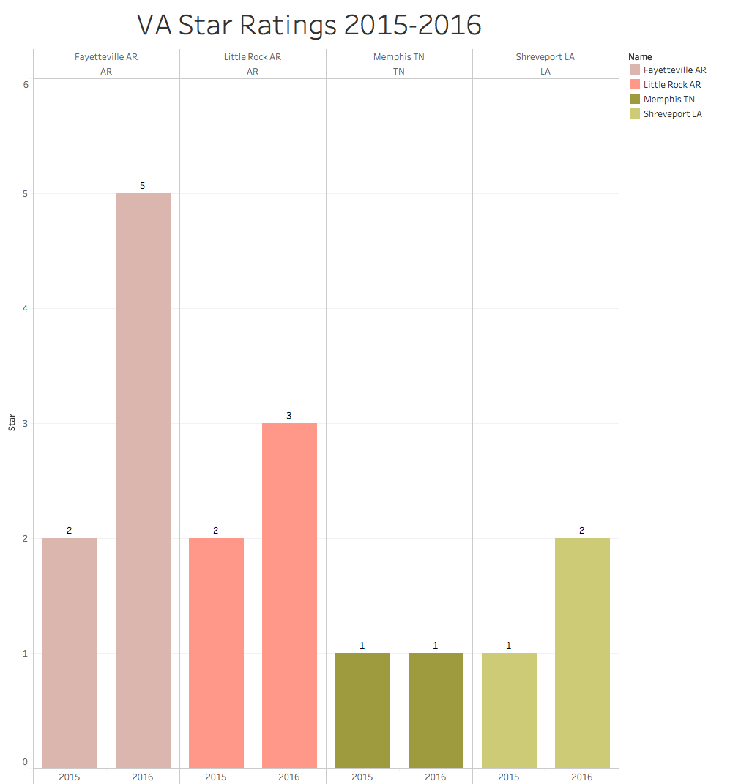

From left to right:

Rodney Hicks, 60, lives at 675 E Frankie Kelly Cir. Apt. 315, Fayetteville, AR, [iq2hi@yahoo.com](mailto:iq2hi@yahoo.com), (479)685-1198

Chuck Adkins, 61, lives at 3055 N Quartz Dr., Fayetteville, AR, [charles.w.adkins.jr@aol.com](mailto:charles.w.adkins.jr@aol.com), (479)263-6772