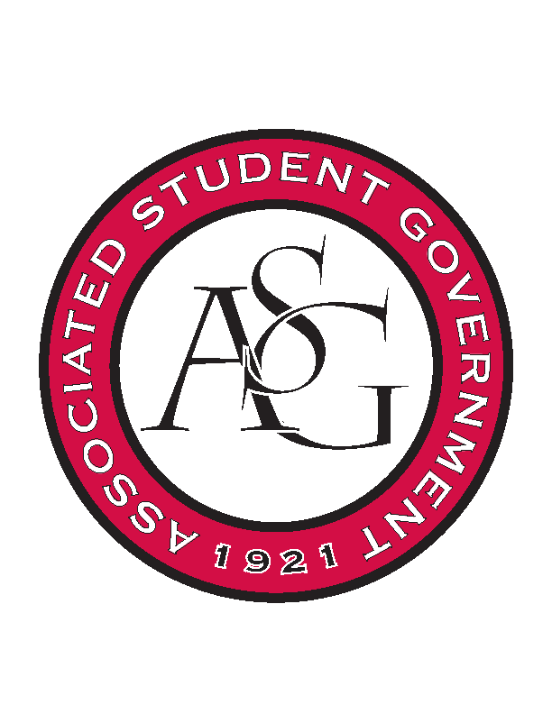
Associated Student Government

Executive Council Meeting

Monday, January 23, 2017 | 10:00 a.m.

- Call To Order
- Roll Call
- Approval of Minutes
- Approval of Agenda
- Special Orders
  - Advisor’s Report
    - Weekly Update
      - Joint Bill going through first reading Senate tomorrow and second reading in GSC on Wednesday
      - Vacancy applications close this week, and general election applications are about to open
  - Office Manager’s Report
    - Budgets
  - Graduate Assistant’s Report
    - Katherine
    - Katie
- Reports and Discussion
  - President’s Report
    - Weekly Update
      - Town and Gown meeting and will bring back any notes and updates from the meeting.
    - Out of Office Tuesday
    - Senior Walk Update
      - Met with Mark Power Thursday of last week, the Campaign Arkansas kickoff will be starting near the end of February. Partnering with SAA to begin raising the student’s portion of the Campaign Arkansas fundraiser.
      - Hoping to have Senior Walk completed by next Fall
    - SEC in DC
      - Will be happening at the end of this month, four students will be going to that.
    - Athletic Budget Surplus
      - Student attendance initiative back on Athletics radar
  - Treasurer’s Report
    - Weekly Update
  - Secretary’s Report
    - Weekly Update
  - GSC Speaker’s Report
    - Weekly Update
  - Chair of the Senate’s Report
    - Weekly Update
  - Chief of Staff’s Report
    - Cabinet
    - RED Talks Diversity on the Feb 24th
  - Chief Justice’s Report
    - Vacancy Apps close on Thursday
    - Exec Apps open on 2/2/17
  - FLF Coordinator’s Report
    - First meeting of the semester is 2/1
    - 4/8 is the BIG Event dodgeball tournament
  - Vice President’s Report
    - Weekly Update
- Announcements
- Adjournment

