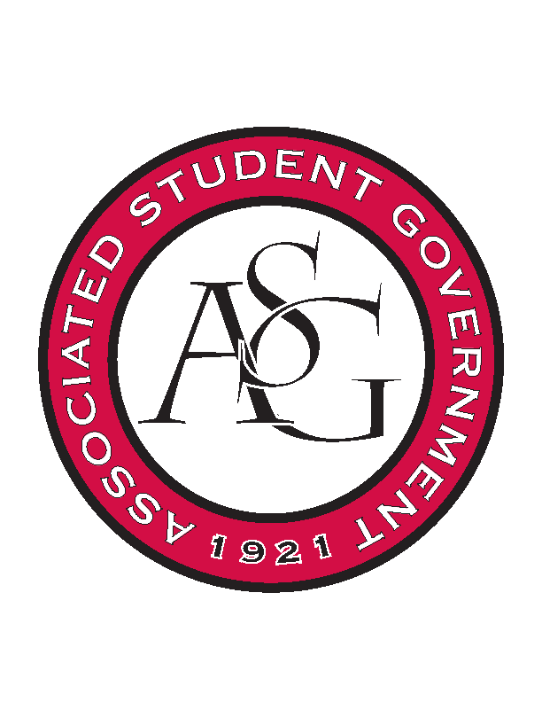
Associated Student Government

Executive Council Meeting

Tuesday, October 11, 2016 | 4:00 p.m.

- Call To Order
- Roll Call
  - Cory, Shelby, Kyle, Connor, Michael, Will, Taylor, Jase
- Approval of Minutes
- Approval of Agenda
- Special Orders
  - Advisor’s Report
    - Weekly Update
      - Good start to the week with deadlines, etc.
      - Please be updating the events calendar. It does not need to be big events, but anything from events throughout the week, meetings, etc.
  - Office Manger’s Report
    - 1st Quarter Budget Reports

    - Out of Office Thursday and Friday
  - Graduate Assistant’s Report
    - Katherine
    - Katie
- Reports and Discussion
  - President’s Report
    - Weekly Update
    - Provost Search
      - Three candidates selected. They will be coming to campus this Thursday and Friday.
      - There will be astudent panel online that we will all need to attend.
      - We should have received an invitation from Chancellor’s office for a sit down with these candidates.
      - Sheryl Tucker,
    - Athletics Town Hall for Students
      - Pushed back another week to October 26th
      - 6-7:30PM
    - Ole Miss Student Seating
      - Upper deck for student section will be closed off for this game.
      - You can buy guest passes for up to four people for $10 for this game
    - Homecoming Feedback
      - Much more representive of the student body, but there are still areas that we need to be looked at and revisited.
      - Sitting down with Dr. Robinson to talk about how that process went
    - It’s On Us Week
    - Haven
      - All Exec members need to get this completed
      - Work with the It’s On Us week
      - Eventually have all ASG to have completed it by the It’s On Us week so that we can go and challenge other organizations
      - Look into a goal meter on website of how many members have completed Haven
      - Use the kickoff of that week as the goal of ASG to have the entire organization completing it.
      - This will be talked about tonight at All Call and send out email to ASG listserv
    - Marketing Banners
      - SAA uses banners hanging around campus
      - We should look into this for events like Health Week and Sexual Assault Awareness/Prevention
    - PAB Funding Requests
  - Treasurer’s Report
    - Weekly Update
      - Getting a better idea of who in ASG is going to need funding
  - Secretary’s Report
    - Weekly Update
    - Homecoming Photographer
      - Look into Spirit Squad marketing. Talk to Taylor about
  - GSC Speaker’s Report
    - Weekly Update
  - Chair of the Senate’s Report
    - Weekly Update
      - Holding a legislative workshop tonight in Senate
  - Chief of Staff’s Report
    - Cabinet
      - Will have cabinet report updates to everyone by Friday
    - Health Week
      - 24th-28th
    - SAAPD
      - 31st-4th
    - BHO
      - 27th there is a career fair that Boss Hog Outfitters will be at
      - Considering putting in a request for more inventory, cost estimated based on GA Tech’s program
      - Want to make sure that the student’s do not look outdated and there is a quality standard of the inventory
    - Multimedia
      - There had not been applicants by last week
      - Make sure to encourage friends to do it
    - Calendars
    - Member of the Month T-shirts
    - Line Items
      - Motion to move remainder of line 2 to line 29
        - Aye- unanimous
      - Motion to move $61.45 from line 5 to line 29
        - Aye- unanimous
      - Motion to move $376.54 from unallocated programming budget to Line 28
        - Aye- unanimous
      - Motion to move line 10 to line 9
        - Aye- unanimous
  - Chief Justice’s Report
    - Homecoming elections going very well
    - About 2600 votes have been casted
  - FLF Coordinator’s Report
    - Fresh HOGS will be tabling at It’s On Us and Health Week
    - We have received an email with our peer mentees
  - Vice President’s Report
    - Weekly Update
      - There is a homecoming pep rally this Friday where Court will be recognized
      - Winner will be announced at halftime of the Ole Miss game
- Announcements
  - At 5:30 there is a talk about cyber security
  - Soccer coach is coming to speak
  - 5:45 UREC is coming to speak about the advancement of UREC facilities on campus
- Adjournment

