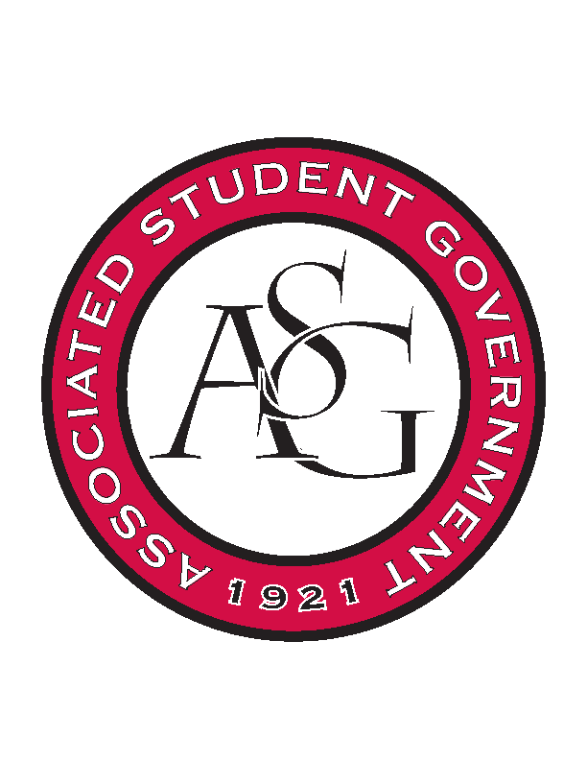
Associated Student Government

Executive Council Meeting

Tuesday, October 25, 2016 | 4:00 p.m.

- Call To Order
- Roll Call
- Approval of Minutes
- Approval of Agenda
- Special Orders
  - Advisor’s Report
    - Weekly Update
  - Office Manager’s Report
    - Weekly Update
  - Graduate Assistant’s Report
    - Katherine
    - Katie
- Reports and Discussion
  - President’s Report
    - Weekly Update
    - Exec Meeting Times
    - Provost Candidate Feedback
  - Treasurer’s Report
    - Weekly Update
    - OFA Standing Rules
      - To be presented to Senate tomorrow
  - Secretary’s Report
    - Weekly Update
  - GSC Speaker’s Report
    - Weekly Update
  - Chair of the Senate’s Report
    - Weekly Update
  - Chief of Staff’s Report
    - Triston Locke
    - All Call
      - November 16th
    - Cabinet Updates
  - Chief Justice’s Report
  - FLF Coordinator’s Report
  - Vice President’s Report
    - Weekly Update
- Announcements
- Adjournment

