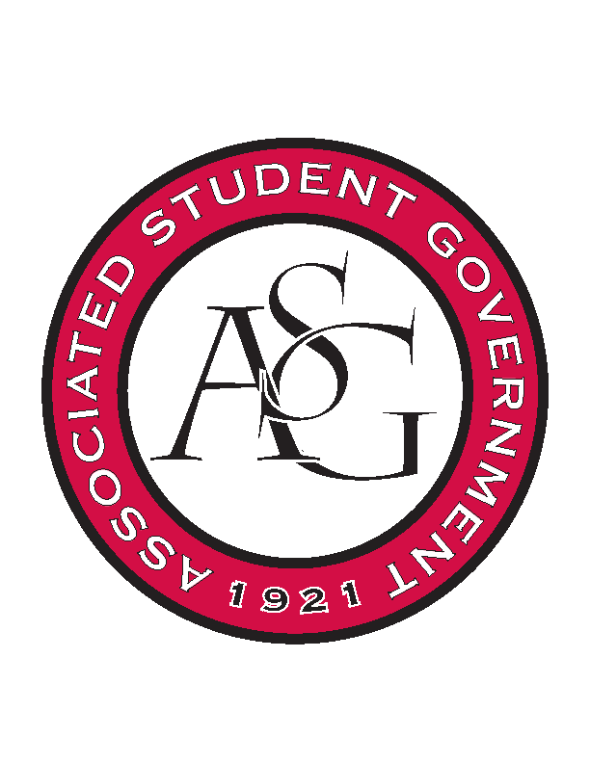
Associated Student Government

Executive Council Meeting

Tuesday, October 4th, 2016 | 4:00 p.m.

- Call To Order
- Roll Call
  - Connor, Scout, Cory, Shelby, Michael, Jody, Kyle, Taylor, Will, Jase
- Approval of Minutes
- Approval of Agenda
- Special Orders
  - Advisor’s Report
    - Weekly Update
      - Tough time meeting deadlines, leeway is kind of over
      - Next week, looking through November no exceptions for missed deadlines
      - Begin to work ahead on events if you feel caught up
    - Rollin with the Razorbacks
      - Michael will be emailing to confirm spot later in the week
  - Office Manager’s Report
    - Budget Update
      - When a budget is approved there can be no more changes to that budget
      - Ms. Jody will walk anyone through the budget process if there is any questions
  - Graduate Assistant’s Report
    - Katherine
    - Katie
- Reports and Discussion
  - President’s Report
    - Weekly Update
    - PAB Funding
      - Will be presenting funding allocations to the Chancellor to be approved
      - If you have an upcoming event that might be underfunded or you have another idea, bring it to our attention because there are still opportunities to receive more funding from PAB.
    - Provost Search Committee
      - Scout and Connor went this morning, the committee has given the final selections to the Chancellor
      - Next week the candidates will be invited to campus and made public
    - Athletics Town Hall for Students
      - Going to be two weeks from tomorrow
    - Student Camping
      - Not happening for the Alabama game, keep in mind pending this Saturday’s outcome it is not out of question for future games
      - Students cannot camp if Division of student Affairs is not organizing it
    - Chancellor’s Ball
      - Make sure this is a top priority for the rest of the week
      - Be there, let Maggie or Jase know today. Sign up on a google doc with five guests.
  - Treasurer’s Report
    - Weekly Update
    - Student ID phone app
      - Student poll might include question about a digital ID card
  - Secretary’s Report
    - Weekly Update
    - Teal Talk, Stick or Treat
  - GSC Speaker’s Report
    - Weekly Update
    - GSC Cabinet Next week
      - Monday 3:30- Location TBD
    - Committee for inclusivity
      - Issues of race, inclusion, making campus more comfortable for all U of A students
      - Any member of ASG can sit on this committee
    - Upcoming schedule
      - First week of November, Scout will be flying to NY through Sunday 6th
      - Will be checking email but not overly available through the 18th
    - Review Code and Constitution
      - “Hot mess” not updated since 2014. A lot of typos and pieces missing
      - Was talked about a lot last year but nothing was ever done.
  - Chair of the Senate’s Report
    - Weekly Update
      - If you’re working on something within Senate then let Will know
  - Chief of Staff’s Report
    - Cabinet
      - Thursday, Oct 6th- Tommy Norman is coming to speak over positive policing
    - Hog out the Vote
      - 470ish students are registered to vote through Hog out the Vote
    - Committee applications
      - Reopening soon
    - Pause and Unwind
      - Will be out in the Union Mall
      - $1 to play with little pups. Working with CAPS on this.
    - Nominations for member of the month
      - August/Summer
        - Taylor- Ryann Alonso
          - Aye- Unanimous
        - Will- Trevor Villines
        - Shelby- Spencer Bone
        - Scout- Arley Ward
        - Kyle- Triston Cross
      - September
        - Cory- Julianna Tidwell
        - Maggie- Jessie Loechler
          - Aye- unanimous
        - Taylor- Alex Smith
        - Will- JP Gairhan
        - Shelby- Pierce Phillips
        - Scout- Jessie Sims
        - Connor- Raygan Sylvester
        - Kyle- Kianna Sarvestani
    - motion to move $734 from line item 2 (All ASG Retreat) to line item 29 (Cabinet Expense Budget)
      - passed unanimously
    - motion to move $265.81 from line item 1 to line item 29 (Cabinet Expense Budget)
      - passed unanimously
  - Chief Justice’s Report
  - FLF Coordinator’s Report

  - Vice President’s Report
    - Weekly Update
- Announcements
- Adjournment

