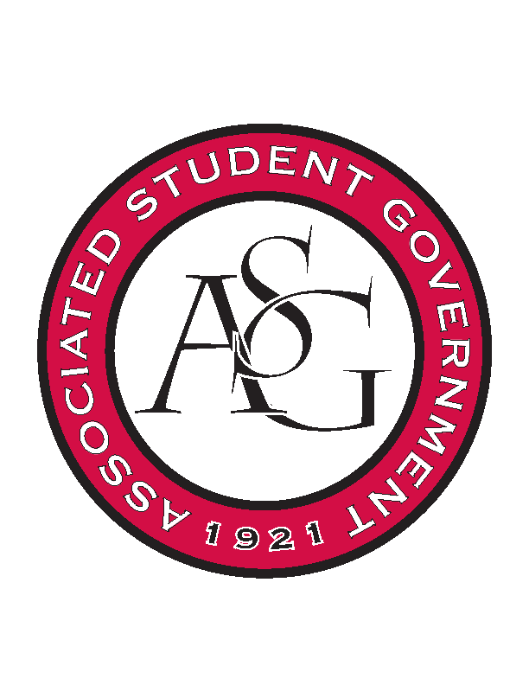
Associated Student Government

Executive Council Meeting

Tuesday, November 1, 2016 | 4:00 p.m.

- Call To Order
- Roll Call
  - Connor, Cory, Shelby, Arley, Kyle, Katie, Michael, Taylor, Ms. Jody, Jase
- Approval of Minutes
- Approval of Agenda
- Special Orders
  - Advisor’s Report
    - Weekly Update
    - Out of Office: Monday 11/14-Thursday 11/17
    - Reminder: Arley Ward (asggcvs@uark.edu) is the primary contact for GSC related matters until Scout returns from to full GSC Speaker responsibilities upon the completion of her written comps after the Thanksgiving Break.
  - Office Manager’s Report
    - Weekly Update
    - VIP Card
      - Challenge the Exec to reach out to other groups within ASG and use the VIP card with them. Take advantage of having this money, but do not take advantage of it. Office hours are what interdepartmental meetings are for.
    - Housekeeping
      - We are Hogs, but we have been pigs.
      - Common area has been very cluttered through the week.
      - Take care of the little things, when we finish up an event a big part of that event is cleaning up afterwards
      - When doing an event with food or something that can stain the tablecloths, use the red one instead of the nice white ones to avoid having to getting them cleaned all the time.
      - Needs to get in contact with Ryann about the voting day shuttles.
      - Plan to be out of the office Friday of this week.
  - Graduate Assistant’s Report
    - Katherine
    - Katie
- Reports and Discussion
  - President’s Report
    - Weekly Update
      - Talked to Will, an organization on campus scheduled an event for every Tuesday already for Senate. On the search for a room on Tuesday nights of next semester.
      - Second semester exec meetings for now are scheduled for Mondays at 10AM.
    - SEC Nation
      - A tweet going out after this meeting, a competition with SEC Nation and whatever organization gets the most retweets will get a certain number of backstage passes to the show.
      - ASG also has a skybox for this week at the Florida game.
      - If a non-University student would like to sit in the skybox we must get the name, and for students it would be good to get the email address.
        - Make separate emails for the sky box ticket information in the SEC Nation email
    - Over the Hill
      - About that time in the semester where we begin to work on some of initiatives with events beginning to slow down.
    - Future Goals and Priorities
    - Over-programming
      - We do not need to have events every day whenever ASG is hosting something. Students are over programmed
    - Senior Walk Postponed
    - Provost Search
      - Has made our recommendations to the Chancellor about the provost candidate.
  - Treasurer’s Report
    - Weekly Update
      - People have been upset with the misunderstanding on funding application due dates because of Thanksgiving break
      - PAB is on Sunday
  - Secretary’s Report
    - Weekly Update
      - Use RED Talk logo for Teal Talk logo, create a Facebook event
      - Veterans initiative, ask KK to make a Green Light the Hill. Incorporate Fayetteville into it.

  - GSC Speaker’s Report
    - Weekly Update
    - Joint Resolution II for Life Event Leave
      - Has voted to send to faculty senate and is requesting that a resolution is written
  - Chair of the Senate’s Report
    - Weekly Update
  - Chief of Staff’s Report
    - Cabinet
    - All Call is November 16th
    - Last RED Talk is in December
  - Chief Justice’s Report
    - Election commissioner application coming out in the next day or two
  - FLF Coordinator Report
    - Weekly Update
      - Will be doing a sand volleyball tournament benefitting Northwest Arkansas Children’s House
      - November 30th, all of Exec is invited to mentor social from 5-6:30.
      - Will be looking for a new meeting space because of space conflicts
      - One of Kyle’s staff will be getting a job next semester and will be searching to fill that vacancy.
  - Vice President Report
    - Weekly Update
    - End of the Year Party
      - Tuesday, Dec 6th (Week before finals)
      - November 29th is other option
- Announcements
- Adjournment

