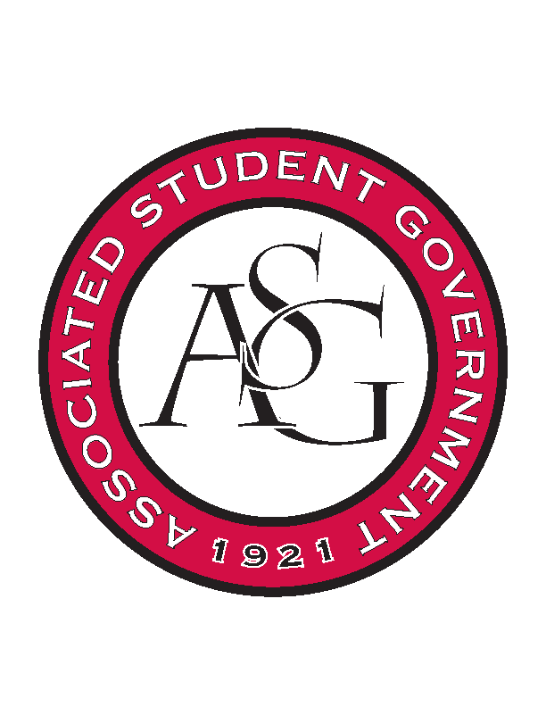
Associated Student Government

Executive Council Meeting

Tuesday, November 29, 2016 | 4:00 p.m.

- Call To Order
- Roll Call
- Approval of Minutes
- Approval of Agenda
- Special Orders
  - Advisor’s Report
    - Weekly Update
    - ASG brunch at Ms. Jody’s
      - Saturday 12/3
      - 9AM
      - Directions to come in email
  - Office Manager’s Report
    - Weekly Update
  - Graduate Assistant’s Report
    - Katherine
      - Interview Prep Workshop
        - February 22nd
        - Offered to all ASG members
        - To be able to communicate in an interview what you do on ASG
    - Katie
- Reports and Discussion
  - President’s Report
    - Weekly Update
  - Treasurer’s Report
    - Weekly Update
    - OFA Proxy applications
      - Due December 5th at noon
    - Campaign finance reform legislation
  - Secretary’s Report
    - Weekly Update
  - GSC Speaker’s Report
    - Weekly Update
  - Chair of the Senate’s Report
    - Weekly Update
  - Chief of Staff’s Report
    - Triston Locke
  - Chief Justice’s Report
  - FLF Coordinator’s Report
  - Vice President’s Report
    - Weekly Update
- Announcements
- Adjournment

