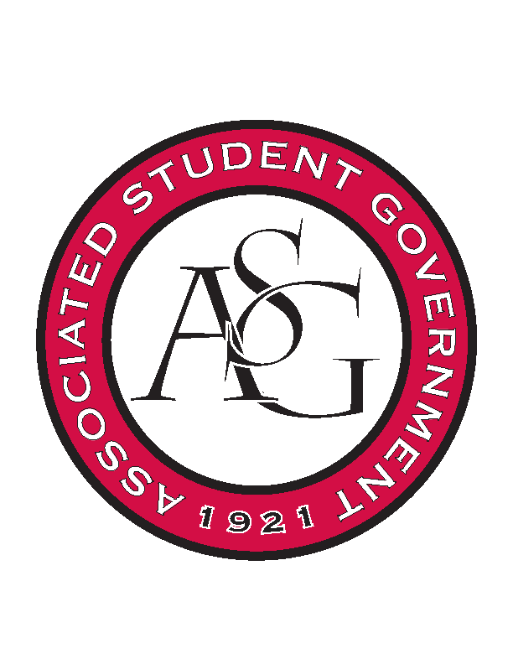
Associated Student Government

Executive Council Meeting

Monday, February 13, 2017 | 10:00 a.m.

- Call To Order
- Roll Call
- Approval of Minutes
- Approval of Agenda
- Special Orders
  - Advisor’s Report
    - Weekly Update
      - Make sure to meet deadlines and be diligent while communicating to your branches.
      - Drink water
    - OSA Day Tabling
      - A lot of promo to be handed out, plugging for Senate, general, and GSC positions that close the next day.
    - HogSync and ASG
      - On track and likely to streamline a lot of usual processes
    - Friday office hours
      - Both Ms. Jody and Michael will be out of the office Friday afternoon
  - Office Manager’s Report
    - Weekly Update
    - Tues, Thurs, Friday will be in about 9AM.
    - Budgets are up to date
    - Motion to move progCost68 $250 from Judicial unallocated to town hall debates, passed unanimously.
    - Motion to move progCost65 $250 from Unallocated to special events, passed unanimously.
  - Graduate Assistant’s Report
    - Katherine
    - Katie
    - Amber
- Reports and Discussion
  - President’s Report
    - Weekly Update
    - Will Doerhoff
      - Would like to do an event in the Union to honor Will and for awareness
    - Senior Walk
      - Students filmed that on Friday and will be finished by next week
    - Student Poll
      - Going to try and limit the student poll to about 30-40 to get more feedback
  - Vice President’s Report
    - Weekly Update
  - Treasurer’s Report
    - Weekly Update
  - Secretary’s Report
    - Weekly Update
  - GSC Speaker’s Report
    - Weekly Update
  - Chair of the Senate’s Report
    - Weekly Update
    - Plan to table all business that is not going to be voted on to go to referendum
  - Chief of Staff’s Report
  - Chief Justice’s Report
    - Runoff election has ended
    - Candidate orientation session on Wednesday
    - Applications close on Thursday
  - FLF Coordinator’s Report
    - Community Service event changed to April 1st
- Announcements
- Adjournment

