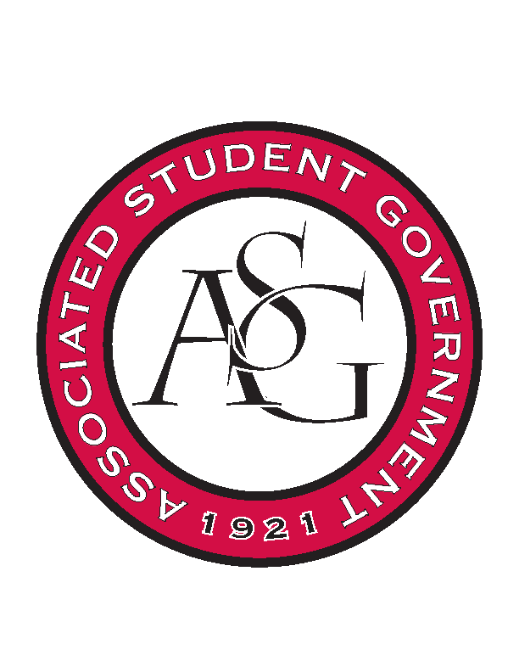
Associated Student Government

Executive Council Meeting

Monday, February 27th, 2017 | 10:00 a.m.

- Call To Order
- Roll Call
- Approval of Minutes
- Approval of Agenda
- Special Orders
  - Advisor’s Report
    - Weekly Update
    - Likely out Friday and next Monday
  - Office Manager’s Report
    - Reminder that spring break does not count for five days, to keep in mind when turning in paperwork to Ms. Jody
  - Graduate Assistant’s Report
    - Katherine
      - Interview Prep Workshop
        - This Wednesday! From 12-1:30 in 504.
          - Listserv today
    - Katie
    - Amber
      - Involvement Fair
        - Have spent the rest of the Fall budget
- Reports and Discussion
  - President’s Report
    - Weekly Update
    - Will not be here on Wednesday. Or the following M,T,Wed.
    - JB4 email
      - Apologize for information in the Traveler
    - Senior Walk Fundraiser
      - Campaign kicks off the same day as exec elections.
    - Student Poll
      - Once a draft is made up of questions, they’ll be brought to exec for revisions.
    - Scooter Awareness Campaign
      - Begins roughly around the 27th
  - Vice President’s Report
    - Weekly Update
    - FAB
      - Monday the 13th applications due at noon
  - Treasurer’s Report
    - Weekly Update
    - Will be out of office the week before Spring Break
  - Secretary’s Report
    - Weekly Update
    - Election Promo
    - Tournament Update
    - Brownie
  - GSC Speaker’s Report
    - Weekly Update
    - JB 5,6
      - Both passed unanimously in Cabinet meeting. Tabled because there was not an author present.
  - Chair of the Senate’s Report
    - Weekly Update
    - This week’s Agenda includes Senate Bill 7, JR6, JR8
  - Chief of Staff’s Report
    - Old Main Oath
      - Would like to see if incorporated across campus. Sending memos to professors and Deans.
    - Boss Hog Outfitters
      - Looking for ways to create space in the Union for a physical room
    - Scooter Safety Week
      - Leads up to the Pangburn Golf Tournament
      - Working on a shirt design and orders
    - Safe Ride
    - RED Talks Thursday the 20th
  - Chief Justice’s Report
    - Busy couple of weeks for Cory
    - Debate Questions
      - Give Cory ideas that are applicable to your position
    - Two tickets are running
    - Three Debates are next week
  - FLF Coordinator’s Report
    - Senate simulation last week
    - Promotions for BIG Event coming after elections
- Announcements
- Adjournment

