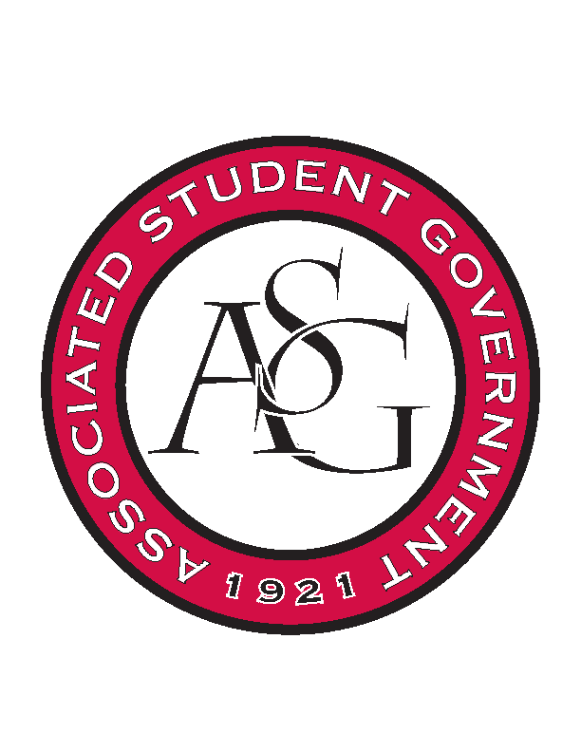
Associated Student Government

Executive Council Meeting

Monday, February 27th, 2017 | 10:00 a.m.

- Call To Order
- Roll Call
- Approval of Minutes
- Approval of Agenda
- Special Orders
  - Advisor’s Report
    - Weekly Update
  - Office Manager’s Report
  - Graduate Assistant’s Report
    - Katherine
    - Katie
    - Amber
      - GA Interview day last week, interviewed for new Graduate Assistants
      - Involvement Fair went great
- Reports and Discussion
  - Treasurer’s Report
    - Weekly Update
    - Connor and Maggie in DC
    - OFA Standing Rules
      - Will be redoing them March 9th
  - Secretary’s Report
    - Weekly Update
    - Will not be able to come to the debate on Wednesday
  - GSC Speaker’s Report
    - Weekly Update
    - Passed JB 7 electronically, must get in the Traveler twice to go to referendum
    - There will be another GSC Vacancy Election to get new members in before last meeting of the year
  - Chair of the Senate’s Report
    - Weekly Update
  - Chief of Staff’s Report
    - Letter Writing Campaign, Triston Cross
      - Thursday 12-3 in Connections Lounge
        - There is a graphic for it. Yay!
      - Scooter Safety
        - Week after Spring break, backup- April 4th
        - 11:30-1:30 on the Union Mall
    - Out of Darkness Walk
      - Probably not going to happen
    - Safe Ride
      - Meeting Wednesday at 11 about Safe Ride rebranding
    - Google Doc to come from Sarah Keuter
  - Chief Justice’s Report
    - Debates are this week
    - Campaigning started at 9 today
  - FLF Coordinator’s Report
- Announcements
- Adjournment

