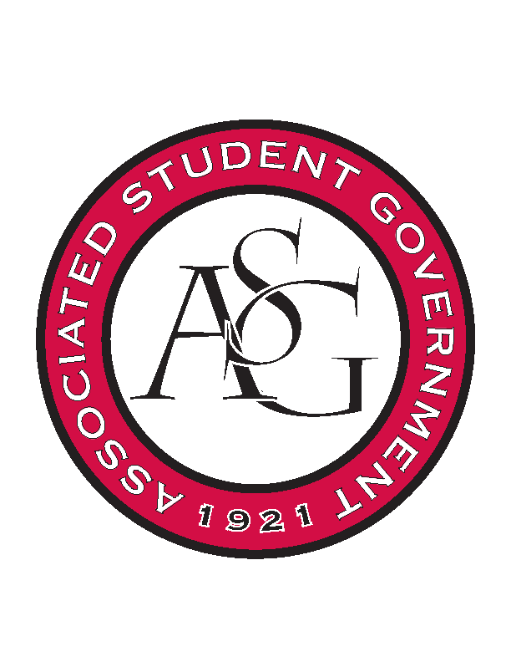
Associated Student Government

Executive Council Minutes

Monday, February 6, 2017 | 10:00 a.m.

- Call To Order
- Roll Call
- Approval of Minutes
- Approval of Agenda
- Special Orders
  - Advisor’s Report
    - Weekly Update
    - ASG Master Roster Updates – Due Monday 2/6 by 5:00pm
    - Hog Sync Training
      - Two training sessions on Wednesday, keep an eye out on that email.
    - Senate Vacancy Runoff
  - Office Manger’s Report
    - Transfer of funds (amount to be determined) from senate unallocated, Prog Cost # 50 to senate legislative workshops, Prog Cost #53
    - Transfer of $250 from judicial unallocated, Prog Cost # 60 to judicial Town Hall Debates, Prog Cost # 68
    - Time sheets to be signed
    - Discussion about graduation sashes & honor cords
  - Graduate Assistant’s Report
    - Katherine
    - Katie
      - Interview Workshop on the 22nd
- Reports and Discussion
  - President’s Report
    - Weekly Update
    - Senior Walk
      - UA Productions filming this week for fundraising of Senior Walk
    - SAAC partnership for the Pangburn Safety Act
  - Vice President’s Report
    - Weekly Update
    - Graduation Stoles and Cords
    - Faculty Appreciation Banquet
      - April 11th
      - Applications are online and due March 13th at noon
  - Treasurer’s Report
    - Weekly Update
    - First funding session of the semester tomorrow night
      - Food recovery and zero waste will be highly encouraged at all events
  - Secretary’s Report
    - Weekly Update
  - GSC Speaker’s Report
    - Weekly Update
  - Chair of the Senate’s Report
    - Weekly Update
  - Chief of Staff’s Report
    - Feb 24th RED Talks
    - Feb 14th Business professional fashion show
      - Dress for Success partnered with BHO
  - Chief Justice’s Report
    - Runoff election, 9AM Tuesday-4PM Thursday
  - FLF Coordinator’s Report
    - FRESH Hogs event changed to April 1st
- Announcements
- Adjournment

