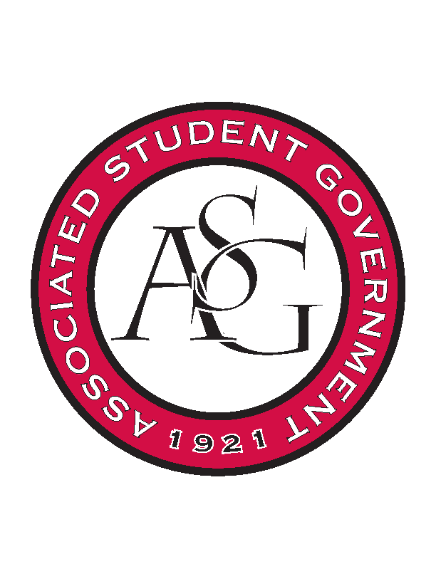
Associated Student Government

Executive Council Meeting

Monday, March 13, 2017 | 10:00 a.m.

- Call To Order
- Roll Call
- Approval of Minutes
- Approval of Agenda
- Special Orders
  - Advisor’s Report
  - Office Manager’s Report
    - Time Sheets
    - EOY Event spending data
    - Budgets
      - Look through budget and communicate to Ms. Jody this week
    - Motion to move progCost $1560.24 from Senate unallocated to Line Item #56, passed unanimously.
  - Graduate Assistant’s Report
    - Katherine
    - Katie
    - Amber
      - Collin will be chairing OFA this week while Shelby is out.
- Reports and Discussion
  - President’s Report
    - Weekly Update
    - Senior Walk
      - Campaign is underway, looking to send an email to all students this week.
    - Arkansas legislature
      - Campus carry bill, was heavily amended and NRA has dropped support. The process has restarted and the unamended bill is going back through.
    - Scooter safety awareness
      - Planning to be happening the Thursday after Spring Break
      - Waiting on graphic approval, appealing athletics’ rejection of the Hog logo
      - Actual event is on Thursday, the rest is mainly a social media campaign the rest of week
    - Out of Office Dates

  - Vice President’s Report
    - Weekly Update
    - FAB Nominations due today at noon
    - Recommendations for EOY Party appreciated.
  - Secretary’s Report
    - Weekly Update
  - GSC Speaker’s Report
    - Weekly Update
    - Meeting on Wednesday, Grad Ed Auditorium
  - Chair of the Senate’s Report
    - Weekly Update
    - Chair of Senate nomination speeches this week
    - Second reading for JB9, UREC Funding Bill, Food insecurity research bill, RAZORBACK Transit
    - New business, campus lighting
  - Chief of Staff’s Report
    - Motion to move remaining budget in Line Item #23 to Line Item #25, passed unanimously.
    - Thomas will be leading cabinet tomorrow night, Laura Jacobs coming to speak at cabinet
  - Chief Justice’s Report
    - Hoping to announce the Exec results this month, best case tomorrow or Wednesday
  - FLF Coordinator’s Report
    - Motion to move remaining budget of Unallocated to Line Item #74, passed unanimously.
    - Promo social media logo in the groupme, (look at that)
    - Tabling this week, $5 a person
    - Deadline is the 30th
- Announcements
- Adjournment

