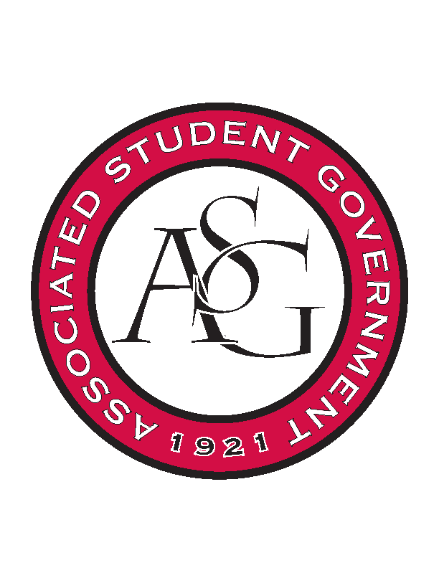
Associated Student Government

Executive Council Meeting

Monday, March 13, 2017 | 10:00 a.m.

- Call To Order
- Roll Call
- Approval of Minutes
- Approval of Agenda
- Special Orders
  - Advisor’s Report
    - EOY Reports
      - Work on making sure all necessary spring documents are on GIZMO
    - Incoming exec transition Meetings
      - Plan on having multiple meetings to help spread out the amount of the information you will cover
    - Hog Sync Profile
      - Please complete ASAP
      - This will factor into RSO reregistration
    - Student involvement awards
      - Nomination deadline is Friday 4/7
    - 2017/18 PAB Funding requests
  - Office Manager’s Report
  - Graduate Assistant’s Report
    - Katherine
    - Katie
    - Amber
- Reports and Discussion
  - President’s Report
    - Weekly Update
  - Vice President’s Report
    - Weekly Update
  - Secretary’s Report
    - Weekly Update
  - GSC Speaker’s Report
    - Weekly Update
  - Chair of the Senate’s Report
    - Weekly Update
  - Chief of Staff’s Report
  - Chief Justice’s Report
  - FLF Coordinator’s Report
- Announcements
- Adjournment

