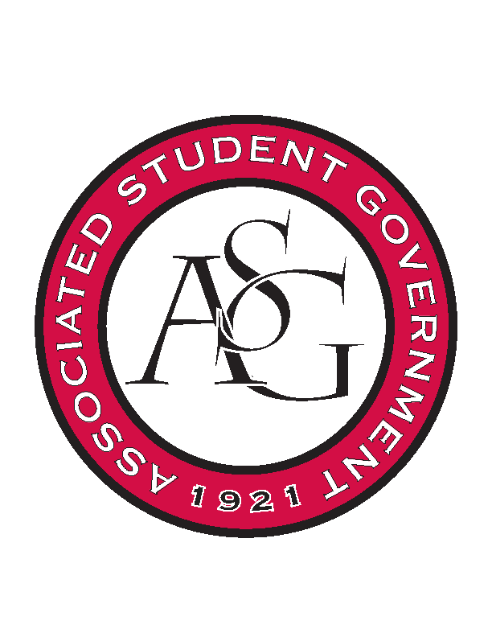
Associated Student Government

Executive Council Meeting

Monday, April 10, 2017 | 10:00 a.m.

- Call To Order
- Roll Call
- Approval of Minutes
- Approval of Agenda
- Special Orders
  - Advisor’s Report
  - Office Manager’s Report
  - Graduate Assistant’s Report
    - Katherine
    - Katie
    - Amber
- Reports and Discussion
  - President’s Report
    - Weekly Update
  - Vice President’s Report
    - Weekly Update
  - Treasurer’s Report
    - Weekly Update
    - Started transition meetings with Macarena last week
    - OFA Standing Rules on second reading on Tuesday
  - Secretary’s Report
    - Weekly Update
    - Beginning Transition this week with Ashton
  - GSC Speaker’s Report
    - Weekly Update
  - Chair of the Senate’s Report
    - Weekly Update
  - Chief of Staff’s Report
  - Chief Justice’s Report
  - FLF Coordinator’s Report
- Announcements
- Adjournment

