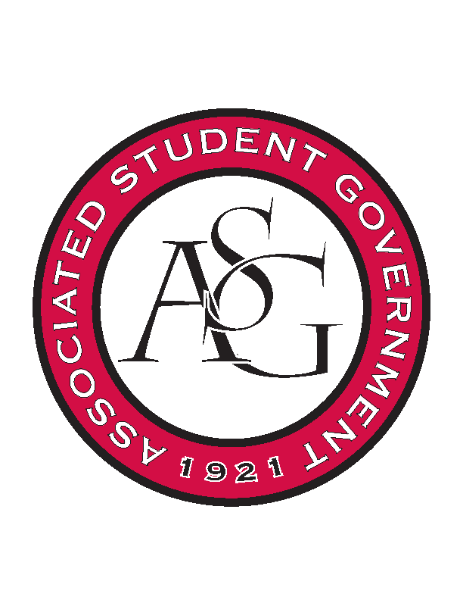
Associated Student Government

Executive Council Meeting

Monday, April 3, 2017 | 10:00 a.m.

- Call To Order
- Roll Call
- Approval of Minutes
- Approval of Agenda
- Special Orders
  - Advisor’s Report
    - Student Involvement Awards due Friday
      - Outstanding RSO Award
      - Service Project of the Year
      - RSO Program of the Year
        - MLK Vigil
        - Hog Out the Vote
      - Collaborative
        - Boss Hog
        - Red Talk: Diversity
      - Member/Officer of the Year
        - Trevor Villines
      - Advisor of the Year
        - Ms. Jody
    - SEC Awards
      - Rising to the Challenge
        - HOTV/Voting Center
      - Outstanding Initiative
    - Transition
      - Be updating Gizmo as you go
      - Planning documents
  - Office Manager’s Report
    - All Exec should be saving all official ASG documents (agendas, minutes, legislation, budgets, etc.) to Gizmo. Please take time to do this each week through the end of the semester.
  - Graduate Assistant’s Report
    - Katherine
    - Katie
    - Amber
- Reports and Discussion
  - President’s Report
    - Weekly Update
    - Scooter Safety
    - Primary PAB
      - Information being sent out today
      - In about 3 weeks
    - Student Poll
      - Are going to be contacting departments around campus
      - Email out to ASG this week
    - Senior Walk
      - Over $11,000 raised by students
  - Vice President’s Report
    - Weekly Update
  - Treasurer’s Report
    - Weekly Update
    - Funding Session tomorrow, last one!
  - Secretary’s Report
    - Weekly Update
    - Transition Meetings with Ashton
  - GSC Speaker’s Report
    - Weekly Update
  - Chair of the Senate’s Report
    - Weekly Update
  - Chief of Staff’s Report
  - Chief Justice’s Report
    - GSC Application Closing tomorrow at noon
  - FLF Coordinator’s Report
    - Fresh HOGS last week in the office
    - EOY Celebration April 17th
- Announcements
- Adjournment

