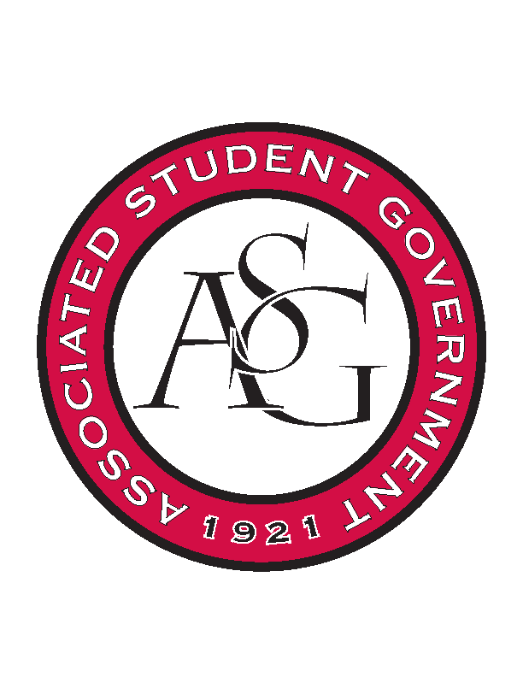
Associated Student Government

Executive Council Meeting

Tuesday, August 2, 2016 | 4:00 p.m.

- Call To Order
- Roll Call
  - Not present- Scout, Kyle, Katie, Katherine
- Approval of Minutes
- Approval of Agenda
- Special Orders
  - Advisor’s Report
    - Weekly Update
    - Out of office Friday, Sept 2nd
      - Both Michael and Jody will be out of office, Katherine and Katie will schedule their office hours shortly. If you need anything see either Jody or Michael before Friday.
    - Laptops
  - Office Manger’s Report
    - Updated budget with July entries posted
      - Budgets as of July 31st
    - Laptops
      - When you are using a laptop do not leave them sitting out, it doesn’t happen often but we are not immune to theft. We will get the forms out soon to check out the laptops.
  - Graduate Assistant’s Report
    - Katherine
    - Katie
      - Would like to give Lane at least two weeks before applications go out to give him time before they are available on ASG forms
      - Maybe have a running application for everything that we do
- Reports and Discussion
  - President’s Report
    - Weekly Update
    - Rollin with the Razorbacks
      - Anna Kay will begin working on that soon with Taylor.
      - Friday, October 21st 11PM- Back around 10:30 AM
    - Athletics roundtable
      - Camping Policy, Chancellor seems against it.
    - Chancellor’s focus group
      - Be on the lookout for an email from Matt in the next 24 hours about the Chancellor’s focus group.
    - Campaign Arkansas
  - Treasurer’s Report
    - Weekly Update
    - ASG operating budget on first reading at Senate
    - Zero Waste update
    - Funding session- Wednesday
  - Secretary’s Report
    - Weekly Update
    - Social Media Posts
      - Any request for a social media post or something, please email and include a sentence or two of any information that you would really like to include.
      - CC Mackenzie and Grace in those emails as well
  - GSC Speaker’s Report
    - Weekly Update
    - OER
  - Chair of the Senate’s Report
    - Weekly Update
      - Everyone has an opportunity to report, roughly five minutes.
      - “I’d like to turn the meeting back over to the chair” to give the meeting back to Will.
      - “Hog out the Vote Expense” renamed to “Hog out the Vote Expenses”
        - Unanimously passed
  - Chief of Staff’s Report
    - Health Week Sept 29-23
      - Animals will come out with CAPS to talk about stress.
      - Movie possibility that week
      - Sunrise Yoga
    - Ask Taylor
    - Refer to calendar for dates on cabinet sponsored events
  - Chief Justice’s Report
    - Vacancy Apps closed today
      - About 75 vacancy applications turned in, 62 senate vacancies and 13 GSC vacancies.
  - FLF Coordinator’s Report
    - 67 Applicants for FLF as of today, an email will be going out tonight to the ASG listserv about promoting the applications.
    - Interviews are September 6th and 7th, be looking for a calendar invite from Kyle
  - Vice President’s Report
    - Weekly Update
- Announcements
  - Code and Constitution is not very clear on how referendum works. If we use referendum and not making changes to code then it usually deals with a change in student fees. To put something to referendum you would write a bill to senate to be putting up to referendum.
    - Issue with the Hogs Abroad bill is that bills die after each year so has been taking off the referendum. The bill is dead for tonight’s meeting. The other Code and constitution issue is that the bill did not state that it needed to go to referendum.
    - Some wording that needed to be revised.
    - If there is anyone that you are wanting to work with when putting a bill through senate, anything that affect the entire student body we need to communicate better and let people know what we are working on exactly. The Chancellor, Deans, Vice Deans, etc should be made aware of things like that. Just steps to be above reproach and keep good relationships with different groups around campus.
- Adjournment

