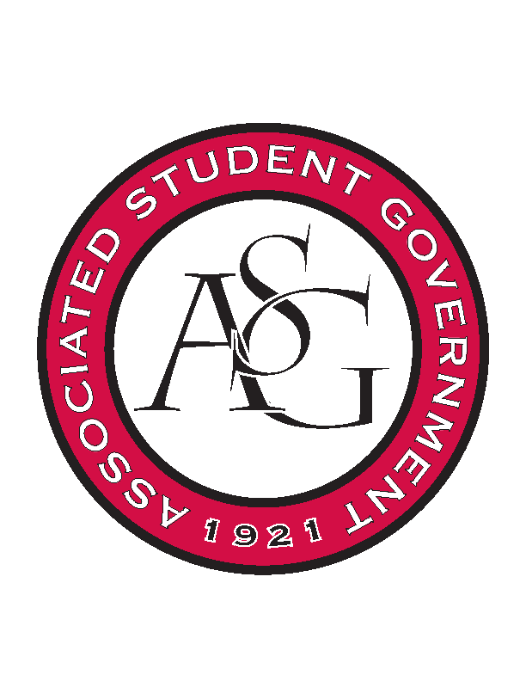
Associated Student Government

Executive Council Meeting

Monday, August 28, 2017 | 12:00 p.m.

- Call To Order
- Roll Call
- Approval of Minutes
- Special Orders
  - Advisor’s Report
    - Weekly Update
      - Standing Rules Approval Date
        - Will vote on at next week’s meeting
      - 10 events in 10 days
        - Thank you to everyone for their hard work
      - Hurricane Harvey
        - Opportunity to volunteer and promote aid efforts
  - Office Manger’s Report
    - Weekly Update
      - C3 under cabinet for venue costs
        - Includes audio and visual
      - Allocations budget add venue costs for those meetings
  - Graduate Assistant’s Report
    - Amber
      - First OFA meeting went great, continue working with Maca on incoming budgets
    - Josh
      - None
    - Sage
      - 11 applications for FLF Staff currently
      - 76 applications for FLF, close this Friday
- Reports and Discussion
  - President’s Report
    - Weekly Update
      - Event Participation
        - Thank you to everyone who helped out last week
      - GSC referendum vote
        - Coming up soon, be well versed on the subject
      - Empower Program
        - Works to make students with mental disabilities feel more welcomed on campus, opportunity for ASG to be a part of this effort
      - United Way Campaign
        - Kicks off September 25, ASG can help promote
      - PAB
        - Meeting coming up soon, funding proposals need to start being worked on for programs
      - Student Poll
        - Comes out in the next two weeks
  - Vice President’s Report
    - Weekly Update
      - Family of the Year
        - Applications have closed, 14 applicants
        - Announcement will be at the September 30th game
      - Homecoming Applications
        - Open Friday, close September 13th
        - Scheduled a reception rather than a banquet this year
        - Begin telling RSOs to nominate 3 queen and 3 king candidates
          - RSO tour to promote nominations
      - Diversity Day/ Week
        - October 23, Samia and TJ are being referred to JT
        - Courageous Conversations Maine
  - Treasurer’s Report
    - Weekly Update
      - OFA intro meeting
        - Pictures were taken
      - HogSync
        - Still transitioning, working on getting applications online
      - OFA Board Member
        - Conflicting class scheduled caused one member to resign their seat
          - Searching for someone to fill position
  - Secretary’s Report
    - Weekly Update
      - Givepulse Tabling
        - Reach out to VAC for administrative access
  - GSC Speaker’s Report
    - Weekly Update
      - Ballot initiative
        - Coming soon
        - Be informed, available to answer questions
  - Chair of the Senate’s Report
    - Weekly Update
      - None
  - Chief of Staff’s Report
    - Weekly report
      - Cabinet
        - RAG
          - Applications open
        - Safety
          - UAPD tabling next week for campus carry
            - JP wants to do more tabling
          - It’s On Us Week
            - Keep ongoing count of people signing the pledge against sexual assault on website
      - All ASG Retreat
        - September 17th
  - Chief Justice’s Report
    - Weekly Update
      - Fall Election
        - 11- 13 are the voting dates
        - If you have ballot initiative questions see Arley
      - ASGJ
        - Meets Wednesday
          - Candidate orientation meeting to follow
      - Homecoming
        - Meeting with Natalie soon
  - FLF Coordinator’s Report
    - Weekly Update
      - None
- New Business
- Announcements
  - Mrs. Jody out of the office tomorrow
  - Find tablecloths from Welcome Week Cookout and get dry cleaned
- Adjournment

