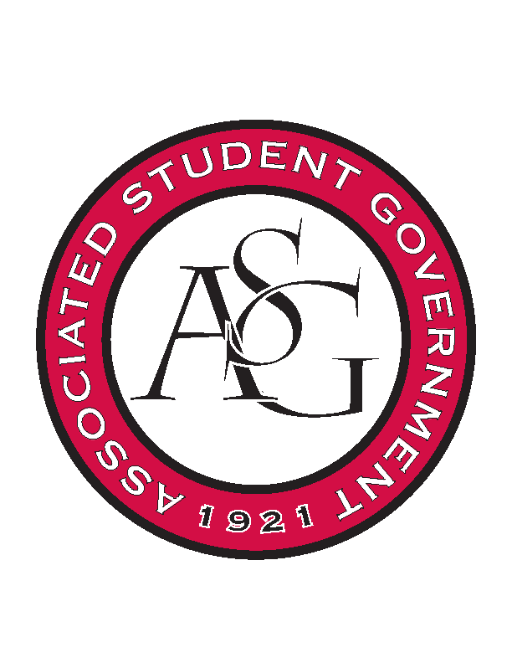
Associated Student Government

Executive Council Meeting

Tuesday, September 13, 2016 | 4:00 p.m.

- Call To Order
- Roll Call
- Approval of Minutes
- Approval of Agenda
- Special Orders
  - Advisor’s Report
    - Weekly Update
    - Promo Items
      - Use the promo for events in the fall. Do not worry about using it up for the year, that is the goal.
      - If we do go through all the promo items we will find short term solutions
      - Make sure that we get shirts to current ASG members
      - Have some promo on hand in your office for when you are meeting or speaking with someone.
      - Take promo from the office first, and then take from the new wooden cabinets.
      - All-ASG Retreat is when senate, cabinet, FLF, Judicial will get their shirts at the retreat
      - It will be better to not have a lot of promo leftover for when the next term begins.
  - Office Manager’s Report
    - Weekly Update
      - All is in place for the Family of the Year breakfast
      - Look into making a statement about Savvy winning Miss America
  - Graduate Assistant’s Report
    - Katherine
    - Katie
- Reports and Discussion
  - President’s Report
    - Weekly Update
    - Scooter Safety
      - Connor met with Police Chief
      - If you are under the age of 21 you are already required to be wearing a helmet, but you cannot pull someone over for it, it is a secondary offense.
      - Even if we implemented a policy they would still not be able to pull them over because they may not be a student of the U of A.
      - Could go through Senate to be put on referendum
      - Exec safety initiatives with Parking and Transit and Director of Safety, do not need to go through Senate.
      - Look into working with a community partner about looking into discounted helmets to students.
    - Provost Search
      - Scout and Connor are going to Dallas next week.
      - Chancellor Steinmetz will crown the Homecoming Queen and King
    - Chancellor’s Update
    - Campaign Arkansas
      - Campaign Arkansas concert is Thursday night, Friday is a closed campaign AR meeting
      - Saturday there is a dedication to the extension on the Fowler house
  - Treasurer’s Report
    - Weekly Update
    - Standing Rules task force
      - Any Exec is welcome to attend
      - Set for next Wednesday
    - Funding update
    - Funding session tomorrow
  - Secretary’s Report
    - Weekly Update
    - Review of Calendar
      - Update the calendar on GIZMO when you have an event that you know the date of. The earlier the better
      - Make sure to fill it in in the exact format, do not add columns, Alex uses this to upload information to the website
  - GSC Speaker’s Report
    - Weekly Update
  - Chair of the Senate’s Report
    - Weekly Update
      - New Senators will be sworn in and pinned tonight
  - Chief of Staff’s Report
    - Cabinet
    - Website Discussion
      - Be thinking about what Alex can put on the front of the website
        - Exec agenda, what we are doing
        - Tallies of number of applications, etc.
        - Status bar of how much of student population has completed scooter safety (just an example) training
    - Sustainability- Wes Prewett
      - Skylar is no longer on cabinet because of conflicts in band
      - Wes Prewett was selected to fill in for Skylar
    - Multimedia Director
      - Might be beneficial to bring that position back in
      - Two options:
        - Could just be a cabinet position
        - Could become an actual, paid position- it would require referendum. Would allocate part of the budget
      - Would still use UA Productions for repetitive events (RED Talks, etc.)
      - Great at working with things like video, but are under staffed and we do not want to overload them.
        - Photoshop
        - Graphic design
        - Flyers
  - Chief Justice’s Report
    - Senate will take a vote of confidence
    - 10 GSC Members
  - FLF Coordinator’s Report
    - Finished FLF interviews- 37 have accepted the position, others had class conflicts
    - Waiting for responses from three more people
    - October 12th- Exec will come to this one
    - Mentor information will be sent out
  - Vice President’s Report
    - Weekly Update
- Announcements
- Adjournment

