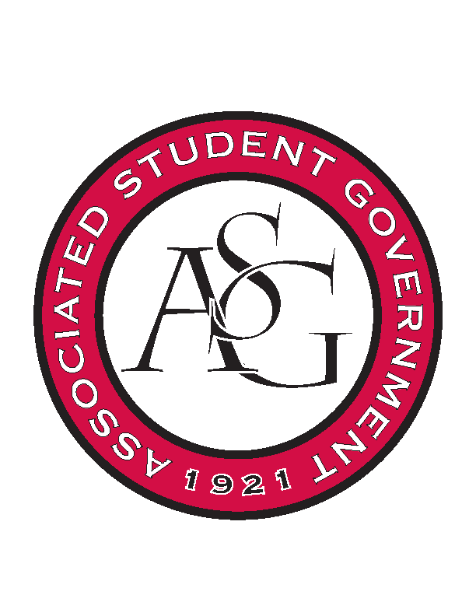
Associated Student Government

Executive Council Meeting

Tuesday, September 27, 2016 | 4:00 p.m.

- Call To Order
- Roll Call
  - Connor, Shelby, Cory, Taylor, Michael, Jody, Kyle, Will, Jase
- Approval of Minutes
- Approval of Agenda
- Special Orders
  - Advisor’s Report
    - Weekly Update
    - Advisor Challenge- Haven
      - Will be emailing the exec branch to challenge them to complete the Haven challenge
      - Will do a branch at a time, joint combo
      - Might have FLF do it first because freshman are required to do it
      - Advisor staff is also working on completing it
      - Once all branches of ASG completes it, then we can challenge another group on campus
      - When it is finished, email Michael a certificate of the finished page
      - Connor- maybe get lists of students who have completed it
    - Rollin with the Razorbacks
      - Sending one bus of 54 students going over to Auburn
      - Cutting back to save some money, we will be able to reuse those funds to hopefully be able to get students to other athletic events
      - Exec members who are listed as going need to turn in their applications
  - Office Manager’s Report
    - Weekly Update
    - Time Sheets
      - Clock in, clock out
    - New line item; ProgCost #29
      - The budget for cabinet programs
      - May need to move this to next week so that Ms. Jody can meet with Katherine
      - Votes for- unanimous
    - Gizmo- revisit/budgets
      - Moved to next week
    - Priority Registration
      - For classes second semester
      - Decide together when we are going to have exec meetings for spring semester
  - Graduate Assistant’s Report
    - Katherine
    - Katie
- Reports and Discussion
  - President’s Report
    - Weekly Update
    - PAB
      - Happening tomorrow morning at 8am, Connor Maggie and Shelby will be going
    - Football camping
      - Not going to happen
    - Athletic’s Budget
      - Money was saved by cutting back on Rollin, budget just went up $8,000
    - Athletic’s Focus Group
      - Next Wednesday, oct 5- broyles center in the Miller room, 6-6:30
      - Free chickfila
      - 6:30-7:30, facilitators will move around and ask questions to students to get their opinions on this
    - CAPC
      - Meets once a semester to run through everything going on in the University
    - Haven
      - 45% of first year students have completed it
  - Treasurer’s Report
    - Weekly Update
    - OFA web updates
      - Added a ticker to the OFA website
    - Budget passed GSC and Senate
      - The standing rules will be going through GSC first this year
  - Secretary’s Report
    - Weekly Update
    - Review of Calendar
  - GSC Speaker’s Report
    - Weekly Update
  - Chair of the Senate’s Report
    - Weekly Update
      - Tonight’s meeting will be pretty quick
      - CAPS Speaker is tonight
  - Chief of Staff’s Report
    - Cabinet
    - Website Discussion
      - There are tickers on the website now
    - Budget line
      - Be thinking about printing/other cabinet expenditures budgets
    - All-Call
      - Oct 11, Eve from the IT department will be coming
      - Member of the month awards, be ready to nominate 2 members for each month
      - Be looking for a google form
  - Chief Justice’s Report
  - FLF Coordinator’s Report
    - Mentor program
    - Freshman are starting their office hours this week
    - FLFers are called FreshHOGS
  - Vice President’s Report
    - Weekly Update
- Announcements
- Adjournment

