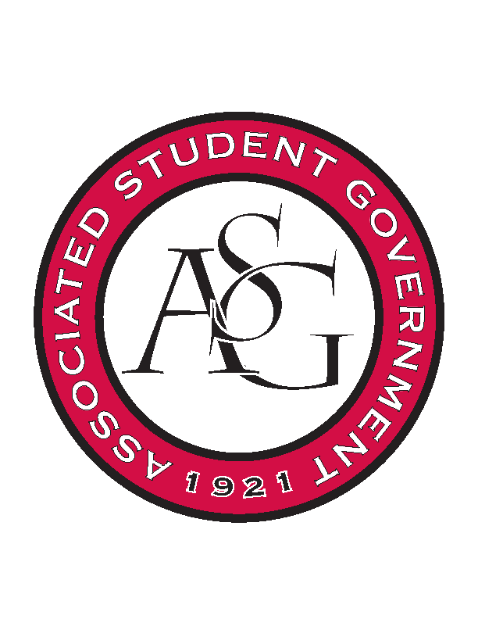
Associated Student Government

Executive Council Meeting

Tuesday, September 6, 2016 | 4:00 p.m.

- Call To Order
- Roll Call
- Approval of Minutes
- Special Orders
  - Advisor’s Report
    - Weekly Update
      - Election underway
        - Vote.uark.edu redirects to new platform
        - Paper ballot-
          - Qualtrics isn’t letting them sign in
          - Cory email the PDF to students and they can email their ballot back
            - CC Michael
        - Katie and Katherine are not here today
    - Fall exec meeting times
      - Maggie cannot attend
        - Are we going to change since Homecoming is so important?
      - 3 or 4 members will miss at any other time
      - Send representative for Maggie?
      - Check C&C about exec proxy
    - Thank you card: Trang Mai
      - For future reference, any last minute events that we have coming up (like the ASG Sky Box this last week) let OSA staff know what is going on.
    - Pop-up event/ giveaway discussion
  - Office Manager’s Report
  - Graduate Assistant’s Report
    - Katherine
    - Katie
- Reports and Discussion
  - President’s Report
    - Weekly Update
      - Looking into the logistics of putting a team together to raise money for the senior walk
    - Cole Pangburn
      - Looking into sending flowers to the Pangburn family.
      - Talking to Dean Harwood Rom about being notified when a student has passed away or is injured
    - Change.org petition- helmets on campus
      - Petition started for ASG to take action to make helmets a requirement on campus.
      - Scooter safety day in the future
        - Online training to park a scooter on campus
        - Helmet awareness
      - Come out with a statement about the passing of Cole and that we are aware of the petition
    - US Senate Candidate Debate
      - Republican candidate is not willing to have a debate on campus.
      - Talking about still holding a debate but making it clear that we did invite all three candidates.
    - Provost Search Committee
      - Scout and Connor are going to Dallas in a couple of weeks with the search committee
    - Title IX
      - Connor met with Dr. Robinson and Dean Harwood-Rom about sexual assault awareness day
      - Both are very passionate about Title IX
      - There will be a committee set up this approaches
    - Senate Room Reservation
      - In Willard J. Walker, initially designed to be a senate style room, seats 68
      - Has all the technology
      - Request is put in for the room
  - Treasurer’s Report
    - Weekly Update
    - Funding Session next Wednesday
      - Another funding session so let RSOs know to come to that.
    - First budgets second round approved this Thursday
      - Next week we will have the actual numbers of what is approved
    - GSC Standing Rules team
      - Shelby wants to put together a GSC Standing Rules Team to get that figured out
  - Secretary’s Report
    - Weekly Update
    - Chick-fil-a / Budget
      - Possibilities:
        - Zoe’s
        - Sterling District
        - Cane’s
        - Elvis Moya
  - GSC Speaker’s Report
    - Weekly Update
    - Traveler Article
      - The article referenced quotes from over a year and a half ago. Getting in touch with the editors to try and get that cleared up
      - Make sure that all are careful when talking to any type of media
    - First GSC meeting, 21 September
      - Dress requirement: business
    - Life Event Leave
      - There have been amendments to last year’s bill recommending that there are accommodations for graduate students having to take life event leave.
      - Dean Rom suggested that this is widened into a joint resolution with Senate to affect all U of A students with scholarships.
      - We cannot tell the state scholarships how to spend their money, need to make a point of clarifying that it is University of Arkansas scholarships being affected
      - RAG could lobby for this in the next trip
      - Hope to get this on the GSC agenda on Wednesday
      - Could be discussed during a joint legislative session
  - Chair of the Senate’s Report
    - Weekly Update
      - Second meeting tonight
      - ASG Budget is going through
      - Additional resolution that Spencer Bone is putting through requiring that senators goes to two different RSO meetings this a semester- like OFA does with audits
      - Elections wrapping up this Friday
  - Chief of Staff’s Report
    - Cabinet
    - Website Discussion
      - Students seeing what all we have accomplished
      - Brainstorm some ideas for what can go on the website

    - Comprehensive internal newsletter
    - Athletics
    - Changing Director of Diversity to Director of Diversity and Inclusion
    - Faculty and Staff Senate
    - Health and Safety week
      - October 24-29th
  - Chief Justice’s Report
    - 1600 votes in the election so far
    - hoping for a mass email to students about the elections going on
    - Expenditure reports being submitted
    - Legislative diversity act of 2016- Senate cannot run in tickets but GSC can run in tickets
    - Executive Officers and ASGJ cannot endorse any candidate in the senate elections
      - Sitting senators can endorse any candidate, but only one at a time to avoid putting senators on tickets
      - Want to avoid the perception of two campaigns coordinating
      - Anybody can submit a campaign complaint
  - FLF Coordinator’s Report
  - Vice President’s Report
    - Weekly Update
    - Court Applications available
    - Hand out HC timelines
    - Meal with Family of the Year
      - Might need to do breakfast
- Announcements
- Adjournment

