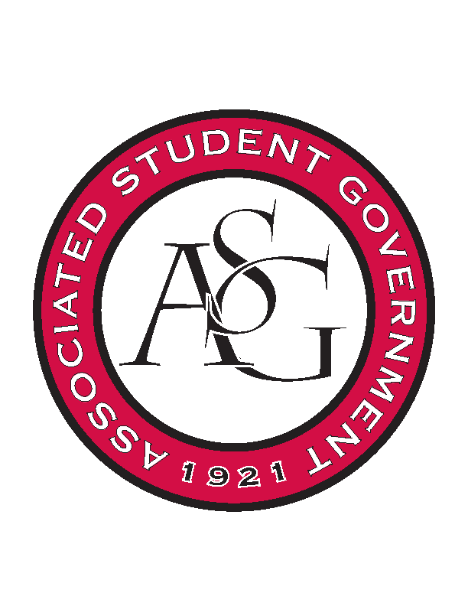
Associated Student Government

Executive Council Meeting

Monday, September 11, 2017 | 12:00 p.m.

- Call To Order
- Roll Call
- Approval of Minutes
- Special Orders
  - Advisor’s Report
    - Weekly Update
      - Voting
        - Live, but have some issues
        - 800 votes so far, not including paper ballots
        - Small groups of students not getting through
          - First year law students who are undergraduates example
      - Enrollment
        - 11th day hit last week
        - 27,558 students enrolled
        - Read the newswire article
          - 55% from AR
          - 39.6% from outside state in US
          - 5.3% international
          - 52.5% women
      - Union Day
        - In two weeks, ASG table with OSA volunteer sheet to be sent out
  - Office Manger’s Report
    - Tweaks to the budget
      - August budget updated and sent out this week
        - Reminder about order for turning in purchase forms
    - Timesheets need to be signed
      - Regular pay begins the 25th
    - PAB requests needed ASAP
    - Out Friday afternoons
  - Graduate Assistant’s Report
    - Josh
      - None
    - Sage
      - 145 FLF applications
      - First set of interviews Friday, second coming soon
      - Next Wednesday first FLF meeting
        - Maca- Will they come to the retreat?
          - If chosen by then, yes
- Reports and Discussion
  - President’s Report
    - Weekly Update
      - Student Poll
        - Currently working on with Michael
      - PAB
        - Happens in two weeks, anyone who needs funding needs to start working on proposals
      - Campaign AR
        - Met Friday, very close to their goal 785 million dollars so far
        - Thinking about raising the goals because they think the funds will be acquired soon
        - School of Art advantages
      - Voting
        - Vacancy and referendum voting starts today
        - Look out for peers to ensure rules are being followed
      - Senate Tuesday at 6:00 first meeting, Grad Ed
        - Many elections going on so it will be long
      - Homecoming Applications
        - Extended to September 15th
        - Encourage others to nominate people
  - Vice President’s Report
    - Weekly Update
      - Scoring of Family of the Year
        - Mary Kate Harrison’s family will be recognized September 30th
        - Grad Student
        - Update later on specific role for the day
  - Treasurer’s Report
    - Weekly Update
      - OFA intro meeting
        - Record attendance at funding session last week
          - 27 new budgets expected
        - 15 budgets so far completed, 70 more to go
  - Secretary’s Report
    - Weekly Update
      - Giveaways
        - Marc and Erin are meeting with Mrs. Jody about the possibility of a big giveaway to increase social media at Chancellor’s Ball
      - Camera
        - Lens broken, in search of new one
      - Welcome Back Cookout Video
        - Almost finished, hope to show at All ASG Retreat
  - GSC Speaker’s Report
    - Weekly Update
      - None
  - Chair of the Senate’s Report
    - Weekly Update
      - Parliamentary Procedure
  - Chief of Staff’s Report
    - Weekly Update
      - Cabinet
        - Rollin with the Razorbacks
          - LSU decided game
          - Budget down, start moving forward on details
        - RAG
          - Trevor finishing selection
        - Safety
          - Campus carry tabling moved to the Spring
          - JP talking with Greek Life about partnering for Its On Us Week
        - Boss Hog
          - Inventory now cataloged
          - Get on website and HogSync next
        - Veterans’ Affairs
          - Will working on ASG being a part of Veterans Game
      - All ASG Retreat
        - Tentative schedule to be sent out later
          - Welcome
          - Speaker
          - HogSync overview
          - Break up into branches
  - Chief Justice’s Report
    - Weekly update
      - Voting
        - Starts today, some issues but not many with casting ballots
        - Candidates and ASGJ met last week and meeting was successful
  - FLF Coordinator’s Report
    - Weekly Update
      - None
- New Business
  - Standing Rules
    - Approved unanimously
- Announcements
- Adjournment

