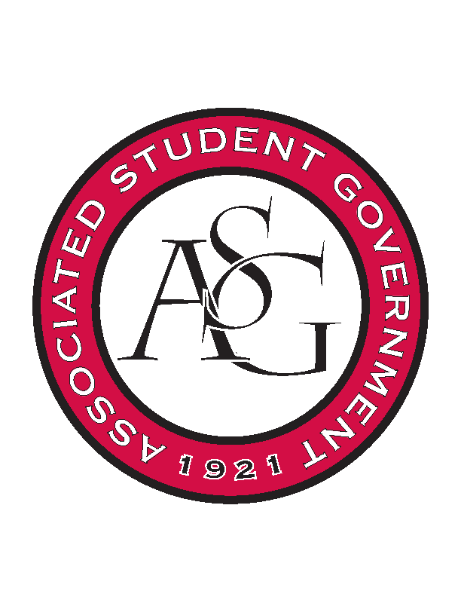
Associated Student Government

Executive Council Meeting

Monday, September 18, 2017 | 12:00 p.m.

- Call To Order
- Roll Call
- Approval of Minutes
- Special Orders
  - Advisor’s Report
    - Weekly Update
      - Standing Rules
        - Added to the website under governing documents and exec pages
      - Rollin’ with the Razorbacks
        - Planning continued with OFA to ensure all procedures are followed
      - Homecoming Applications
        - Co-curricular checks and RSO checks in the works
        - Promising number of applications, competitive top 20
        - Applications will be passed on to student judges in the next few days
      - Volunteers Needed
        - Tuesday UP Course, 3:30- 4:20
          - Andrew volunteered
        - McCloud video interview about the benefit of staff members to students
          - Passing our names along, less than 15 minute interviews
      - ASG Retreat
        - Well managed and well done, very timely and practical content
  - Office Manger’s Report
    - Family of the Year
      - Need requisitions from Natalie this week
    - Rollin’ with the Razorbacks
      - Waiting on Michael for timeline and then will contact bus company about scheduling
    - PAB Requests
      - Due today by 3:30, reviewed by Mrs. Jody by Wednesday
  - Graduate Assistant’s Report
    - Josh
      - None
    - Sage
      - FLF Update
        - Now have 6 staff members, 52 FLF members
          - Held over 111 interviews for the positions
        - First meeting is 9/20 at 5:00 in Grad Ed
          - Asking Exec to come and introduce themselves
- Reports and Discussion
  - President’s Report
    - Weekly update
      - PAB
        - Due this week, finalized on Wednesday
      - Thank you
        - Both branches up and running now
        - Already have accomplished so much, keep working hard
  - Vice President’s Report
    - Weekly Update
      - Family of the Year
        - Finishing up final details
        - Family will be introduced on the field next weekend
          - Working on attaining Exec field passes
        - Family recognition dinner at Emelia’s on Dickson
  - Treasurer’s Report
    - Weekly Update
      - OFA
        - Reviewing first appeals of the semester
      - PAB
        - Assisting in requesting money for RAG, Sustainability, Boss Hog Outfitters, Diversity Week, and Safe Ride
      - HogSync
        - Working on continuing to add applications
        - Goal to have all uploaded by October 20th
  - Secretary’s Report
    - Weekly Update
      - Chancellor's Ball giveaway item
        - Meeting soon with Mrs. Jody to fill out purchase sheet and receive more information on donation regulations
      - Chancellor's Ball lawn signs
        - Designs are in the works, will send out later this week to be approved by team
      - Bus Video Board Location
        - Group vote on placing board in bus waiting area
          - Approved
        - Will contact Facilities/ Parking and Transit and move forward on getting video board relocated
      - RAG logo
        - New logo created last week per Trevor’s request
  - GSC Speaker’s Report
    - Weekly Update
      - Election results
        - Excited the ballot initiative passed
        - GSC has full body, some growing pains but learning as they go
      - Legislative Action Days
        - Coming up in a few weeks, sending two representatives
  - Chair of the Senate’s Report
    - Weekly Update
      - None
  - Chief of Staff’s Report
    - Weekly Update
      - ASG Suggestion Box
        - Tristan suggested moving downstairs to reach more students
          - Contacting Union to see if we can move it
      - Rollin’ with the Razorbacks
        - Work in progress
  - Chief Justice’s Report
    - Weekly update
      - Confirmations
        - Justices and proxies will be confirmed this week
      - Spring Election
        - Planning and preparations beginning now
  - FLF Coordinator’s Report
    - Weekly Update
      - None
- New Business
- Announcements
- Adjournment

