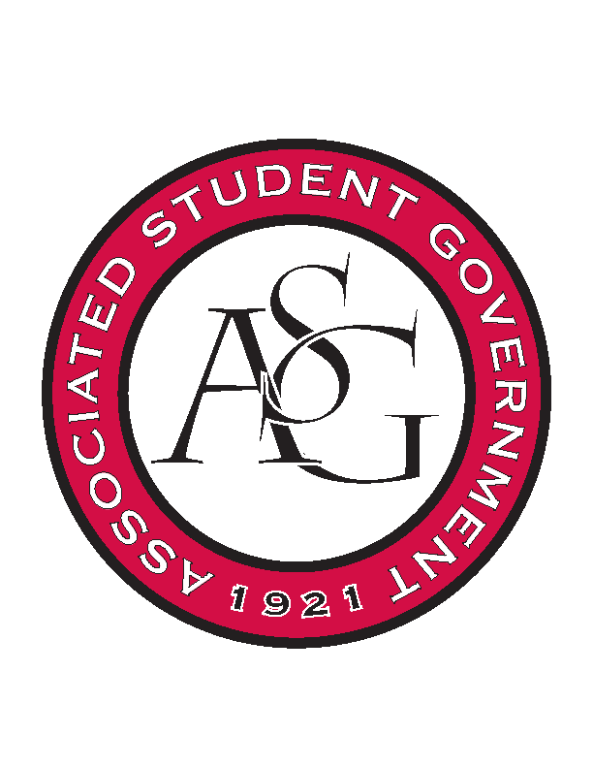
Associated Student Government

Executive Council Meeting

Monday, September 25, 2017 | 12:00 p.m.

- Call To Order
- Roll Call
- Approval of Minutes
- Approval of Agenda
- Special Orders
  - Advisor’s Report
    - Weekly Update
      - ASG News
        - Caution saying “most, first, never, etc.” until research has been used to back it up
      - Election Numbers
        - Results for voter turnout will be sent out later for Newswire article and in case students request information
      - ASG transition to Associated Supreme Constitution
        - Forming a committee
        - Exec role minimal, unless we want a bigger role
          - Senate write resolution to form a committee
  - Office Manager’s Report
    - Weekly Update
      - December 2nd Holiday Gathering
        - Two people graduating in December: Cory and Cody
        - Holiday/ graduation celebration brunch
          - 9:00 – 11:00 (confirm next week)
  - Graduate Assistant’s Report
    - Josh
    - Sage
      - FLF Update
        - None
- Reports and Discussion
  - President’s Report
    - Weekly Update
    - United Way Kickoff is today. Union Connections Lounge
    - First Round of Homecoming Apps come back on Thurs
    - PAB results
      - Most ASG programs received the full funding they requested (aside from Safe Ride)
      - Still more money available
      - Last Wednesday in October is next round
    - Be on the Lookout for Diversity Week, Its on US, Homecoming, and Chancellor’s Ball
      - All in October, stay involved!
    - Keep up the Good Work.
    - Challenge this week: Grab lunch with a Member in your branch that you don’t know well.
  - Vice President’s Report
    - Weekly Update
      - Family of the Year
        - Family Weekend, Elvis needs names of people for field passes; between first and second quarter
      - Emelia’s Kitchen
        - Friday night 6:30
        - Everyone is invited
      - End of the Semester Party
        - Dani working on, December 5th recommended date
  - Treasurer’s Report
    - Weekly Update
      - Hog Sync budget
        - Practicing with fake usernames
      - Funding Session
        - Wednesday 5pm
  - Secretary’s Report
    - Weekly Update
      - ASG Listserv
        - Adding FLF members this week
      - Bus Sign Location
        - Three places have been chosen and are getting forwarded to Mrs. Rosa and parking and transit
      - Cooler Purchase Form
        - Fill out and turn in this week
      - Chancellor Ball Signs
        - Finalize and fill out purchase form this week
  - GSC Speaker’s Report
    - Weekly Update
      - Governing Documents
        - Meetings this week for fee division, so far going well
      - GSC Social
        - At Farrell’s
        - Meet the GSC Event
          - GSC coaster sets given away
  - Chair of the Senate’s Report
    - Weekly Update
      - 3 pieces of legislation this week
  - Chief of Staff’s Report
    - Cabinet
      - It’s On US Week
        - October 9-13
        - Meeting this week to get final details
      - Health Days
        - October 24-25
        - Wednesday sunrise event, Tuesday RSO tabling event
      - Rollin’ with the Razorbacks
        - Applications open next Tuesday
        - Graphic getting approved
      - Veteran’s Event tomorrow
      - Associate Member Program applications to reopen
        - Vote on logo
          - Logo with “Associate” chosen
      - Safe Ride logo vote
        - White logo chosen
    - Associate Member Logo Voting
    - Safe Ride Logo Voting
    - Cabinet Updates
  - Chief Justice’s Report
    - Weekly Update
      - Working on Homecoming
        - Judging comes in for first round Thursday
        - Interviewers confirmed for next week
  - FLF Coordinator’s Report
- Announcements
  - Michael
    - Add calendar before announcements to agenda for upcoming events
  - Jody
    - Spelling very important, couple of instances where spelling has been wrong and comes off as rude
- Adjournment

