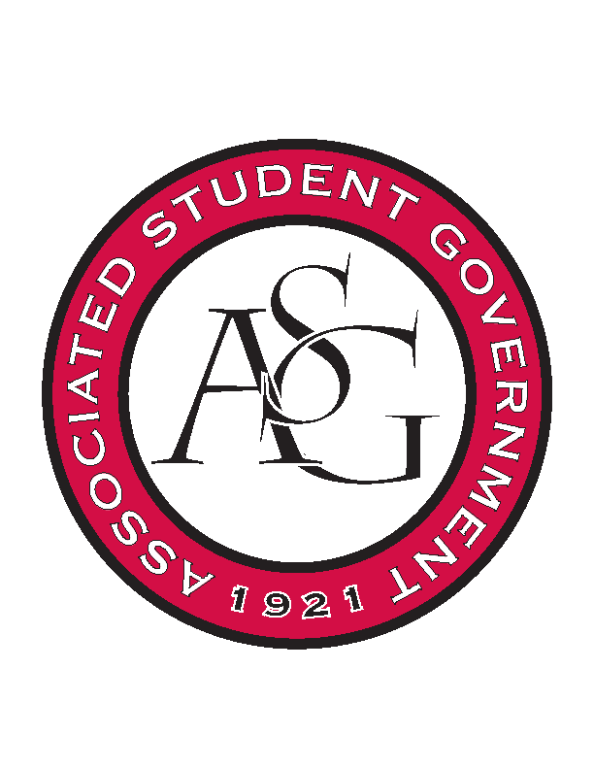
Associated Student Government

Executive Council Meeting

Monday, September 21st, 2015 | 12:30 p.m.

- Call To Order
- Roll Call
- Approval of Minutes
- Special Orders
  - ASG Advisor’s Report
    - Chancellor’s Ball
      - Two weeks away. As always props to Morgan, everything looks on point for that. Make sure you are appropriate at the Chancellor’s Ball. Strongly encourage you not to drink before or during the event.
      - There will be no alcohol at the event.
    - Rollin’ with the Razorbacks Spots
      - Exec has five spots – Tanner, Morgan, Meera, Jace, Lizzi, Jenna
    - Leading by Example
      - Remind you about being the best organization on campus. I want to make sure that as leadership you are setting that example, I want them to be enjoyable but want to recognize that this is a professional setting. It’s okay to have fun but some members are having too much fun.
      - “Traveler” rule.
    - ASG Retreat
      - I want to clear the air. In the theory of team development we are at the “storming” stage. We have to move past that stage. We need to support each other, and back each other up.
  - ASG Office Manager’s Report
    - Scheduling Buyer to Exec. Meeting
      - They enjoy coming to meetings. Sometimes we invite them to meetings and we introduce ourselves and she will speak for about five minutes. This is good PR. EX: the tailgate for Rollin’. Schedule a time for her to come to a meeting. Karen Walls.
- Reports and Discussion
  - President’s Report
    - All ASG Retreat
      - Breakout sessions were really good. Meet with Lizzi and Jace privately to go over event write up. All in one day was better because better retention and people will stay the whole time.
      - If two days – ASG 101 for just new members and then the actual retreat be on one day for everyone. Or even a breakout session that is ASG 101.
      - Going over the agenda at the exec meeting before the retreat. To go over the small details – to go over it as a small group to mitigate any risks and for everyone to be on the same page.
      - Joint legislative branch session was productive and so was the breakout session. Took a while for the first person to ask the question but once the first person did it went really well.
    - PAB Reports Due
      - Ray and Morgan are on the committee. There will be another PAB meeting end of October or early November. There are two supplemental rounds for the fall. Will keep you updated.
    - Campaign Arkansas
      - Update on the billion-dollar campaign. They are ahead of schedule. Wyrick heads that up – a lot of it will go to infrastructure. The campaign will be publicly launched next year. They may ask more out of exec when the time comes. They just got a new chair – the CEO of first security bank.
    - Alumni Tailgate
      - Oct. 24th outside the alumni house. Meet with the alumni who are coming. May receive some emails via Tori.
  - Vice President’s Report
    - FOTY Recap
      - Family had a great time. I send you long emails – I send important information, all the details are in the emails. While im trying to coordinate the family, I’m also coordinating you – It would go so much smoother if you help me out on that end.
      - Dinner went really well – disappointed in the engagement. People were on their phones and on Instagram. You are always representing the organization.
    - Committees
      - Appointments have been made. Sent them to Rainer and Dr. Robinson to approve and then they will go to senate and GSC to be approved and finalized. We still have quite a few open spots and so another round will start once they get finalized.
    - Homecoming
      - Applications closed Friday. Rainer will contact the judges and get the applications to them. Morgan will work on pep rally, gameday and parade
    - Chancellor’s Ball
      - October 9th. I will be sending out more information regarding volunteers. Will be meeting with the Chancellor Hotel about the little details.
    - Creed Committee
      - Tanner, Scout, and I had a meeting. Hope to have a first draft done by late November.
  - Secretary’s Report
    - Upcoming Tabling Events – Branch Responsibility
    - Sexual Assault Awareness Day
  - Treasurer’s Report
    - PAB Requests
      - Tanner already touched on this. Lizzi said that there was some program that wanted money. She is trying to find money for sustainability. Draw up money for the October/November meeting.
    - Ownership
      - Need to be able to take responsibility for all the actions that we are taking. The homecoming apps – Its important for us to make the decision. When we went the email – we got a lot of emails etc.
  - Chair of the Senate’s Report
    - Upcoming Senate Leadership Meeting
      - Very short meeting. Discuss what happened at retreat etc. Caucus chairs set their first meetings. See what day the cabinet meetings work best for the committee chairs.
    - Utilizing Proxies
      - Blaire needs to add the freshman into the group me to request proxies.
  - GSC Speaker’s Report
    - Thank you for coming to the GSC meeting. There were comments that the relationships are getting better.
    - Breakout sessions went great – enjoyed having the joint session. Good conversations and networking within each body.
    - Judicial appointments passed – also done filling the cabinet.
- Announcements
  - Tanner – Look at the Fire Department presentation on the student fee increase and let me know any feedback.
  - Mrs. Jody – Issue a challenge who notice how many “um’s” you say
    - Plan a brunch to meet Callie.
- Adjournment

