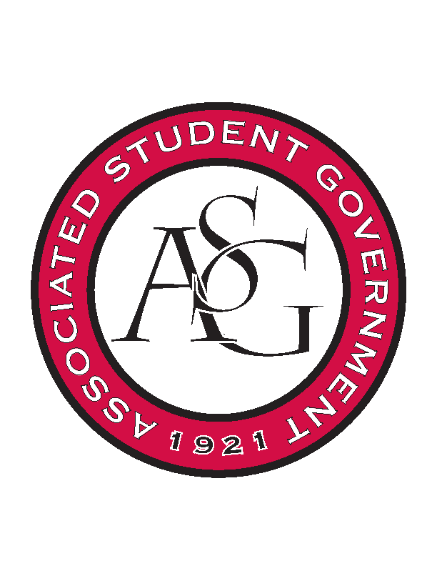
Associated Student Government

ASG Executive Council Meeting

Monday, October 12th, 2015 | 12:30 p.m.

- Call To Order
- Roll Call
- Approval of Minutes
- Special Orders
  - ASG Advisor’s Report
    - Chancellor’s Ball
      - Very successful
    - Football Camping
      - I will be going to a meeting tomorrow to work out some details. Katherine and Rachel will be going to that meeting to work out the details. It will be next weekend – Auburn game is at 11AM so that will change some of the things. Probably won’t do anything in terms of registration. Check in all day Friday 8AM – 11PM. ASG should have representatives out there to help etc.
    - Homecoming
      - Congratulations to our three court representatives. We just take care of game day programming.
    - All Call’s
      - One more on the 27th of October
      - Pizza and cokes. Enough pizza for two slices per person. Ask Mrs. Jody for the funding request from last year. Still have a lot of sodas.
      - 5:45 – 6:15. SAAD Plug. Chancellor’s Update. Quick homecoming update. May be another coach that wants to speak.
    - Enjoy Fall Break
- Reports and Discussion
  - President’s Report
    - PAB
      - Week of Nov. 2-6. I will finalize the time tomorrow as I get responses from members of the committee.
    - RAG
      - Morgan and I met with Chancellor Ferritor. I’ve talked to a few people who have expressed some concerns about the report card. We may revise the format to where it is less controversial.
      - Publishing voting records – recognize those that have supported higher education funding.
      - Consider other alternatives before releasing something. Ultimate goal is to let legislators that we are looking at it. Want to make sure it is effective.
      - Scholarship lottery, why tuition keeps rising, and still deciding on the third issue. Planning the little rock trip for November 2 and we will be able to talk to them before they start taking money away from higher ed.
    - Chancellor’s Search
      - Last week met with April Mason- good discussion with her. Top 50 goal, infrastructure etc. I thought she was personable, professional, and had excellent answers.
      - Second candidate on campus today – 2:30 the same committee of students will meet with him.
      - Public forum tomorrow at 10:30AM for Steinmans. Faulkner Arts Center.
  - Vice President’s Report
    - Chancellor’s Ball Recap
      - If you have any suggestions – venue, date change etc.
      - Less chairs next year?
      - 370 on the scanners not including the written ones.
      - Be more informative with parking.
      - Better transportation.
  - Secretary’s Report
    - Sexual Assault Awareness Day
      - Mayor will be at the RED Talk
      - First draft of t-shirt
  - Chief of Staff’s Report
    - Study Break
      - Dec 4 -18th. Need to let them know at the earlier convenience.
      - Interested to see what their other ideas are.
      - Chartwells donated it all last year.
      - Dec. 13 10PM-12AM
    - Chicken Challenge
      - You all got the detailed report.
    - Cabinet Meeting
      - Chartwells will be there. Bring questions
      - Brainstorm for PAB
- Announcements
  - October meeting for GSC is Thursday Night. GSC is 6PM.
  - Tanner: Ask ASG Day – Jace.
- Adjournment

