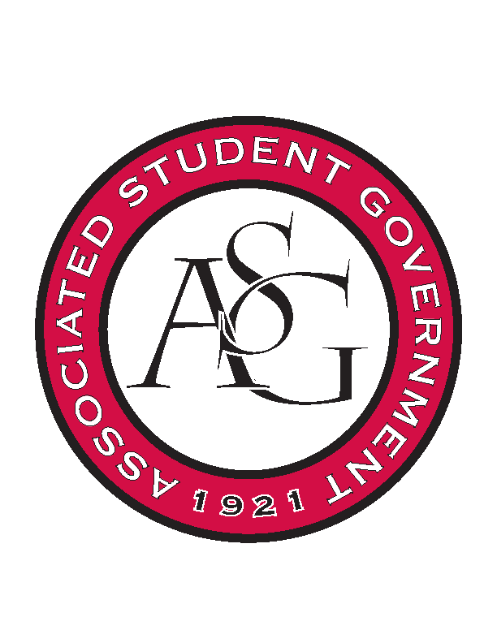
Associated Student Government

Executive Council Meeting

Monday, October 30, 2017 | 12:00 p.m.

- Call To Order
- Roll Call
- Approval of Minutes
- Approval of Agenda
- Special Orders
  - Advisor’s Report
    - Weekly Update
      - Homecoming Election is live
        - Students can’t access? Forward to Michael!
        - Paper ballots are available at OSA while the office is open
        - Voting closes Wednesday at 4:00
          - Polling station will be 10:30-1:30 at MCC tomorrow
      - Homecoming judging
        - Forward emails of concern to Michael so the University can respond
        - Individuals questions go to Michael as well
      - Josh’s Update via Michael
        - Maria and Charles can now create forms, polls, etc for the Associate members on HogSync
          - Want to encourage other members to keep using HogSync
  - Office Manger’s Report
    - Jody’s Report
      - Will send out report via email
  - Graduate Assistant’s Report
    - Josh
    - Sage
      - Fill out your exec reflection by Friday
- Reports and Discussion
  - President’s Report
    - Weekly Update
      - Encourage everyone to vote
      - Legislation submitted to Colman
        - Constitution and Code Committee creation
        - Grade forgiveness policy legislation in the works
  - Vice President’s Report
    - Weekly Update
      - Can’t rent out the Skatium on a night other than Tuesday
        - Midyear awards need to be planned
        - Need to decide between Skatium and US Pizza
  - Treasurer’s Report
    - Weekly Update
      - High attendance at the last finding session
        - Kept running out of chairs!
      - Planning on two more funding sessions since they are in such high demand
        - Spring semester is coming- apply now theme
      - PAB
        - $37,000 left over
          - wants cabinet members to reach out to her to get their events funded
      - Standing rules meeting
        - November 9th
  - Secretary’s Report
    - Weekly Update
      - Winter merchandise survey
        - Sweatshirt in dark grey is winning
      - Weekly Email
        - Include winter party ideas
          - Meet with Natalie to get exact survey wording
      - Senator posters
        - Posters have been finished, printed, and will be distributed Tuesday
  - GSC Speaker’s Report
    - Weekly Update
      - Writing documents
      - Meet with Maca about PAB Funding
      - At a conference next week, available electronically
        - Will be back Friday 11/10
  - Chair of the Senate’s Report
    - Weekly Update
  - Chief of Staff’s Report
    - Cabinet
- Red talk November 30
        - Mark your calendar
        - Chartwells agreed to 24-hour dining during finals
          - Sunday to Wednesday Slims and Quiznos until 2:00am and Starbucks 24/7
- Cabinet looking for new initiatives, pushing to do more
  - Chief Justice’s Report
    - Out of town, minutes sent via email
      - Homecoming voting begins today! Voting will open at 9AM today and will close at 4PM on Wednesday, November 1. Encourage your peers and campus partners to engage in the selection process by voting. You can direct students towards asg.uark.edu/elections. Paper ballots will be available in the OSA office for any student that may have technical difficulties or would prefer to vote via paper.
      - ASG will be hosting a polling station at the Multicultural Center (4th floor of the Union) tomorrow, Tuesday, October 31 from 10:30-1:30.
      - ASGJ will meet on Thursday to certify the election and review expenditure reports.
      - There will be a new Chief Justice chosen on November 8 – this election takes place internally, within ASGJ.
  - FLF Coordinator’s Report
- Announcements
  - Last minute announcements
    - Homecoming Research reception, Grad Student Lounge in Gearhart Hall
    - Dress up for Cabinet/ Senate tomorrow
    - Need to find extra cords for December graduates
      - What qualifications get you a cord?
        - Excludes FLF, University Committees, and Associate Member Program members
        - Elected or appointed ASG student leaders
          - Must be involved in ASG for one entire academic year

- Adjournment

