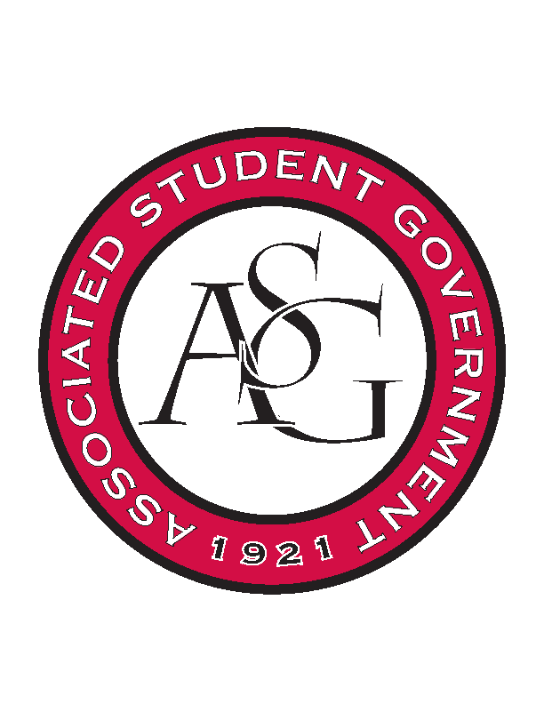
Associated Student Government

ASG Executive Council Meeting

Monday, September 28th, 2015 | 12:30 p.m.

- Call To Order
- Roll Call
- Approval of Minutes
- Special Orders
  - ASG Advisor’s Report
    - Thinking about the All Call and being more organized. October 27th.
    - 5:45-6:15PM. Grad Lobby. Sexual Assault Awareness Day. Homecoming activity update. Tanner gives Chancellor update.
    - Food – pizza and Pepsi’s.
  - ASG GA’s Report
    - Feedback on Qualtrics
    - Historian application
- Reports and Discussion
  - President’s Report
    - PAB last week – Headliners were the only ones. Approved for 65,000 out of the 124,000 available. Want to expand it to more of a festival approach. Looking for it to be one day and off campus (fairgrounds etc) 59,065 left for supplemental funding so we need to apply for some of that money. Working with cabinet.
    - Narrowed the Chancellor’s search to three people; those interviews will be conducted 1. Tuesday. Tanner and Madeline will be in attendance.
  - Vice President’s Report
    - Chancellor’s Ball is Friday – sent out an email line by line of everything that is going on that day. If you have any questions please ask me before Friday. Sent out a Google doc for people to sign up, encourage people to sign up.
  - Chair of the Senate’s Report
    - Davis is going to come speak to Cabinet next Tuesday. And they will also come speak to senate. Jace will invite Hardwood Rom at some point.
    - Emphasis more coordination with cabinet and senate.
    - Dr. Saxena wants student proof that changes are done. He wants to have two resolutions passed to have as support for her meeting with Dr. Saxena next month.
  - Freshman Leadership Forum Coordinator’s Report
    - Mentor Social is October 14th 6:00PM. Grad Ed Lobby
    - They chose their big event and its on Women Empowerment
    - 5K Mid-March
    - November 11th is the Senate Simulation for freshman.
  - Chief Justice’s Report
    - Candidate orientation on Wednesday. Campaigning rules.
    - Qualtrics.
- Announcements
  - Scout – GSC reps are starting their office hours this week. 2014*.
- Adjournment

