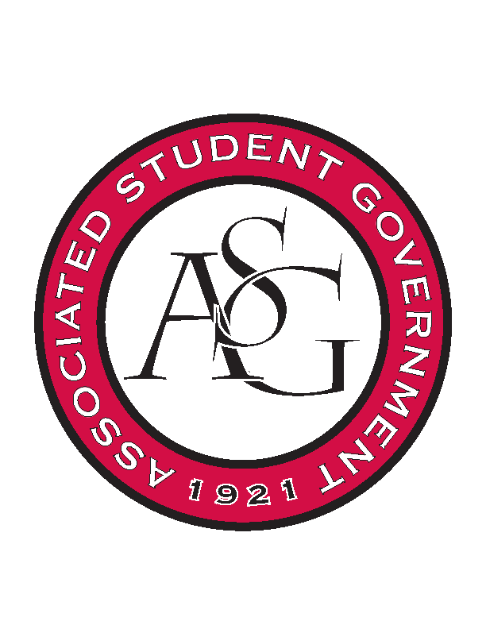
Associated Student Government

Executive Council Meeting

Monday, November 6, 2017 | 12:00 p.m.

- Call To Order
- Roll Call
- Approval of Minutes
- Approval of Agenda
- Special Orders
  - Advisor’s Report
    - Weekly Update
      - Congratulations to Andrew Hansen!
        - New Chief Justice
        - Working with Cory for a smooth transition
      - Start planning for Spring Semester
        - Weekly Exec Meetings
      - Next week is Thanksgiving Week
        - Need to decide if we are meeting
      - Every branch is meeting this week
  - Office Manger’s Report
    - Jody’s Report
      - No report
      - Sign timesheets
  - Graduate Assistant’s Report
    - Josh
    - Sage
      - No report
- Reports and Discussion
  - President’s Report
    - Weekly Update
      - Committee for Constitution and Code passed Senate
        - Representative from each branch by next week
      - We will not be meeting next week (Monday 11/20)
        - Email updates will be sent out in its place
      - Continuing to work on Homecoming document
        - Coming out soon
  - Vice President’s Report
    - Weekly Update
      - Vending Machine Initiative
        - Continuing to work with Senators on the legislation
      - Holiday party
        - December 5th
        - Superlatives, giveaways, etc.
        - US Pizza
  - Treasurer’s Report
    - Weekly Update
      - Standing Rules meeting last week
        - Added HogSync vocabulary
        - Reexamined rules
      - Video for HogSync Application
        - Educational video for how to use program
      - Last funding session tomorrow
  - Secretary’s Report
    - Weekly Update
      - Sweatshirts
        - Design has been chosen, price is a little high
          - Recommendations for lowering price>
      - ASGiving
        - Ask each member to bring one item for the Food Pantry this week
          - Each branch will individually decide if they want to offer an opportunity to earn hours/ points by bringing more cans
      - RAG
        - Will be attending RAG trip on November 29,30
  - GSC Speaker’s Report
    - Weekly Update
      - Conference was a huge success!
        - Won every award they were eligible for
      - GSC Constitution is finished
        - Presented in meeting this month
        - Voting next month
      - Research panel discussion
        - Next Thursday, great for people wanting to go to grad school
  - Chair of the Senate’s Report
    - Weekly Update
  - Chief of Staff’s Report
    - Cabinet
      - Red Talk
        - November 30th
          - Budget form has been submitted
          - Waiting to hear from one of the speakers
      - RAG
        - Trip to Little Rock November 29, 30
      - Coffee and Cookies
        - Chartwells donating the cookies and coffee
      - Cabinet is beginning to plan next semester events

  - Chief Justice’s Report
    - Weekly Updates
      - Excited to be here!
      - Associate justice vacancy
        - Application out next week, close on Dead Day
      - Vacancy Spring Election
        - Working on making a timeline
  - FLF Coordinator’s Report
- Announcements
  - JT moving Tuesday office hours to Friday
  - Natalie moving Monday hours to Friday
  - State of the Students
    - November 28th 6:00pm
- Adjournment

