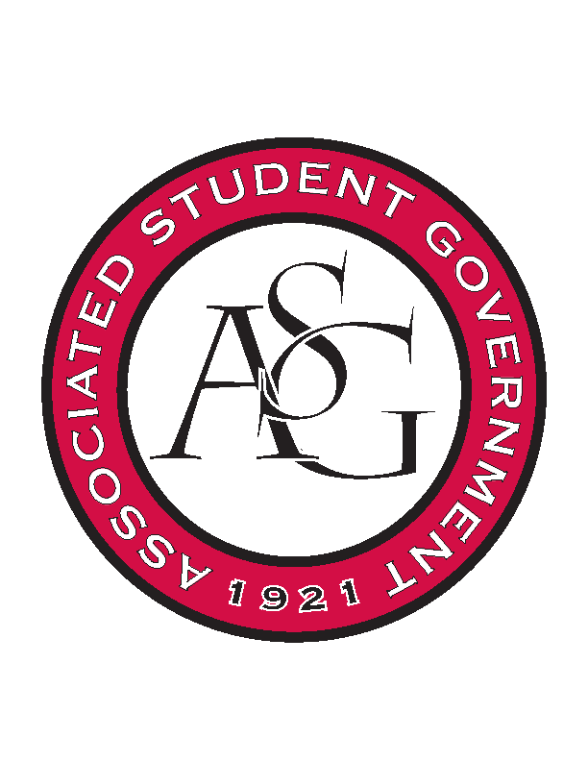
Associated Student Government

ASG Executive Council Meeting

Monday, November 16th, 2015 | 12:30 p.m.

- Call To Order
- Roll Call
- Approval of Minutes
- Special Orders
  - Special Guest: Taylor Farr
    - We talked a lot about diversity in Cabinet. We are going ahead with the RED Talk on Research – December 2^{n} at 6:00 – Union Theatre.
    - What we could do as a university – as per inclusion and being respectful no matter individual opinions.
      - Open to discussion. If we plan it big enough it could be a SEC thing if not then collaborative thing with RIC, Greek Life etc.
  - ASG Advisor’s Report
    - C&C Updates
      - There’s some updates that haven’t made it in the new changes. So just to be on top of that
    - MSU Football Game
      - They want to put something together for Saturday morning. Ill keep forwarding information. They are thinking about doing early line up. 10 AM. Add food trucks. Need volunteers.
    - Thanksgiving Hours
    - Dec. / Jan. Calendar
      - Add things that are missing.
      - Applications for cabinet – State of Students. MLK Vigil.
  - GA’s Report
    - Website
      - If you get really busy and need help doing anything he can help you do that.
    - Historian
      - We got some responses for the position. Hoping to get someone to start in January.
  - ASG Office Manager’s Report
- Reports and Discussion
  - Vice President’s Report
    - Superlatives for Holiday Party
      - Table it.
    - Old Main Oath
      - Formed a creed committee. We are really ahead of schedule. The creed will be called the Old Main Oath. If you will look through the most updated version and if you have any suggestions for me to take back to the committee. The committee will have the final say.
  - Treasurer’s Report
    - Upcoming Events
      - We talked about being more intentional about events on campus.
  - Chief of Staff’s Report
    - Diversity Event
    - RED Talk
    - Study Break in Mullins
      - December 13th. 10-12AM. Davis is meeting with Chartwells this week to see if we can get the donation like we have traditionally have.
    - Next Cabinet Meeting
      - December 1st.
- Announcements
- Adjournment

